Experimental Forecast of JJAS 2010 start time in May

Model used for the experimental forecast of JJAS at May start time:

- ECHAM4p5 CA (24 members)
- ECHAM4p5 CFS (24 members)
- ECHAM4p5 GML (12 members)
- CCM3v6 (24 members)
- ECHAM4p5 MOM3 AC1(12 members)
- ECHAM4p5 MOM3 DC2 (12 members)
- CFS (15 members)
- JAMSTEC (9 members)

Note: All the models except ECHAM4p5CASST and CCMv3p6 are coupled. These models except for the last one are obtained from International Research Institute (IRI). The source for CFS is NCEP.

Here trying to forecast JJAS rainfall by following four methods which are
- MME1
- MME2
- PCR
- Probabilistic MME

MME1:

Simple Arithmetic mean of all models. Before that taking mean of members of each models.

Scale is in percentage departure. Here it is observed southern part, west central part are in excess category. While the remaining part are falling in normal category.

MME2:
This technique is based on the method of Superensemble (Krishnamurti et.al 2000,2003,2005).This is a Multilinear regression method (using singular value decomposition) on model’s and The predictand (dependent variables) is IMD rainfall.

Scale is in percentage departure. . Here it is observed that entire India fall in normal category, while the peninsular part falls in excess category. But Gangetic W.B fall in deficit category.

Principal Component Regression (PCR) Approach:
PCR approach is used to forecast rainfall over India and its subdivisions. It is a regression technique in which the predictors (independent variables) are obtained from different general circulation models and The predictand (dependent variables) is IMD rainfall. Here Jamstec is not used.

Scale is in percentage departure. Here it shows that Tamilnadu and Pondicherry, Rayalseema, South Interior Karnataka and Coastal A.P fall in exces category. While remaining parts of country fall in normal category. The All India average is found to be 910.6 mm (101.6% of LPA).

Probabilistic Forecast
Probabilistic forecast is made in three categories viz. Below Normal, Near Normal and Above normal. These categories are based on the previous year’s observed data set (IMD’s gridded data). The model and observed data sets are normalized to have zero mean and one standard deviation before subjecting to any analysis. As the mean is shifted to zero and standard deviation changed to unity the bounds for the categories become as follows.
Below Normal category: -∞ to -0.43
Near Normal category: -0.43 to 0.43
Above normal category: 0.43 to ∞
The colors in the figure represent chance of occurrence of the particular event; e.g. if we get 20% below normal 30% Normal and 50% above normal means there are 50% chances that the rainfall will be more than 0.43 (Above Normal) at the same time there are 20% chances to get rainfall less than -0.43 (Below Normal) and 30% chances of getting rainfall in the near normal category, thus in this example it becomes wet forecast.

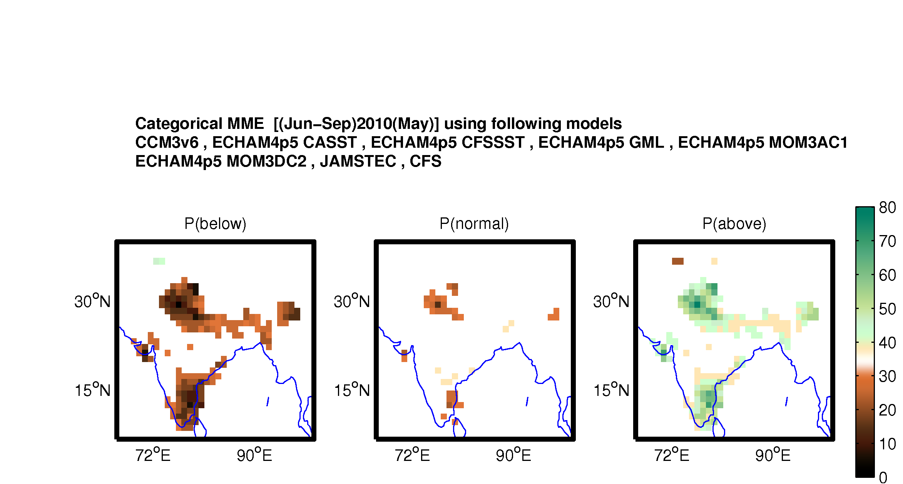

The experimental probabilistic forecast suggest that there are higher chances of getting above normal rainfall in southern part, Foot hills, some part of North-East and Gujrat .

