 |  | 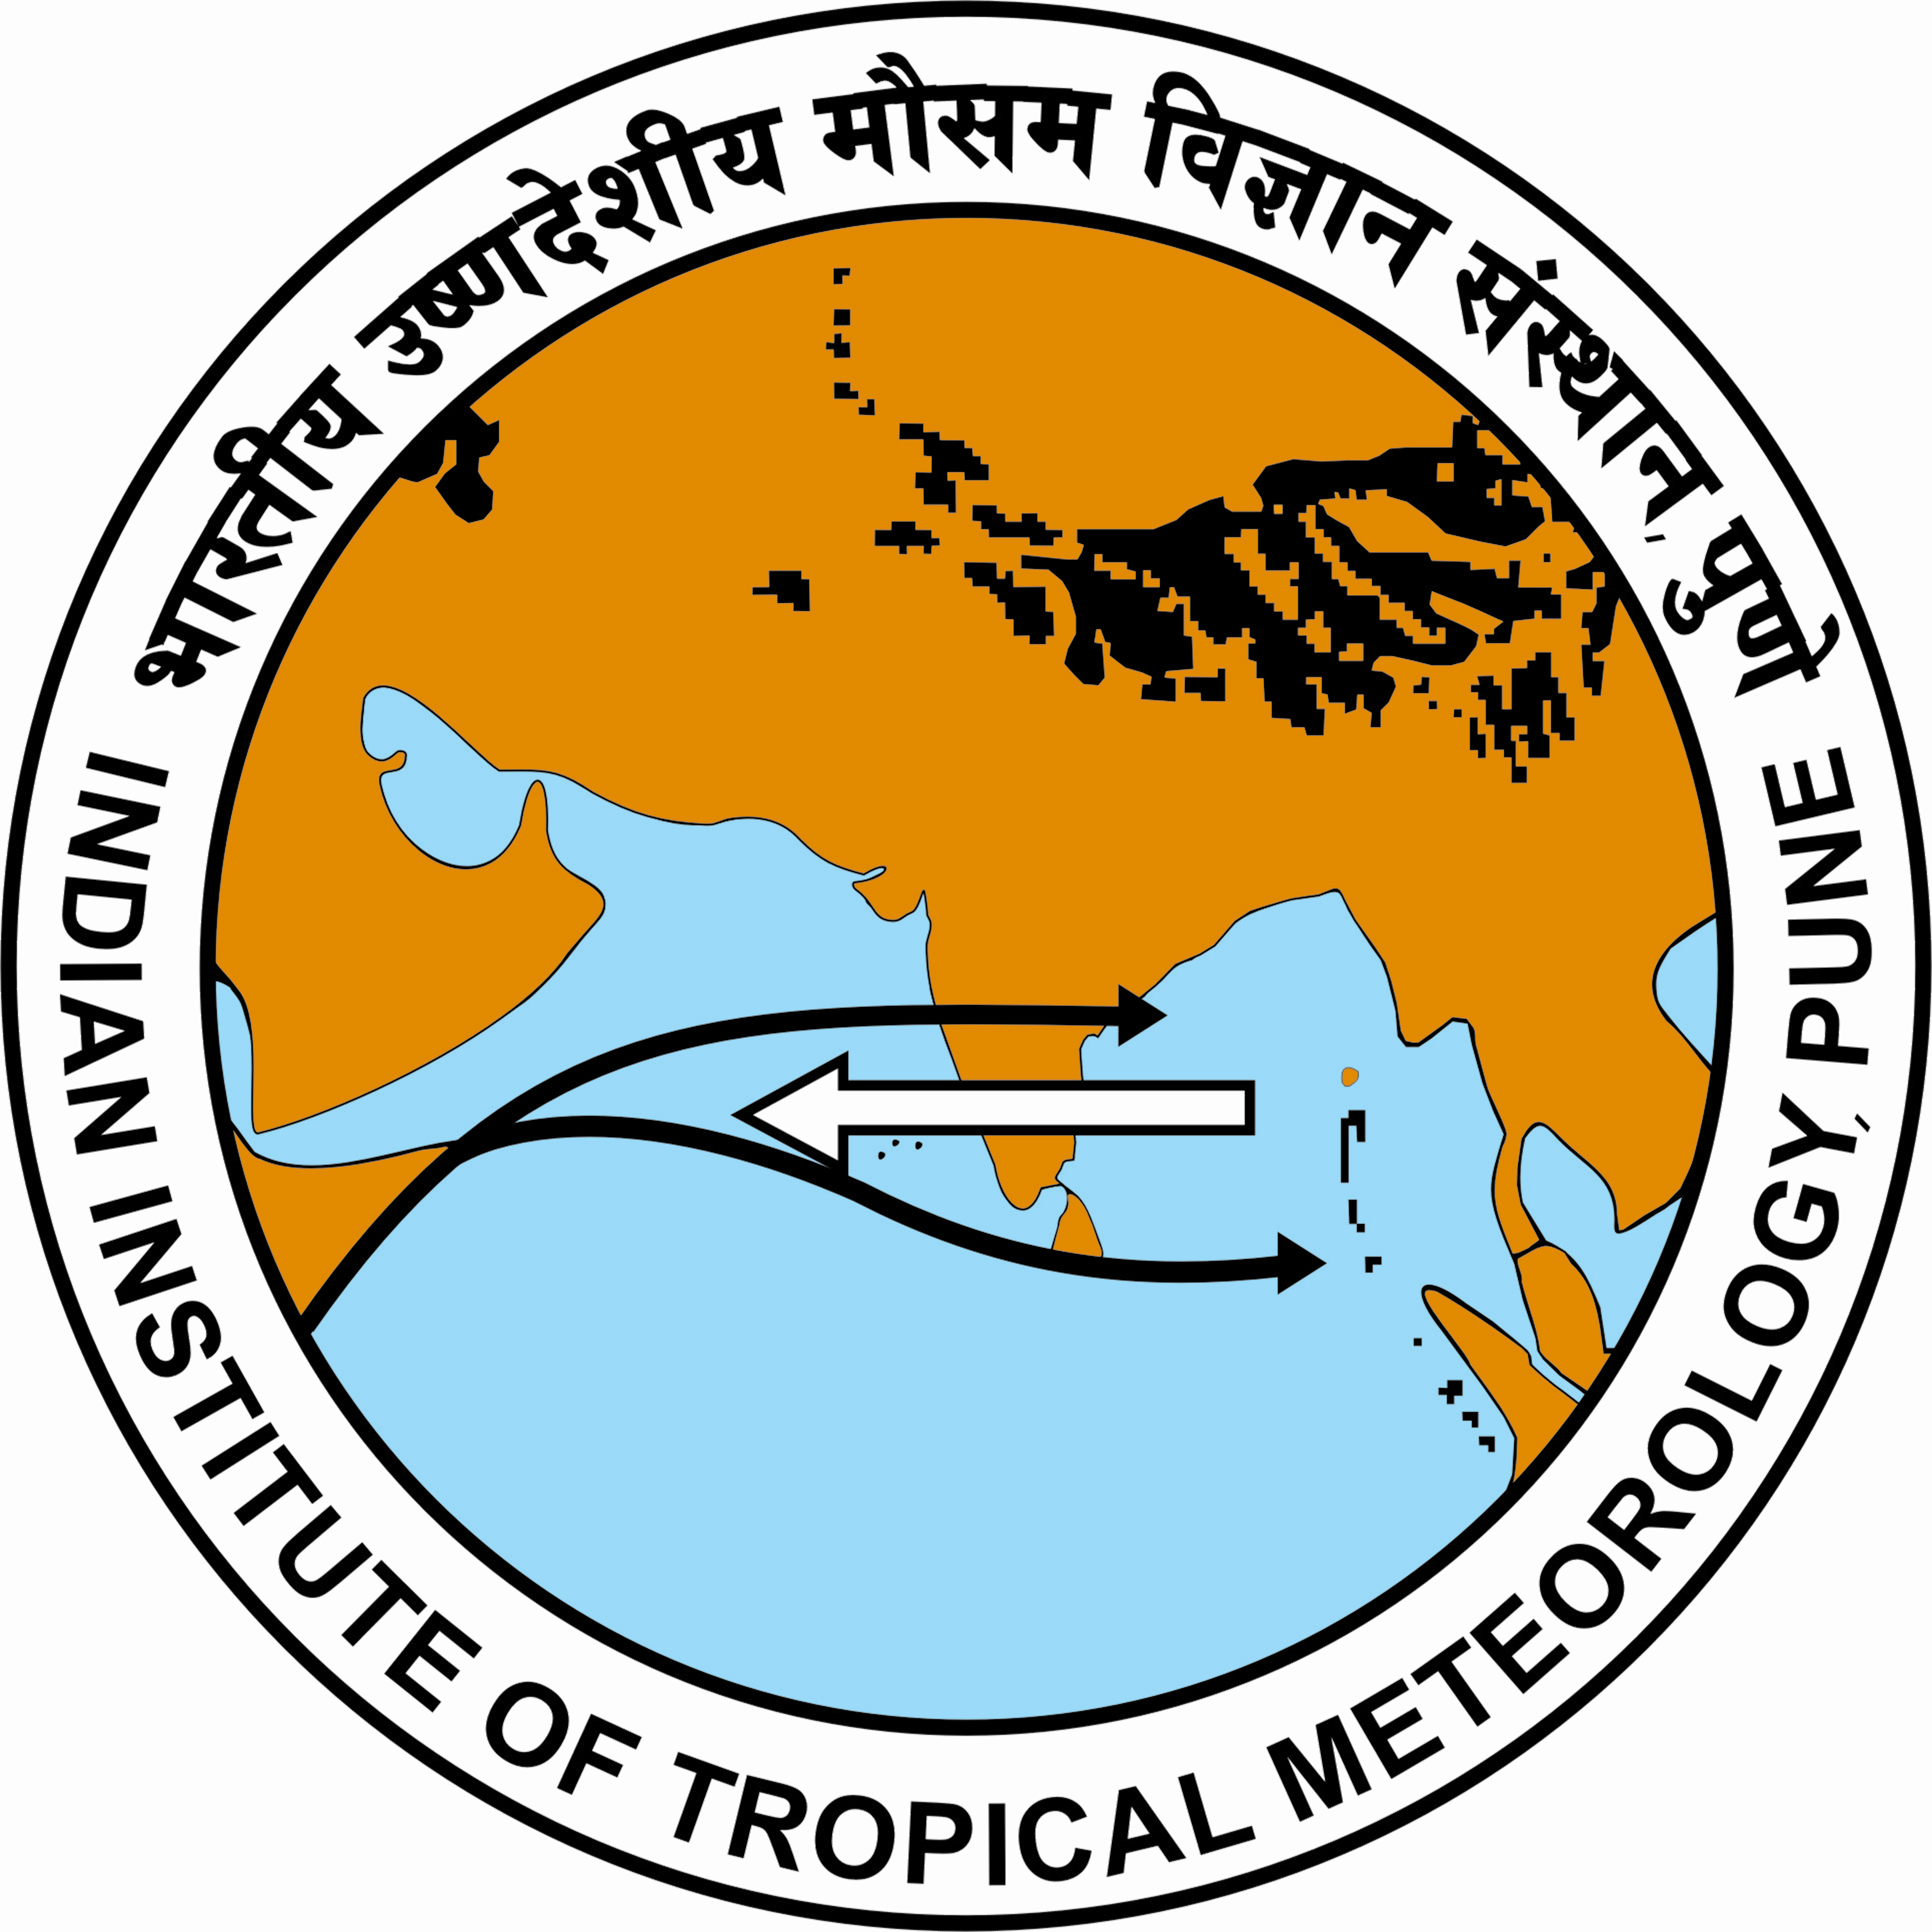

First session of
South Asian Climate Outlook Forum (SASCOF-1)
Pune, India, 13-15 April 2010

AGENDA
Venue: Varaha Mihir Hall
Indian Institute of Tropical Meteorology (IITM), Pune

13 April 2010: Tuesday
08:30 | Registration of delegates
09:30 | Vandana recitation and lighting of traditional lamp
09:40 | Welcome address by Dr. H. R. Hatwar, ADGM(R)
09:50 | Opening Remarks by Prof. B. N. Goswami, Director, IITM
10:00 | Statement on behalf of WMO Secretary-General by Dr. R. Kolli
10:20 | Inaugural Address by AVM Dr. Ajit Tyagi DGM and PR of India with WMO
10:40 | Vote of Thanks by Shri A. K. Srivastava, Co ordinator, SASCOF-1
10:50 | Tea/Coffee
Session I | Approaches to Seasonal Prediction of South Asian Summer Monsoon  Chairman: Dr. G. B. Pant
11:30 | Concept and relevance of SASCOF (R. Kolli, WMO)
12:00 | Prediction of the Indian summer monsoon on seasonal and sub-seasonal scales: IITM Initiatives (B.N. Goswami, IITM)
12:30 | Recent advances in seasonal prediction (M. Vellinga, UKMO)
13:00 | Lunch
14:00 | Model Intercomparison for Seasonal Prediction of Indian Summer Monsoon (S. Gadgil, IISc)
14:30 | Tailoring Seasonal Forecasts (M. Tippett, IRI, USA)
15:00 | Operational seasonal prediction in India (D.S. Pai, IMD)
15:30 | Talk by Dr. A.K. Bohra, NCMRWF
16:00 | Tea/Coffee
16:30 | Role of Ocean in the variability of monsoon onset and rainfall over South Asia (Prof P. V. Joseph
17:00 | Open Discussion (Advances in scientific understanding and operational approaches)
18:00 | Close of Day 1
14 April 2010 : Wednesday
Venue: Arya Bhatta Hall

08:45 | Group Photo
Session II | Seasonal Prediction of South Asian Summer Monsoon : Global and Regional Perspectives  Chairman: Prof. D. R. Sikka
09:00 | Predictions of JMA (Dr K. Takahashi, JMA)
09:20 | Predictions of IRI (Dr M. Tippett, IRI)
09:40 | Predictions of UKMO (Dr M. Vellinga, UKMO)
10:00 | Predictions of CMA (Dr Bing Zhou, BCC/CMA)
10:20 | Predictions of APCC (Dr. R.H. Kripalani, APCC)
10:40 | Tea/Coffee Break
11:00 | Predictions of KMA/WMO LC-LRFMME (Ms J.H. Choi, KMA)
11:20 | Predictions of Meteo France (Mr J.P. Ceron, Meteo-France; presented by Dr R. Kolli)
11:30 | WMO El Nino/La Nina Update (R. Kolli, WMO)
11:40 | SMRC Perspectives (Dr S. Das, SMRC)
12:00 | FOCRAII outlook (Dr Bing Zhou, BCC/CMA)
12:15 | Open Discussion on Global and Regional Perspectives
12:45 | Lunch
Session III | Seasonal Prediction of South Asian Summer Monsoon : Country Perspectives  Chairman: Dr. R. R. Kelkar
14:00 | Country Presentations (Country-level predictions for JJAS 2010 if available, or brief summary of related activities)
20 mins each | India  - Dr D.S. Pai, IMD  - Dr A.K. Sahai, IITM  - Dr S. C. Kar, NCMRWF  - Dr C.M. Kishtwal, SAC
15.20 | Tea/Coffee Break
15:45 | Pakistan (Mr A. Mahmood, PMD)
16:00 | Bangladesh (Mr S. Ahmed, BMD)
16.15 | Nepal (Mr S.K. Baidya, DHM)
16:00 | Bhutan (Mr T.B. Tamang, HMSD)
16:15 | Afghanistan (Mr A.Q. Qadeer, AMA)
16:30 | Sri Lanka (Mr D. Jayasinghearachchi, DoM)
16:45 | Maldives (Mr A.M. Ramiz, MMS)
Session IV | Development of Consensus Outlook for JJAS 2010  Chairman D. R. Sikka
17:00 | Open Discussion on the available indicators of the anomalies of the South Asian Summer Monsoon in 2010 and discussion on SASCOF-1 Consensus Statement
18:00 | Close of Day 2

15 April 2010 : Thursday
Venue: Arya Bhatta Hall

Session V | User Perspectives of South Asian Summer Monsoon Prediction  Chairperson: Dr. Swati Basu
09:00 | Creating platforms for sharing seasonal forecasts (Dr G. Srinivasan, RIMES)
09:15 | Presentations by user sectors
 | Agriculture
 | Water
 | Health
 | Media
10:30 | Tea/Coffee Break
11:00 | Open Discussion on monsoon impacts, user needs, communication of predictions/outlook including uncertainty aspects
12:00 | Presentation of final SASCOF-1 Outlook (A.K. Srivastava, IMD)
12:30 | Lunch
Session VI | Sustaining SASCOF: Way Forward  Chairman: Dr. R. Kolli
14:00 | Open Discussion on Developing an Action Plan for SASCOF-2
 | GPC/RCC Role
 | Regional Coordination
 | Country contributions
 | Methodology aspects
 | Capacity Building Needs
15:20 | Conclusions and Recommendations
15:30 | Tea/Coffee Break
16:00 | Close of SASCOF-1

