The APEC Climate Center

Experimental climate Outlook for Mar-Aug 2010

based on 6-month 1-tier MME Forecasts

(also includes the bulletin for ENSO)

Contents

Highlights…..……...……………………………………………………...……………………..2

Part I. ENSO and IOD Forecast
1. ENSO and IOD forecast outlook…………......……………………………………………3
2. Hindcast Verification of ENSO and IOD indices for MAMJJA (1983-2005)…..………...5

Part II. 6-month MME Forecast
1. Mar-May 2010 forecast…….……….…...…………………………………………………6
2. Jun-Aug 2010 forecast…..…..….………....………………………………………………..6
3. Forecast figures for Mar-May 2010……….………..………………………………………7
4. Forecast figures for Jun-Aug 2010.....………………..…………………………………...10
5. Hindcast verification for Mar-May…...……..…………..………………………………...13
6. Hindcast verification for Jun-Aug.…………………...………...…………………………17

Authors: Doo Young Lee and Hye-In Jeong

Highlights

- Near-Neutral Condition of El Niño in central tropical Pacific through August 2010.
- Anomalously dryer (wetter) than normal conditions expected in southern Indian subcontinent, Philippine islands (maritime continents, southeastern China and Korean Peninsula) during MAM. During JJA, slightly wet conditions likely in mainland of Southeast Asia, Philippine islands and the southeastern Australian continent.
- Slightly warmer (colder) than normal condition expected in maritime continents, mainland of Southeast Asia, southern Indian subcontinent, Central America and southeastern Africa (Japanese archipelago, eastern United States, Caspian Sea basin and most of Europe along with the northwestern portion of Africa) during MAMJJA.

Part I. ENSO and IOD forecast

1. ENSO and IOD forecast outlook

The APCC 6-month ENSO forecast, based on MME predictions using the individual forecasts from 6 coupled models for the March-August 2010 indicates decay of the El Niño event to near-neutral conditions across the tropical Pacific for the period of March through May. During the period of June to August of 2010, the situation in the tropical Pacific will be kept in near-neutral condition (see Figs. 1.1, 1.2). There are no predicted IOD (Indian Ocean Dipole Index) signals during March-May, 2010, the typical period when the events start growing. It is likely to experience slightly warm condition in the Indian Ocean (see Fig. 1.2). The hindcast skills are provided in Figure 2.1.

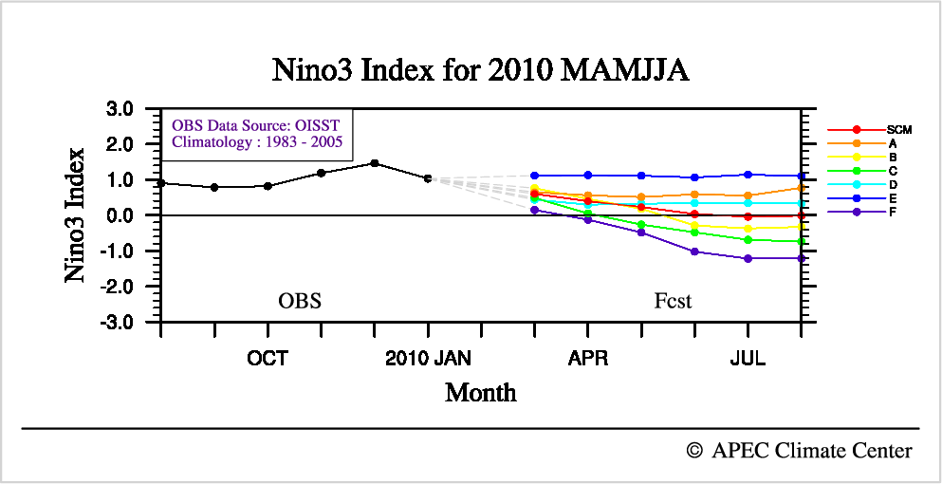

Figure 1.1 Predicted Niño3 Index. The predictions from the individual models are marked as A, B, C, D, E and F, while that from the simple composite MME method is marked as SCM.

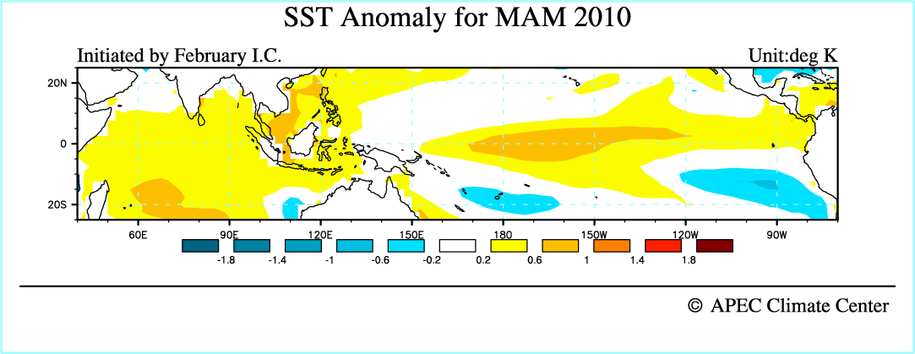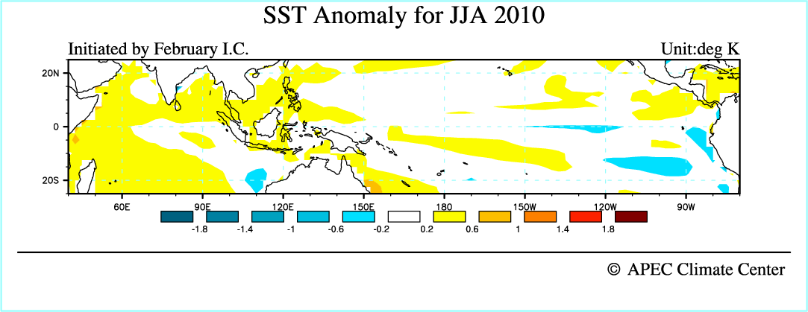
Figure 1.2 Spatial distributions of forecasted SST Anomalies over the tropical Indo-Pacific. Top panel shows SST forecast for March-May 2010, bottom panel represents SSTA forecast for June-August 2010.

2. Hindcast Verification of ENSO and IOD indices for MAMJJA (1983-2005)

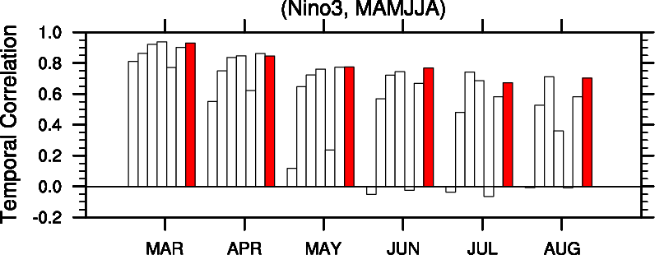

Figure 2.1 Temporal correlation coefficient between the predicted and observed Niño3 indices (5˚S-5˚N, 150˚W-90˚W) for MAMJJA during the hindcast period of 1983-2005. The red bar is MME (SCM) and white bars are individual models.

※ Predictions for several other indices such as Niño3.4, Niño4, Niño1+2, and EMI is available upon request (pl. contact Ms. Hye-In Jeong (gpdls@apcc21.net))

Part II. 6-month MME Forecast

1. Mar-May 2010 forecast

The APCC 1-6 month lead coupled MME prediction indicates that El Niño signal decays in the central and eastern equatorial Pacific Ocean during the period of March to May 2010. The central Australian continent, most of maritime continents, southeastern China and Korean Peninsula are likely to experience slightly wetter than normal conditions. Anomalously dry conditions over the western North Pacific Ocean along with the Philippine islands are expected. The southern Indian subcontinent, most part of mainland Southeast Asia including the Bay of Bengal are likely to experience below normal rainfall with slightly warm condition. It is likely that cold signals occur in the southern United States, Mexico, the Caspian Sea basin, the northwestern Africa, most of Europe and the western Australian continent. The northern portion of Brazil and western Canada may experience anomalously warmer than normal conditions.

2. Jun-Aug 2010 forecast

The SST forecast for the period of June-August 2010 indicates further weakened signals in tropical Pacific as compared with MAM season. Most of the maritime continents and northeastern China may experience anomalously dry and warm conditions. The southeastern portion of the Australian continent, mainland Southeast Asia may experience above normal rainfall. Anomalous warm conditions are expected over the Tasman Sea between Australia and New Zealand and western North Pacific. There is a strong chance that it will be cold in northern regions of the Japanese archipelago, eastern Mongolia, the Caspian Sea basin, most of Europe and the northwestern Africa. It is likely to experience slightly warmer than normal conditions in the southern Indian subcontinent, most part of mainland Southeast Asia, Mexico, and the southeastern portion of Africa.

APCC 6-month climate forecasts are based on 1-tier predictions from 6 institutions in the APEC region, and the hindcast skill are for the period 1983-2005. Deterministic and probabilistic methods are used for 6-month MME forecasts.
3. Forecast figures for Mar-May 2010

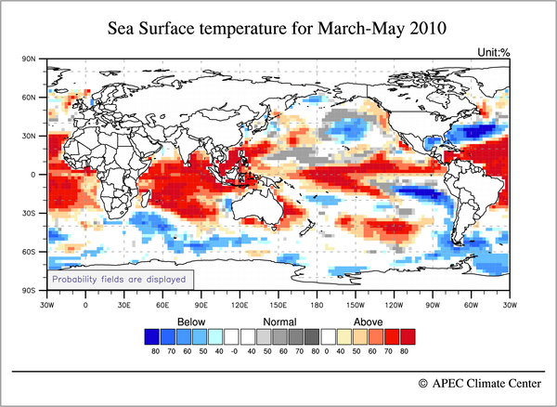
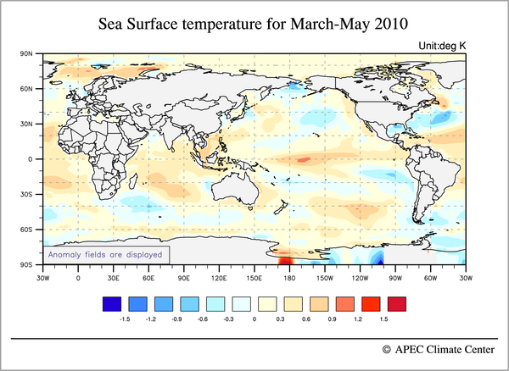
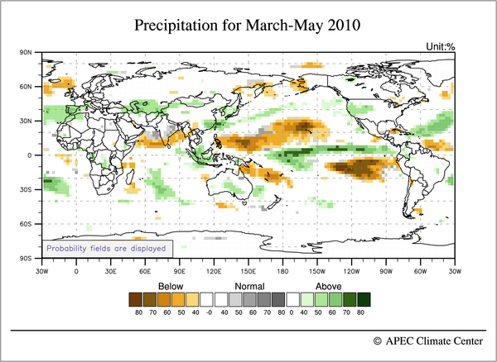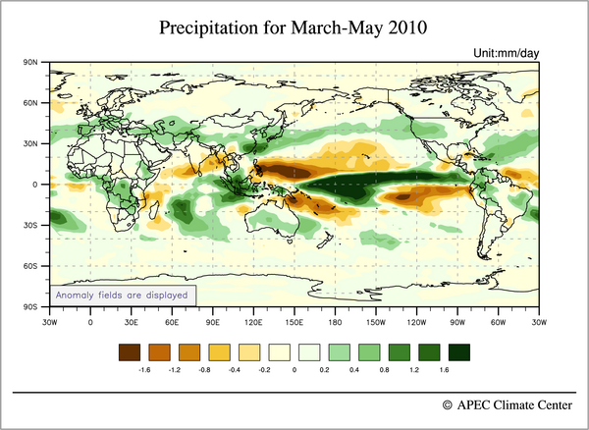

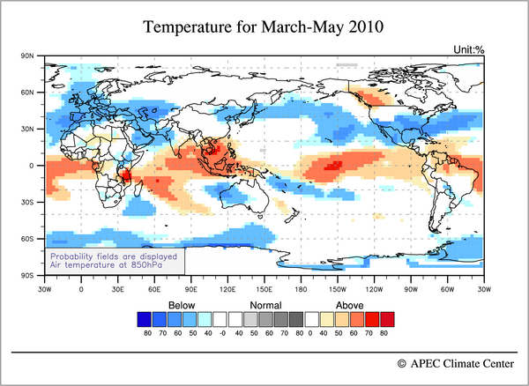
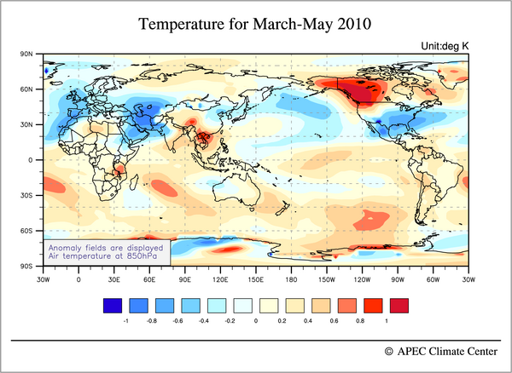
4. Forecast figures for Jun-Aug, 2010

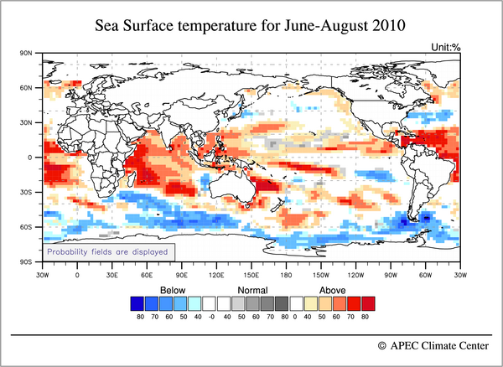
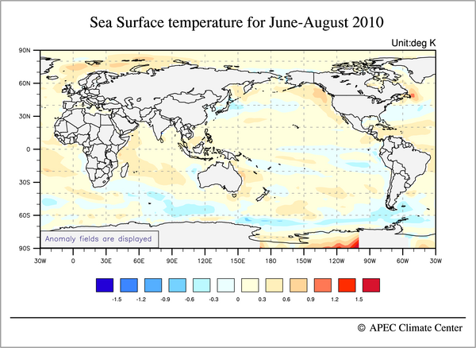
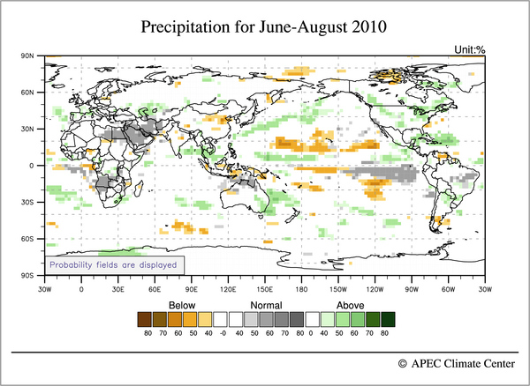
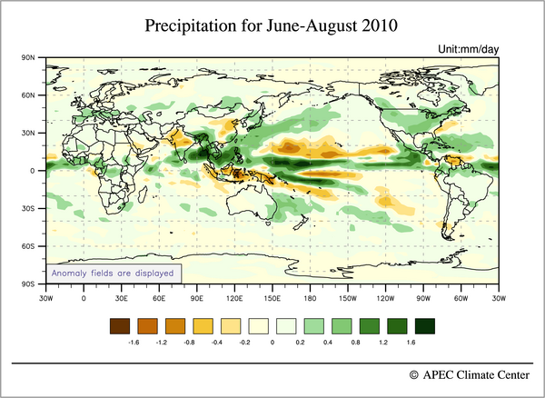
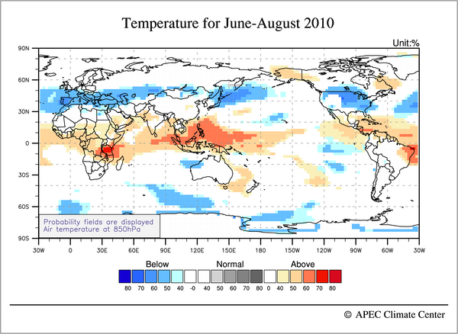
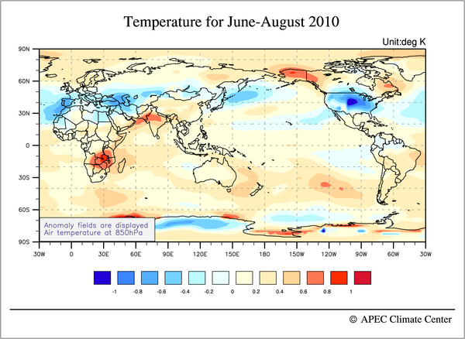

5. Hindcast verification for Mar-May

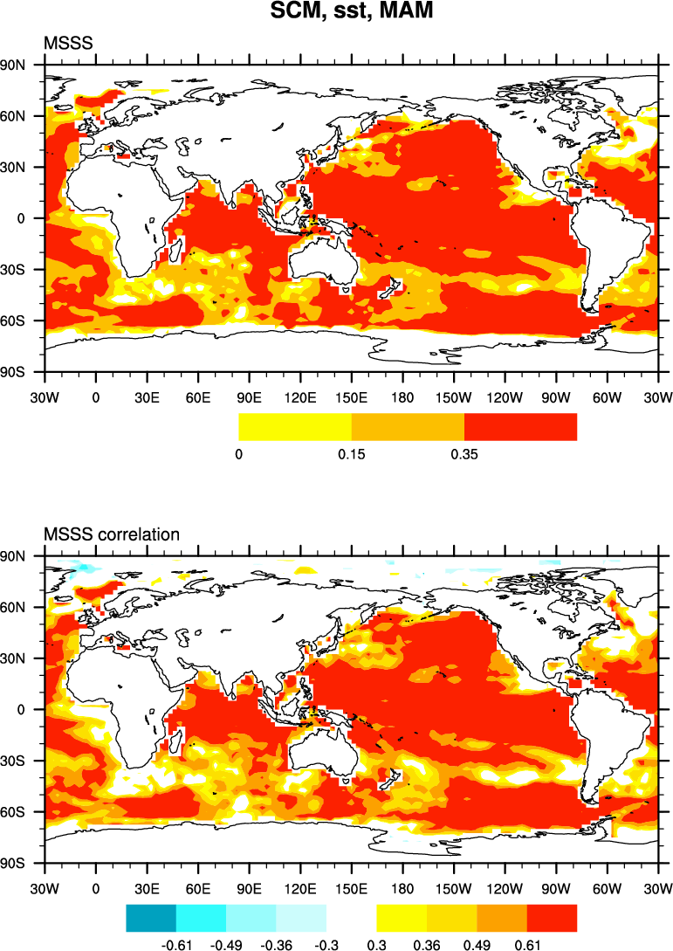
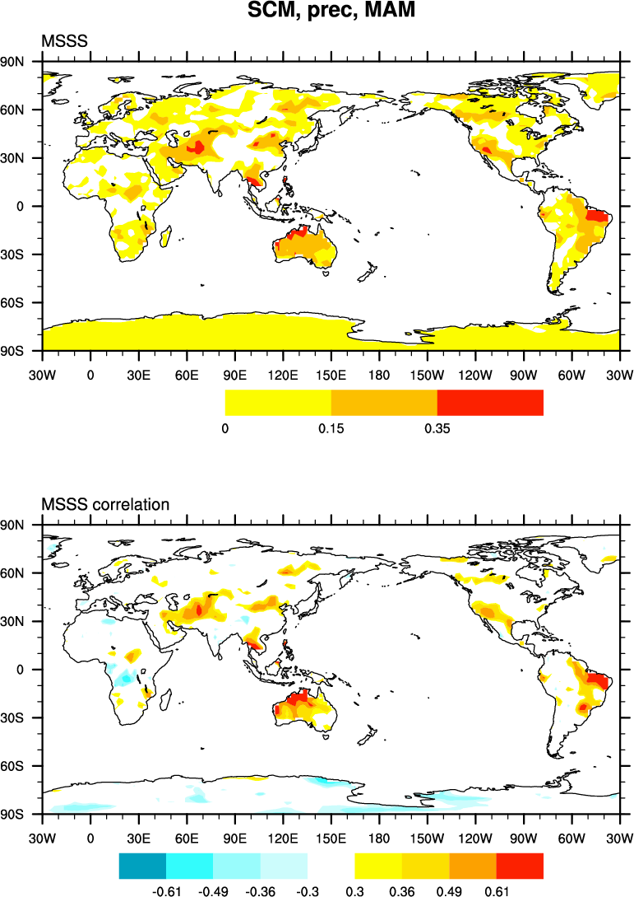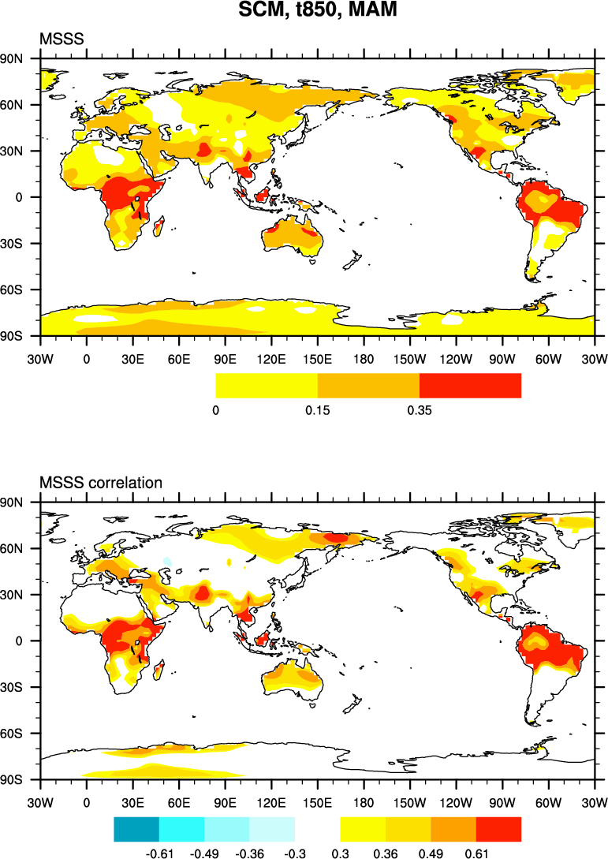

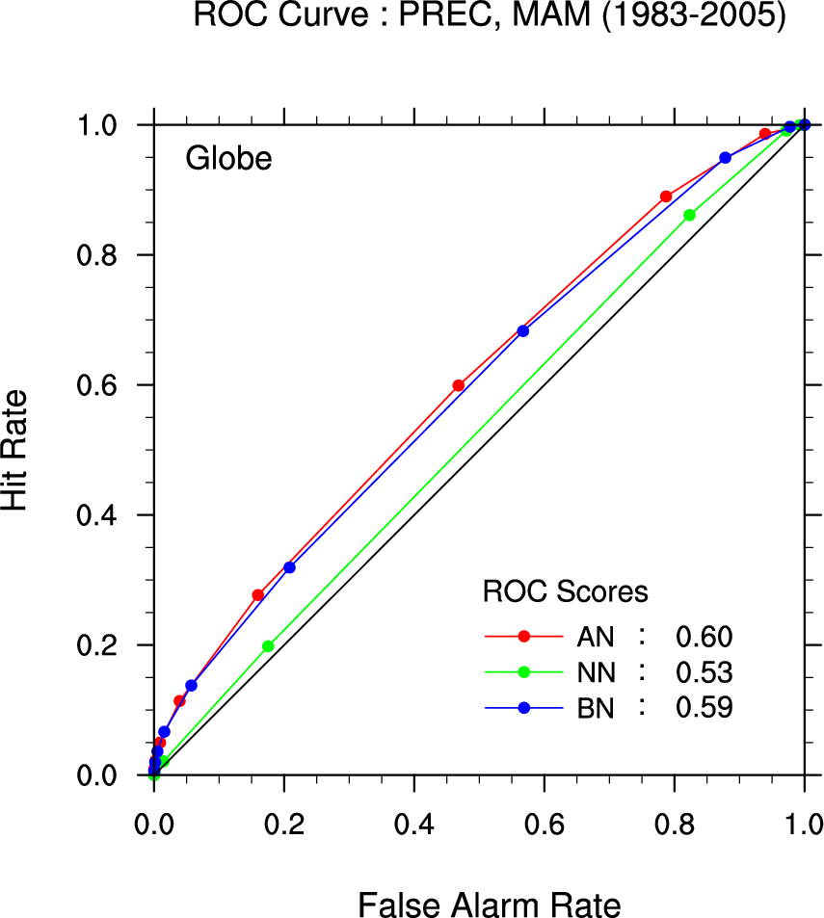

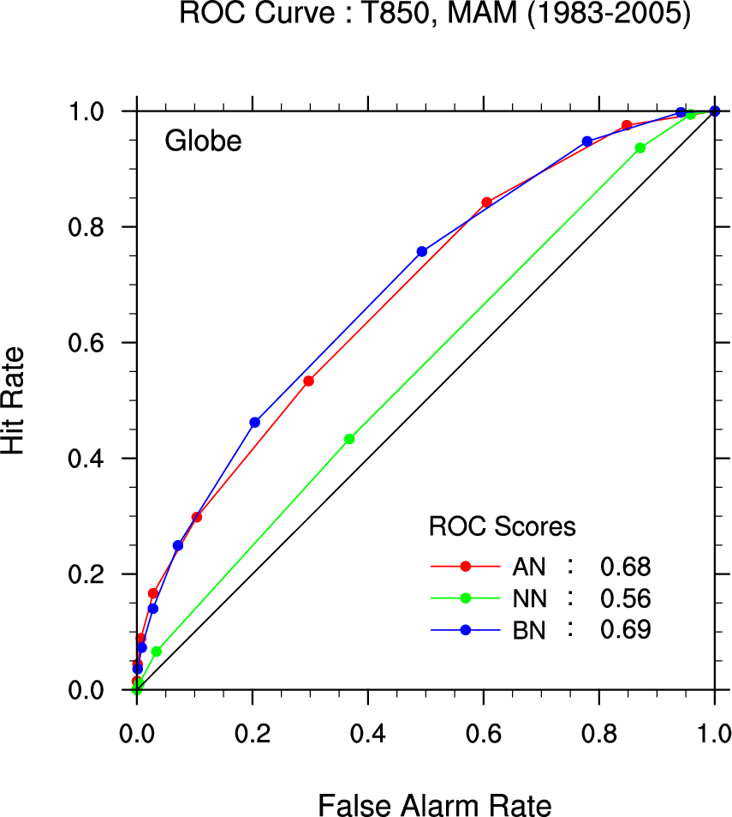
6. Hindcast verification for Jun-Aug

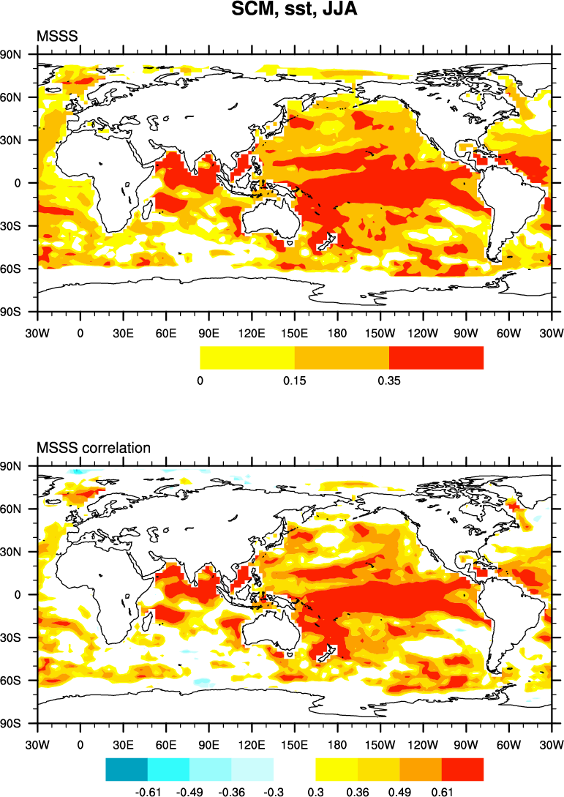

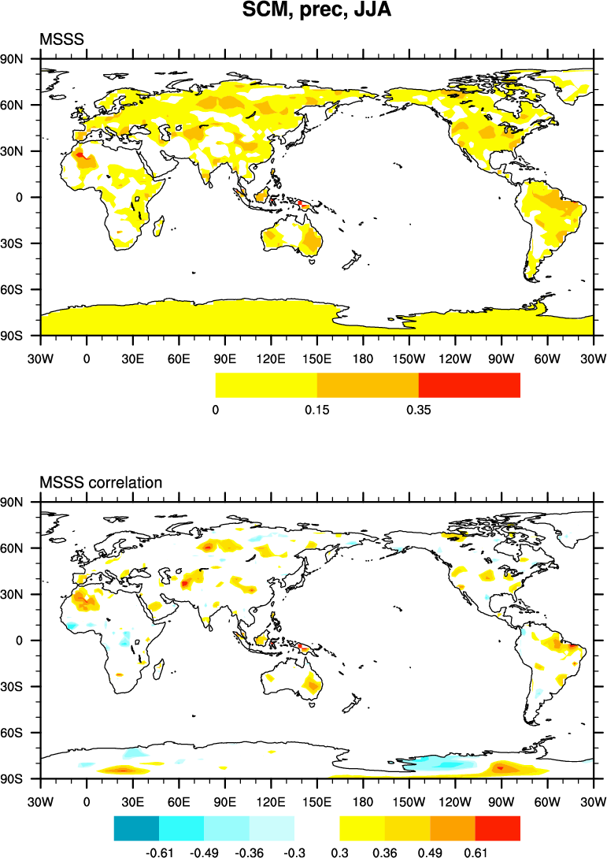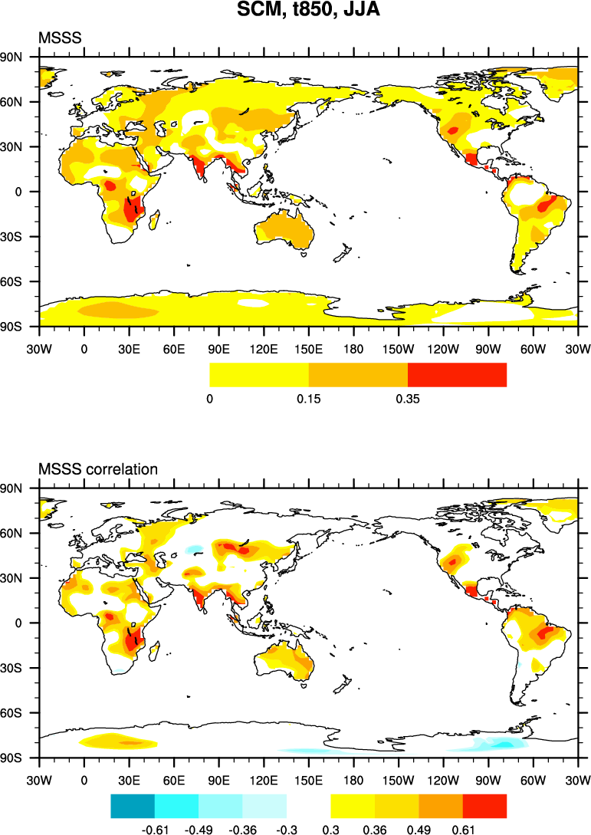

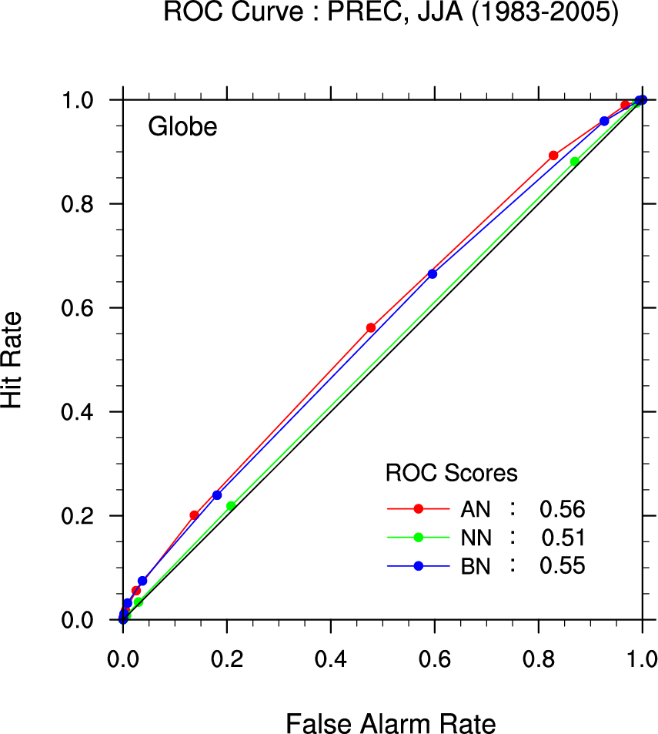

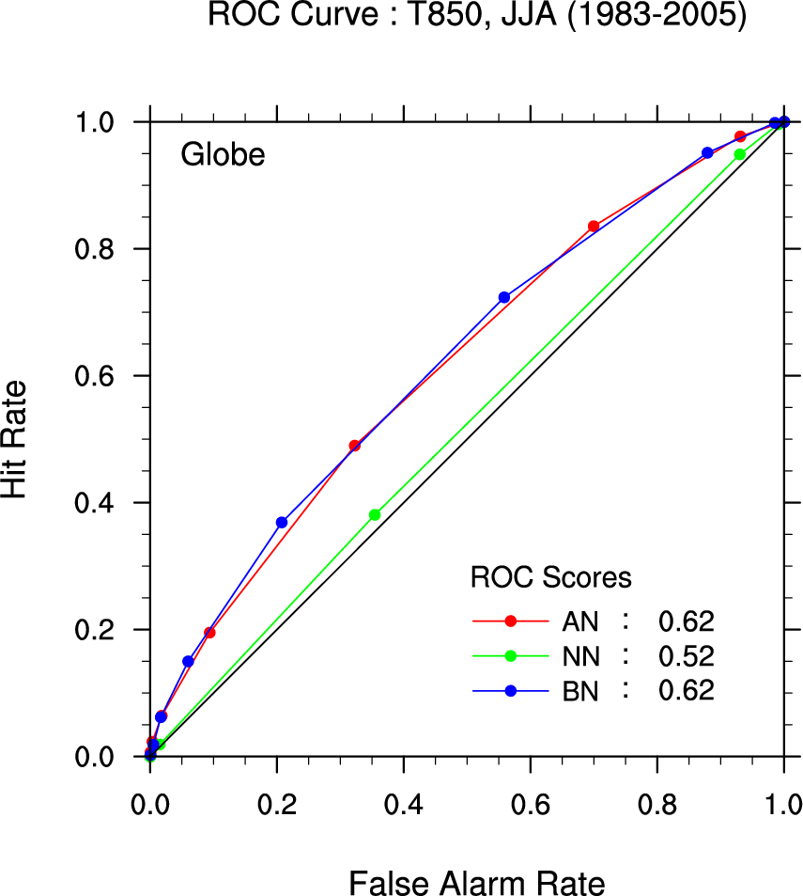

The experimental 6-month APCC forecast outlook, as the name indicates, is currently under development, and does not replace the operational rolling monthly 3-month forecast.
with initial conditions of February 2010, providing a forecast with lead time of 1-6 months.
We define an El Niño event when the predicted Niño3 anomaly exceeds its standard deviation obtained from the hindcast for more than a season.
Two MME methods, namely, Simple composite as well as probabilistic method, have been employed.
APCC 6-month climate forecasts are based on 1-tier predictions from 6 institutions in the APEC region, and the hindcast skill are for the period 1983-2005. The constituent models are APCC’s CCSM3, BOM’s POAMA, NCEP, SINTEX-F, SNU and UH - the last three model predictions are the courtesy of CliPAS (Climate Prediction and its Application to Society).
SSTA difference between the tropical western Indian Ocean (10°S-10°N, 50°-70°E) and the tropical southeastern Indian Ocean (10°S-0°, 90°-110°E).

