The APEC CLIMATE CENTER

Climate Outlook for April-June 2010

BUSAN, 25 March 2010 - Synthesis of the latest model forecasts for April-June 2010 at the APEC Climate Center (APCC), located at Busan, Korea, indicates above normal rainfall over the central to eastern equatorial Pacific, the Caribbean and eastern coastal regions of China, Suppressed rainfall over the Philippines, southern Polynesian Islands and the northeastern part of South America. Above normal temperature is predicted in most of Africa, South and Southeast Asia, Central America, Australia and northern North America.

Current Climate Conditions

Warm sea surface temperature anomalies associated with the El-Nino persist across the equatorial Pacific Ocean. The mean wintertime (DJF) Arctic Oscillation (AO) index of about -3.4 has become the lowest on the seasonal mean index record since 1950, with the February AO index of -4.27 being the lowest on the monthly index value record. Strong negative AO polarity indicates an essential weakening of the high-latitude zonal flow and enhancement of meridional circulation in the northern hemisphere which strongly affects temperature and precipitation patterns.

During the period from December through the first half of March 2010, anomalously cold weather persisted over most of Eurasia, southern parts of the North and South Americas and central Australia. Warm anomalies were observed over the whole tropics and partly into the subtropics, Canada, Greenland and the central Arctic.

Warm and dry conditions were observed over the northern part of Africa, the Middle East and southern Central Asia. Drier than normal conditions persisted over the Maritime continent and western Australia. It was much wetter than normal in the Mediterranean, southern Mexico and the Florida key region in January to the first half of March. In other regions, precipitation conditions were varying. Wet conditions over the Maritime Continent and adjoining northern Australia in January have been replaced by drier-than-normal conditions since February.

Forecast

Seasonal Temperature Outlook:
The APCC forecast for April-June 2010 indicates persistent warm conditions over the tropics, including most of Africa, the Middle East, South and Southeast Asia, Central America to northern South America and Australia. Positive temperature anomalies are also expected in northern North America and Greenland. Below-normal temperature is expected in the Bering Sea and southern South America. The temperature over most of Russia and Europe is likely to be near normal.

Monthly Temperature Outlook:
Above-normal temperature is expected over the tropics, Australia and Canada for the whole period from April to June. Below-normal temperature is expected in Europe, central Russia, Bering Sea, western USA and southern South America in April will steadily rise towards normal in Europe and Bering Sea and above normal in Russia and the USA .

Seasonal Precipitation Outlook:
There is a strong chance of below-normal precipitation in Mexico, northern Brazil, the western South American coast, the Philippines and southern Polynesian Islands. Conversely, wetter than normal conditions are expected in the central to eastern equatorial Pacific, eastern coastal regions of China, Central America, and the Caribbean Sea.

Monthly Precipitation Outlook:
Global features for dry and wet conditions (indicated above) are likely to persist from April to June. However, below-normal precipitation is expected over Indochina during mid-season, and this is likely to expand from Indochina up to South Asia during the later part of the season.

The APEC Climate Center is a major APEC science facility, which was established in November 2005 during the leaders meeting of the Asia-Pacific Economic Forum in Busan, Korea. It produces seasonal and monthly forecasts of climate conditions for all seasons around the globe. APCC collects seasonal forecasts from 16 institutes in the APEC region: the Australian Bureau of Meteorology, Meteorological Service of Canada, Beijing Climate Center China, Institute of Atmospheric Physics China, Japan Meteorological Agency Japan, National Institute of Meteorological Research Korea, Korea Meteorological Administration Korea, Seoul National University Korea, SENAMHI Peru, Hydrometeorological Research Center of Russia, Voeikov Main Geophysical Observatory of Russia, Central Weather Bureau Chinese Taipei, National Aeronautics and Space Administration USA, National Centers for Environmental Prediction USA, International Research Institute for Climate and Society USA, Center for Ocean-Land-Atmosphere Studies USA.

The APCC climate forecasts are based on model simulations from 16 prominent climate forecasting centers and institutes in the APEC region. These forecasts are collected and combined using state-of-the-art schemes to produce a statistically ‘consensual’ forecast. The APCC forecasts are based not just on the magnitude of the seasonal changes that are predicted, but also take into account their simulated probability. Further details as well as the verification for the forecasts on a long term basis are available at http://www.apcc21.net. Historical verification of the forecast performance is based on a retrospective forecast period of all the models for the period 1981-2003.
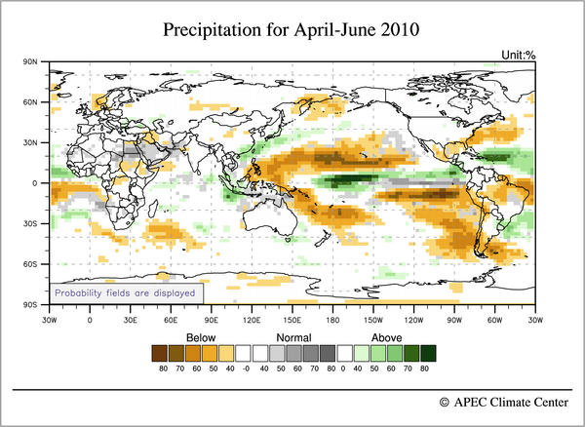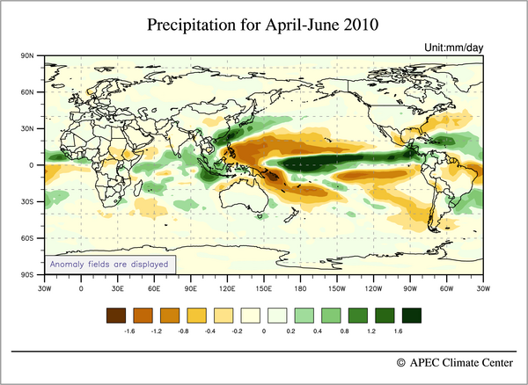
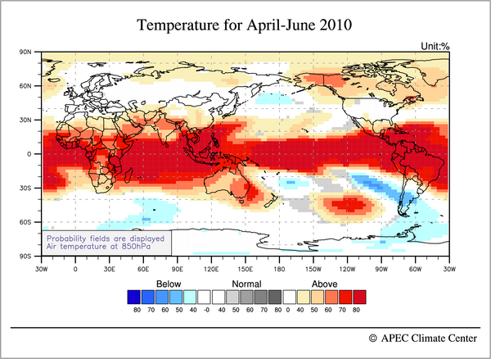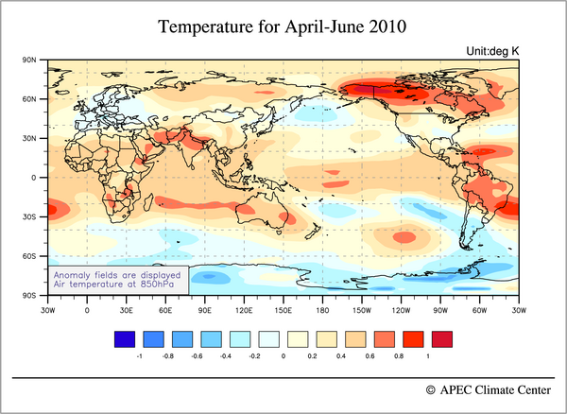

From http://www.cpc.noaa.gov/products/precip/CWlink/daily_ao_index/ao.shtml

