**Interim Report**

Development of Climate Analysis Section for the President’s Malaria Initiative: The Case of Rwanda

Madeleine Thomson, Tufa Dinku, John Del Corral, & Remi Cousin

International Research Institute for Climate and Society

Columbia University

New York.

Introduction 4

Rainfall and Temperature measurements for Rwanda 5

Ground based observations 5

Satellite data 6

Rainfall estimates 6

Minimum and Maximum Temperature 7

ENACTS 8

Generating over 30-year time series of ten-daily rainfall and temperature data. 8

Data 8

Rainfall 9

Temperature 9

Methodology 9

Rainfall 9

Results 10

Rainfall 10

Temperature (Max) 11

Temperature (Min) 12

Customizing and installing the IRI Data Library at National Meteorology Agency (METEO RWANDA) 13

Products and services created for use by the Rwanda Malaria Impact Evaluation Group 14

Spatial and seasonal distribution of rainfall and temperature (1st dekad of year) 14

Climate Analysis Tool (at provincial level) 15

Maximum Temperature 15

Minimum Temperature 16

WASP 16

Appendix 1 Climate section for inclusion in “Evaluation of the Impact of Malaria Control Interventions on All-Cause Mortality in Children under-five in Rwanda” MIEG, 2014. 17

Acknowledgements 17

References 17

Table 1 Possible outcomes if climate information is not incorporated into malaria impact evaluation 5

Table 2 Results for rainfall illustrated using a single dekad. The first panel is station data while the second is satellite-only product. The 3rd figure shoes the satellite data with “climatological” bias removed. In the forth map decadal adjustments has been made to the climatologically adjusted map. The 3rd map shows the 4th map combined with station data for each dekad. Even though this is the best product, it is not temporally homogenous because the varying number of stations used over the years. 10

Figure 1 Graph indicating the meteorological station gap in reporting rainfall for Rwanda (1994-2009) 6

Figure 2 Graph indicating the meteorological station gap in reporting Max T. for Rwanda (1994-2009) 6

Figure 5 Comparison of measured rainfall vs adjusted satellite rainfall estimates for different periods 10

Figure 6 Results for maximum temperatur illustrated using a single dekad. The first map is station measurement while the second one shows MERRA reanalysis at its original resolution. The 3rd and 4th maps shows down scaled and corrected MERRA respectively. 11

Figure 7 Results for Minimum Temperature illustrated using a single dekad. The first map is station measurement while the second one shows MERRA reanalysis at its original resolution. The 3rd and 4th maps shows down scaled and corrected MERRA respectively. 12

Figure 9 Annual rainfall anomalies for Byumba 15

Figure 10 Annual Seasonal Max Temperature Anomalies for Jan-Mar for Byumba 15

Figure 11 Minimum Annual Temperature Anomalies Jan-Mar for Byumba 16

Figure 12 Rwanda country average WASP Index using 1996-2000 as baseline 16

# Introduction

This analysis was undertaken at the request of the US President’s Malaria Initiative (PMI) in support of the Rwanda’s Ministry of Health (MoH) and the Roll Back Malaria Partnership’s (RBM) malaria monitoring and evaluation activities – led by the *Rwanda Malaria Impact Evaluation Group*. The report provides the rationale, data, methodologies and tools for creating relevant climate analysis for “**Evaluation of the Impact of Malaria Control Interventions on All-Cause Mortality in Children under-five in Rwanda”.**

The objective of the Rwandan evaluation is to report on the impact of the scale-up of malaria control interventions during the period, 2000-2010. The interventions evaluated are insecticide treated nets (ITNs), prompt and effective malaria case management, intermittent preventive treatment in pregnancy (IPTp), and indoor residual spraying (IRS) in targeted malaria high burden districts.

During the evaluation period Rwanda has significantly increased control efforts in malaria control, including: the adoption of new first-line treatments; scale up of diagnostics with mandatory confirmatory testing via microscopy or rapid diagnostic test (RDT), and increased access to and utilization of ITNs. Intermittent preventative treatment of pregnant women was implemented in 2004 and scaled-up, however, IPTp was discontinued in 2008. Additional interventions, including IRS, were implemented at a sub-national level.

Rwanda is one of 15 high malaria burden countries in sub-Saharan Africa currently supported by PMI. Through its partnership with the MoH and RBM PMI aims to achieve 85% coverage of vulnerable populations with key interventions, and a 50% reduction in malaria-related mortality. PMI supports key proven interventions: insecticide-treated bednets (ITNs), indoor residual spraying (IRS), intermittent preventive treatment of pregnant women (IPTp), and artemisinin-based combination therapies (ACTs). Since 2010, PMI’s Monitoring and Evaluation (M&E) team, comprising USAID (HQ) and CDC (HQ), along with in-country partners and other stakeholders has been conducting impact evaluations to determine whether its stated goals have been achieved in countries with a minimum of implementation time and scale up of three to four years.

PMI uses the Roll Back Malaria (RBM) Partnership-approved methodology to evaluate whether the deployed interventions have had an impact on malaria morbidity and mortality (RBM 2011). The methodology requires consideration of contextual (potential confounding) factors that affect the epidemiology of malaria when using all-cause mortality as the measure of impact. These factors include increases in household income, better vaccination coverage, improvements in living conditions, etc.

While the RBM methodology provides guidance on how to consider certain confounding factors when determining their potential impact on mortality, the effect of ***climate*** on malaria prevalence, and therefore mortality, is much less clear. Table 1 shows potential errors when not considering climate in malaria evaluations (Thomson et al. 2012; Dinku et al. 2014).

Table Possible outcomes if climate information is not incorporated into malaria impact evaluation

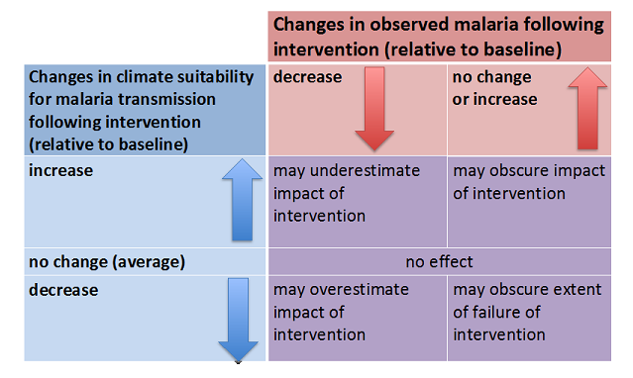

The well-known seasonal increases in malaria during and after the rainy season along with changes in incidence associated with altitude (a proxy for temperature) attest to the importance of climate when studying malaria epidemiology. Therefore, for Rwandas impact evaluations to be complete, the variations in climate during the time periods under review need to be factored in before concluding that declines in all-cause mortality are due to malaria interventions.

# Rainfall and Temperature measurements for Rwanda

In order to assess the impact of climate on malaria in Rwanda it is necessary to obtain relevant climate data (including rainfall and temperature) of sufficient accuracy and at appropriate spatial and temporal scales. Where the data is inadequate it is essential to quality control and triangulate all available data sources to obtain the best “fit for purpose” database (Dinku 2014)

Obtaining accurate rainfall and temperature data for Rwanda is particularly challenging. The routine recording and collation of national ground observations from meteorological stations, owned and managed by Meteo Rwanda, was virtually destroyed immediately following the genocide in 1994 and the subsequent years of turmoil. Only after 2009 were national observing stations re-instigated to levels comparable to the period 1981-1993 (see Figure 1).

## Ground based observations

Figure Graph indicating the meteorological station gap in reporting rainfall for Rwanda (1994-2009)

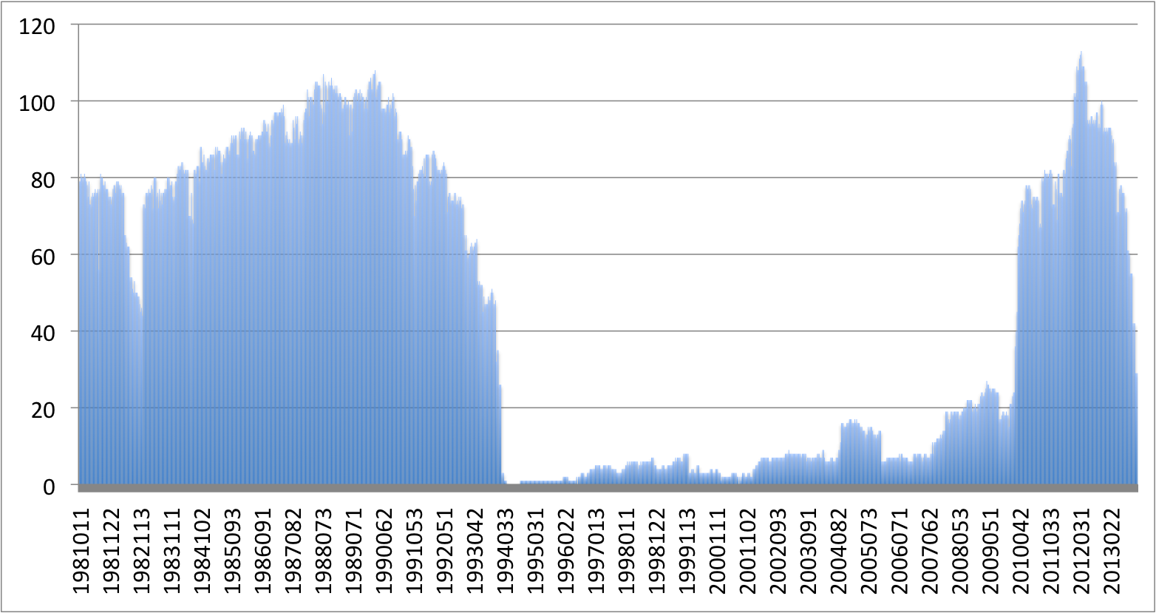

Figure Graph indicating the meteorological station gap in reporting Max T. for Rwanda (1994-2009)

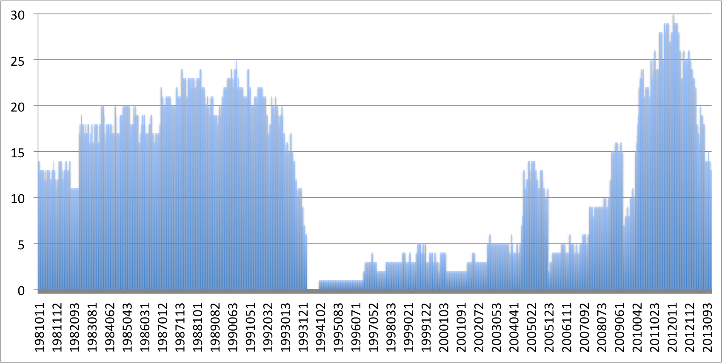

## Satellite data

### Rainfall estimates

Satellite based estimates of rainfall and temperature have been widely used elsewhere to provide information on rainfall in regions where data is scarce or not publically available. They would seem like a logical solution to the data gaps for Rwanda but careful comparison of widely available satellite rainfall estimates of both rainfall and temperature with the available station data in Rwanda indicate that the relationship with observed rainfall is in most instances very weak (Figure 3).

### Minimum and Maximum Temperature

In the absence of appropriate observations of minimum and maximum temperature Land Surface Temperatures (LST) from MODIS satellite data and Reanalysis data is increasingly used as a proxy.

Figure Comparison of MODIS LST and Reanalysis temperature estimates with observed maximum temperature measurements (2007-2012)

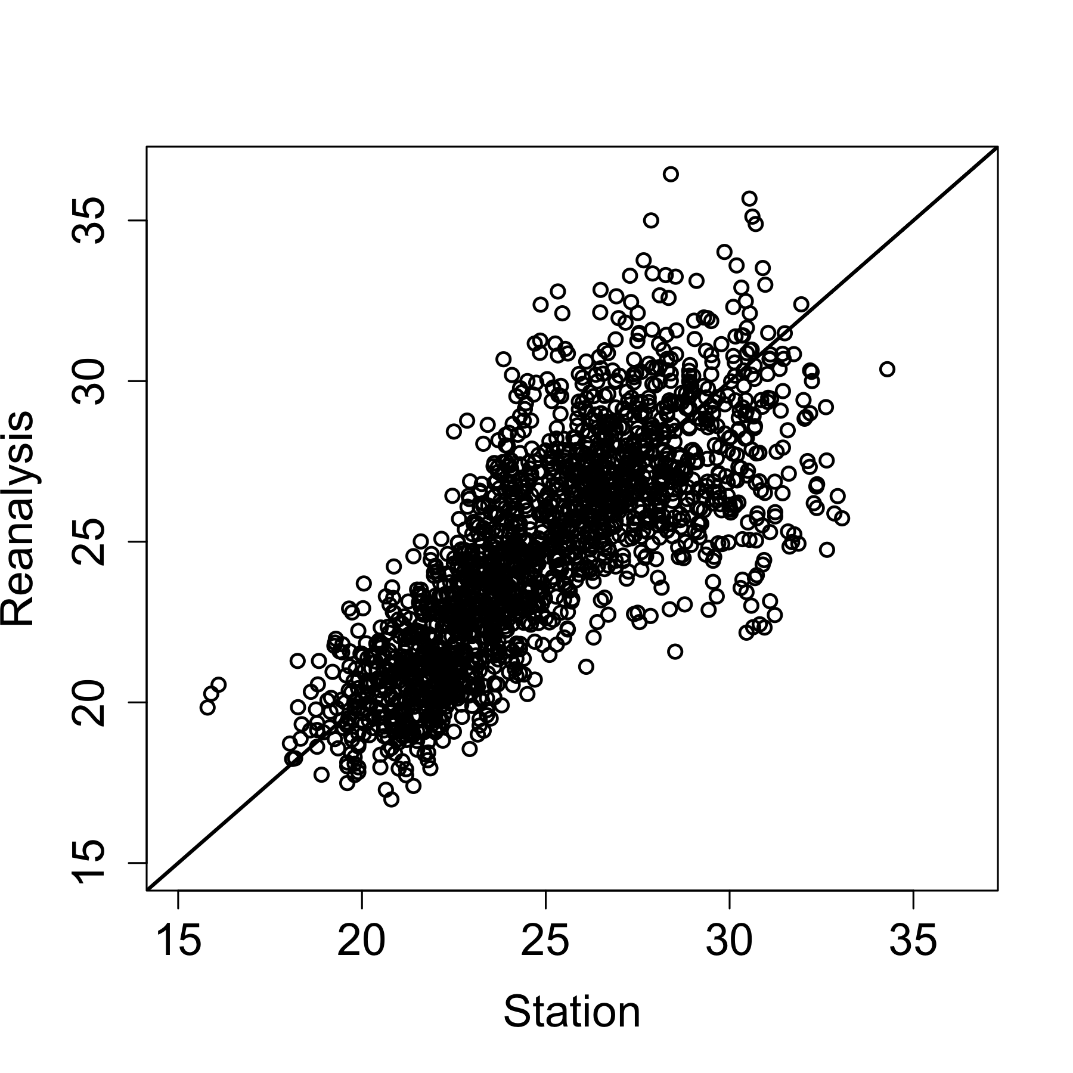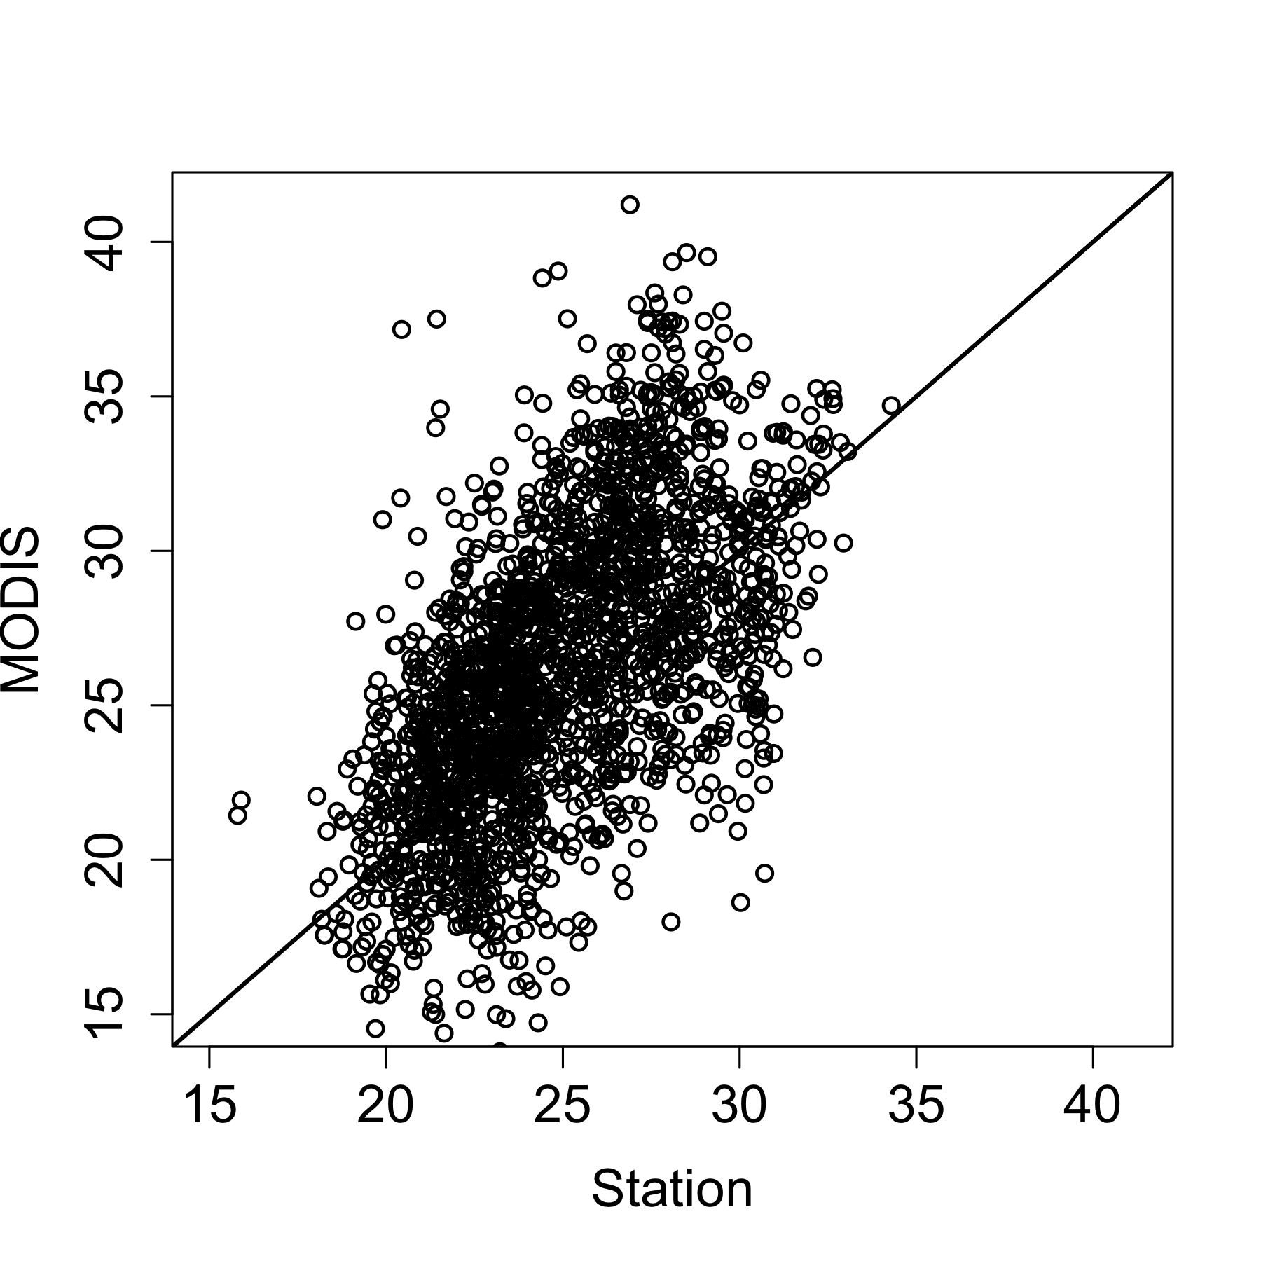

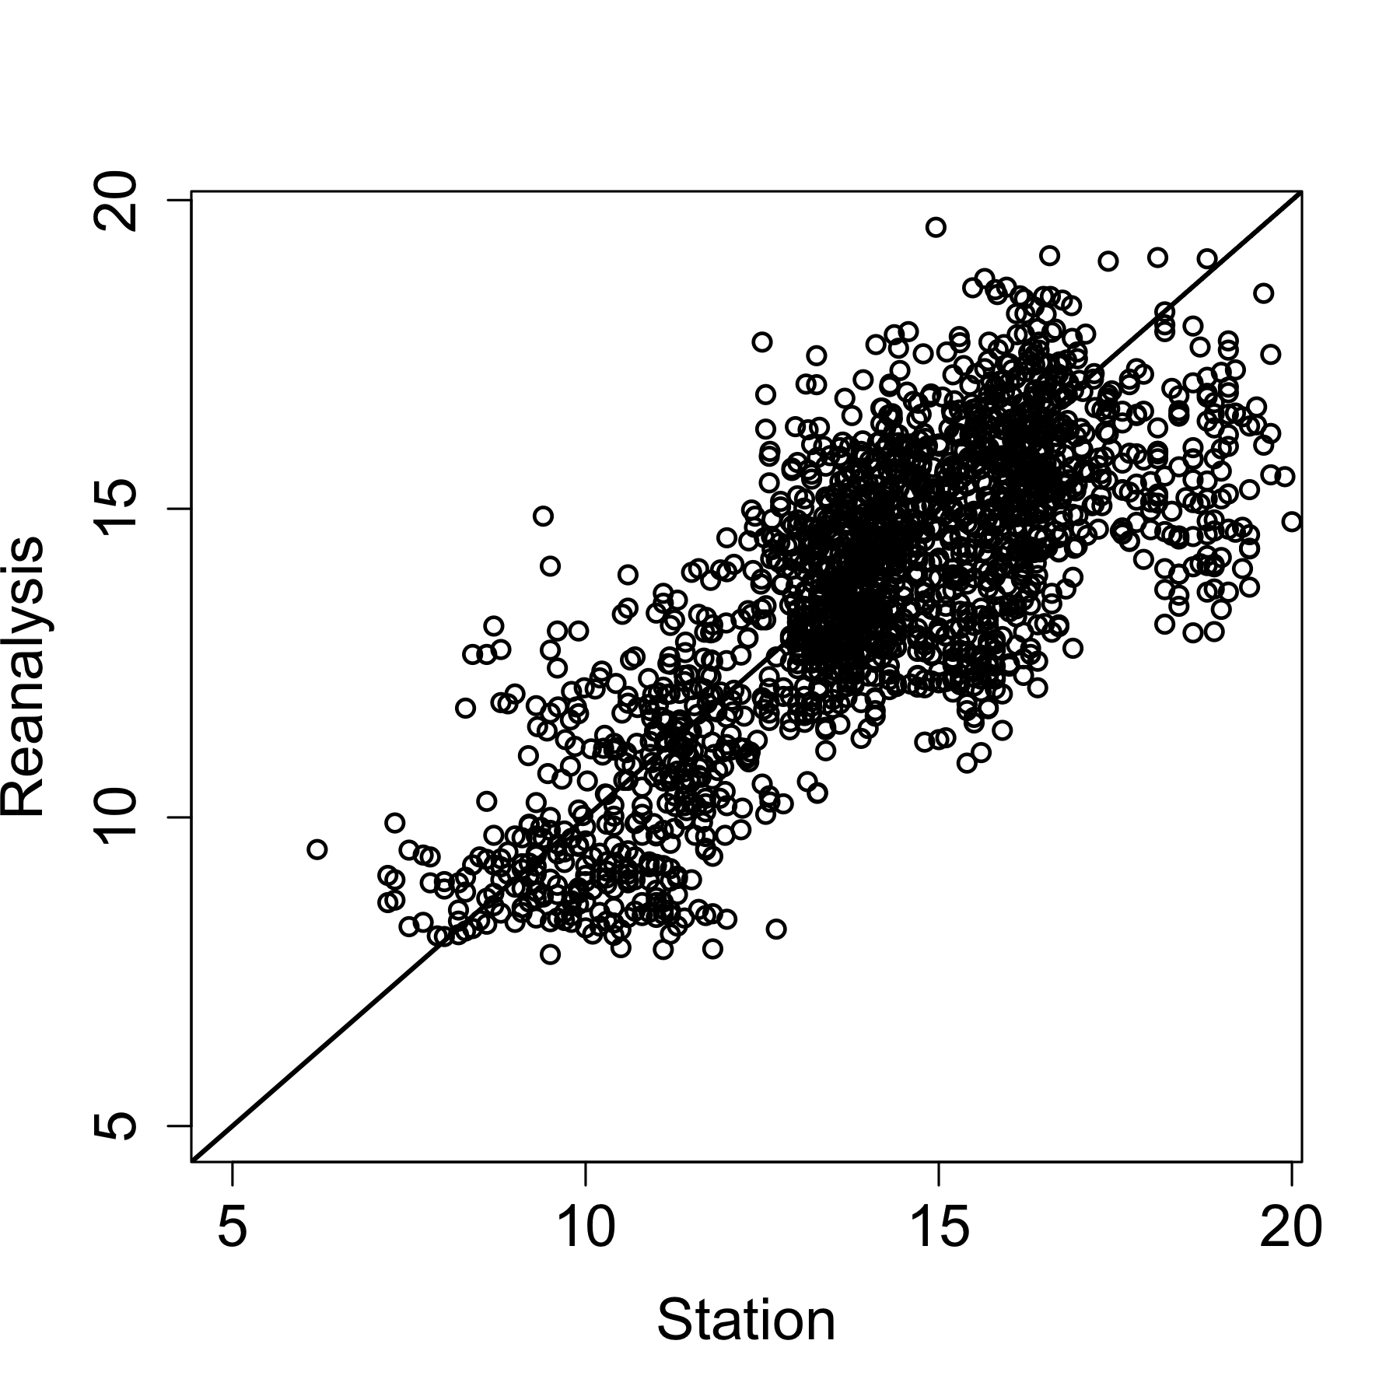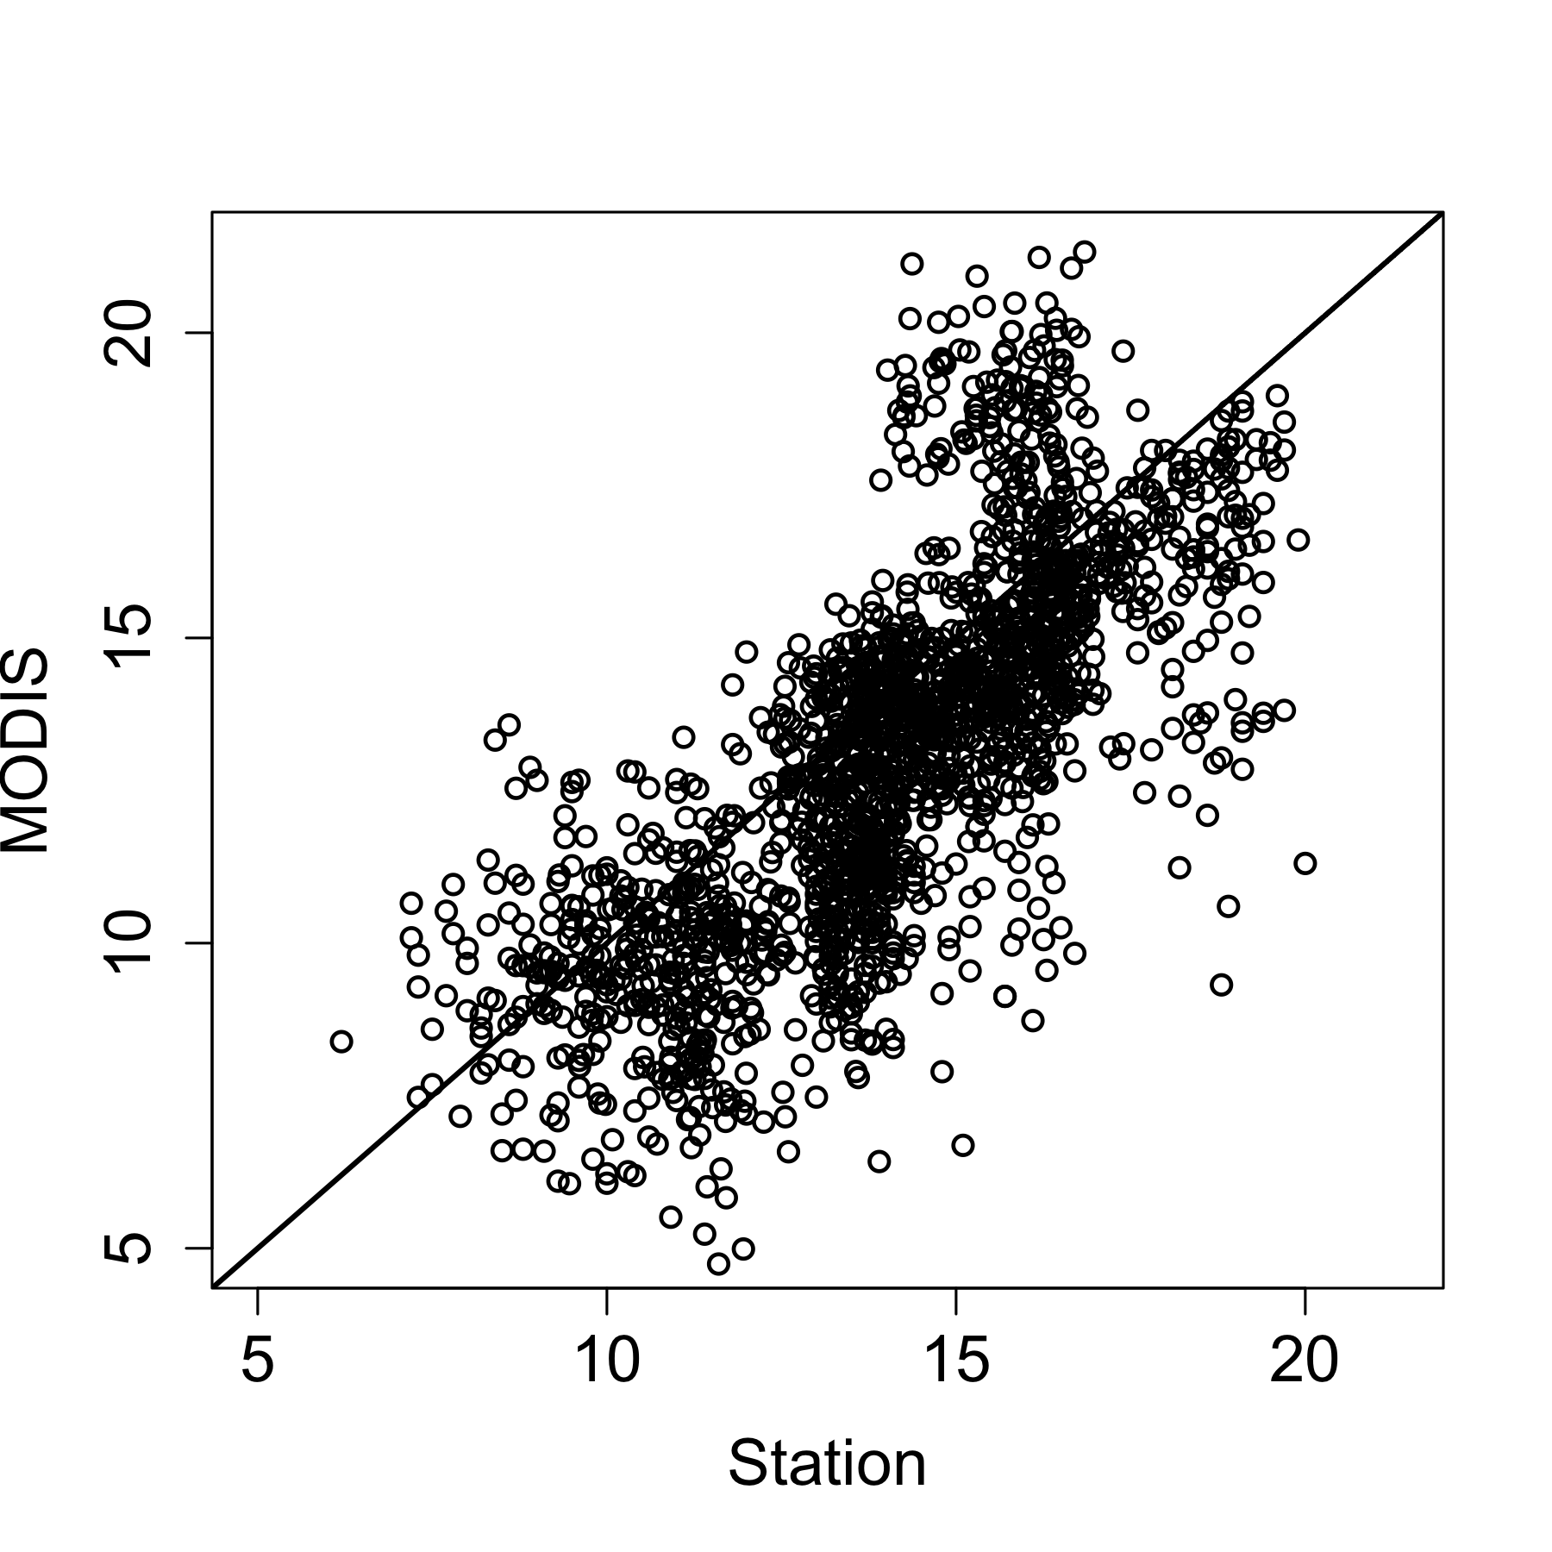

Figure Comparison of MODIS LST and Reanalysis temperature estimates with observed minimum temperature measurements (2007-2012)

To overcome the limitations imposed by both the gap in ground observational data and the poor quality of the satellite data the IRI, in collaboration with Meteo Rwanda implemented a programme of Enhanced National Climate Services (ENACTS). This initiative is described below.

## ENACTS

The International Research Institute for Climate and Society (IRI), in collaboration with national meteorological agencies and regional climate centers, has been leading an effort to simultaneously improve the availability, access and use of climate information at national level. This effort, named Enhancing National Climate Services (ENACTS), focuses on the creation of reliable climate information that is suitable for national and local decision-making. The ENACTS approach has five major components:

1. Building technical capacity at the National Meteorology Agency to make the project sustainable;
2. Generating over 30-year time series of ten-daily rainfall and temperature data for every 4 km grid across the country by blending station observations with satellite and other proxies;
3. Customizing and installing the very powerful IRI Data Library at National Meteorology Agency;
4. Developing on online mapping service providing user-friendly tools for the analysis, visualization, and download of climate information products; and
5. Engaging stakeholders to make them aware of the new products and services, train them on the use of the different tools, and incorporate their requirements in product developments.

ENACTS has been implemented in Ethiopia, Tanzania, Madagascar and the CILSS countries in West Africa through collaboration between the National Meteorology Agencies and the AGRHYMET Center.

In order to ensure that high quality meteorological data were available to the Rwandan Malaria Impact Evaluation Group two of the five major components of the ENACTS process were addressed in this project. These are components 2 and 3.

# Generating over 30-year time series of ten-daily rainfall and temperature data.

## Data

The missing observations is a very serous challenge for Rwanda. The main reason for the missing observations is the 1994 genocide. Data quality control is a time consuming but critical component of ENACTS. Data quality control involves checking station coordinates, identifying outliers as well as checking for the homogeneity of the time series for each station. The homogeneity check identifies sudden changes or breaks in the station time series. The tools for homogeneity check writes the results to a file, which are then inspected and Meteo Rwanda staff who decide, based on their experience and local knowledge, either to accept and fix the breaks or ignore the results and keep the original data.

### Rainfall

These analysis were done using all available observed rainfall data between 1981 and 2013 plus satellite estimate data.

### Temperature

These analysis were done using observed temperature data between 1981 and 2012 and climate model reanalysis data. There are many fewer stations reporting temperature than rainfall. This is not unique to Rwanda.

Unlike rainfall the satellite proxy available for temperature is only available from 2002. After exploring various options, the MERRA (Modern-Era Retrospective Analysis for Research ad Applications) from NASA at a spatial resolution of 50km by 66 km have been used.. The reanalysis data were then downscaled to 5km spatial resolution.

## Methodology

The main objective is to generate temporally homogenous time series of rainfall and temperature data. In the standard ENACTS, the merged time series for rainfall is generated by combing the station observations with satellite estimate for each dekad(10-day period) of each year. For temperature, dekadal averages of MODIS (Moderate Resolution Imaging Radiometer) land surface temperature estimates and elevation maps are used as a background to interpolate station observations for each dekad. However, these approaches would not work for Rwanda because of the close to 15-year break in observation from 1994 to 2009 (Fig. 2). Thus, a different approach had to be developed.

### Rainfall

The methodology adapted is to remove “climatological” differences between station measurements and satellite rainfall estimates. Thus is implemented as follows:

1. Use the data from 1981 to 1990 to calculate adjustments factors for each deakad (1 to 36 dekads total);
2. Interpolate the adjustment factors;
3. Apply the adjustment factors to satellite data(1981 to 2013);
4. Remove dekadal bias using available stations for each deakd; and

**Temperature**

The methodology for temperature also removes climatological differences between station measurements and downscaled model reanalysis data and is implemented as follows:

1. Down scale Reanalysis data to 5km using station data and digital elevation model;

2. Use the data from 1981 to 1990 to calculate adjustments factors for each deakad(1 to 36)

2. Interpolate the adjustment factors

3. Apply the adjustment factors to all reanalysis data from 1981 to 2012

## Results

### Rainfall

Table Results for rainfall illustrated using a single dekad. The first panel is station data while the second is satellite-only product. The 3rd figure shoes the satellite data with “climatological” bias removed. In the forth map decadal adjustments has been made to the climatologically adjusted map. The 3rd map shows the 4th map combined with station data for each dekad. Even though this is the best product, it is not temporally homogenous because the varying number of stations used over the years.

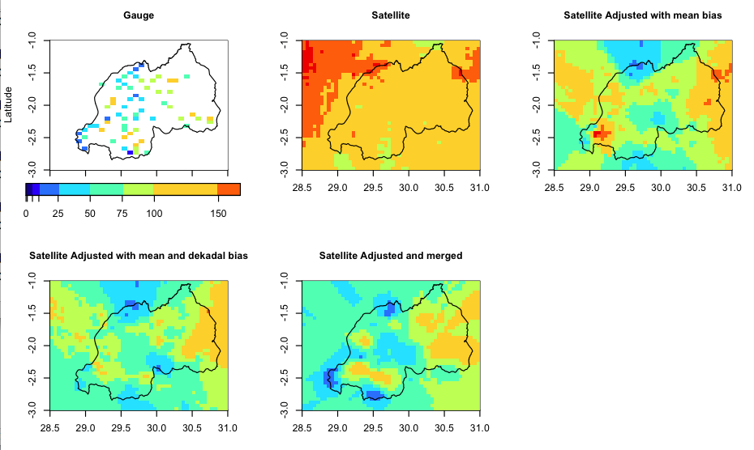

Figure Comparison of measured rainfall vs adjusted satellite rainfall estimates for different periods

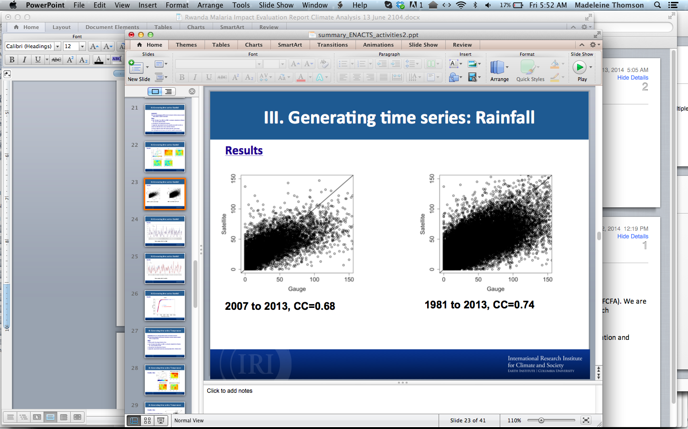

### Temperature (Max)

Figure Results for maximum temperatur illustrated using a single dekad. The first map is station measurement while the second one shows MERRA reanalysis at its original resolution. The 3rd and 4th maps shows down scaled and corrected MERRA respectively.

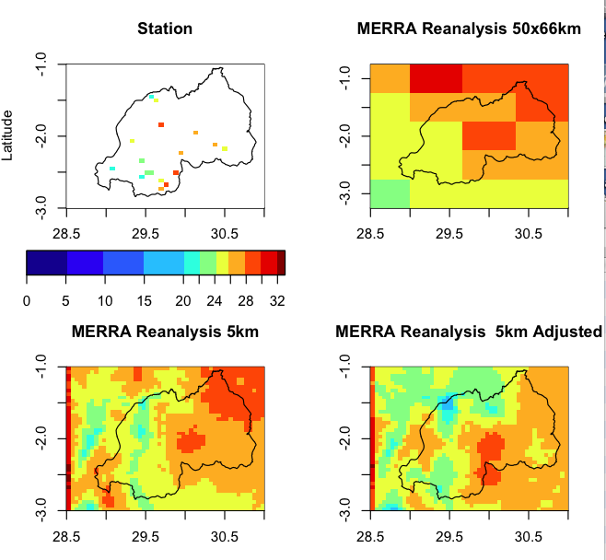

### Temperature (Min)

Figure Results for Minimum Temperature illustrated using a single dekad. The first map is station measurement while the second one shows MERRA reanalysis at its original resolution. The 3rd and 4th maps shows down scaled and corrected MERRA respectively.

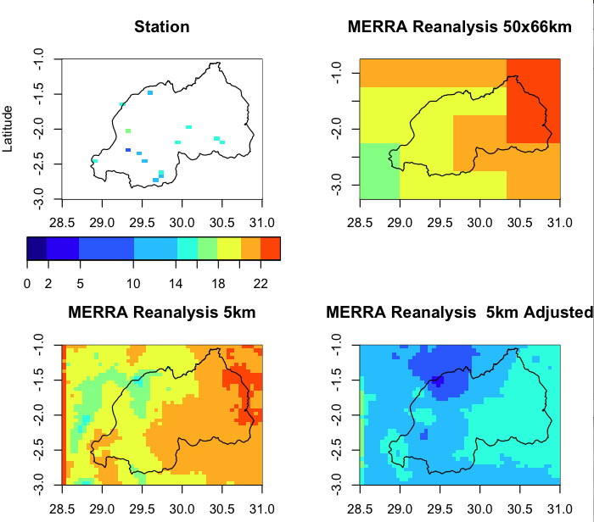

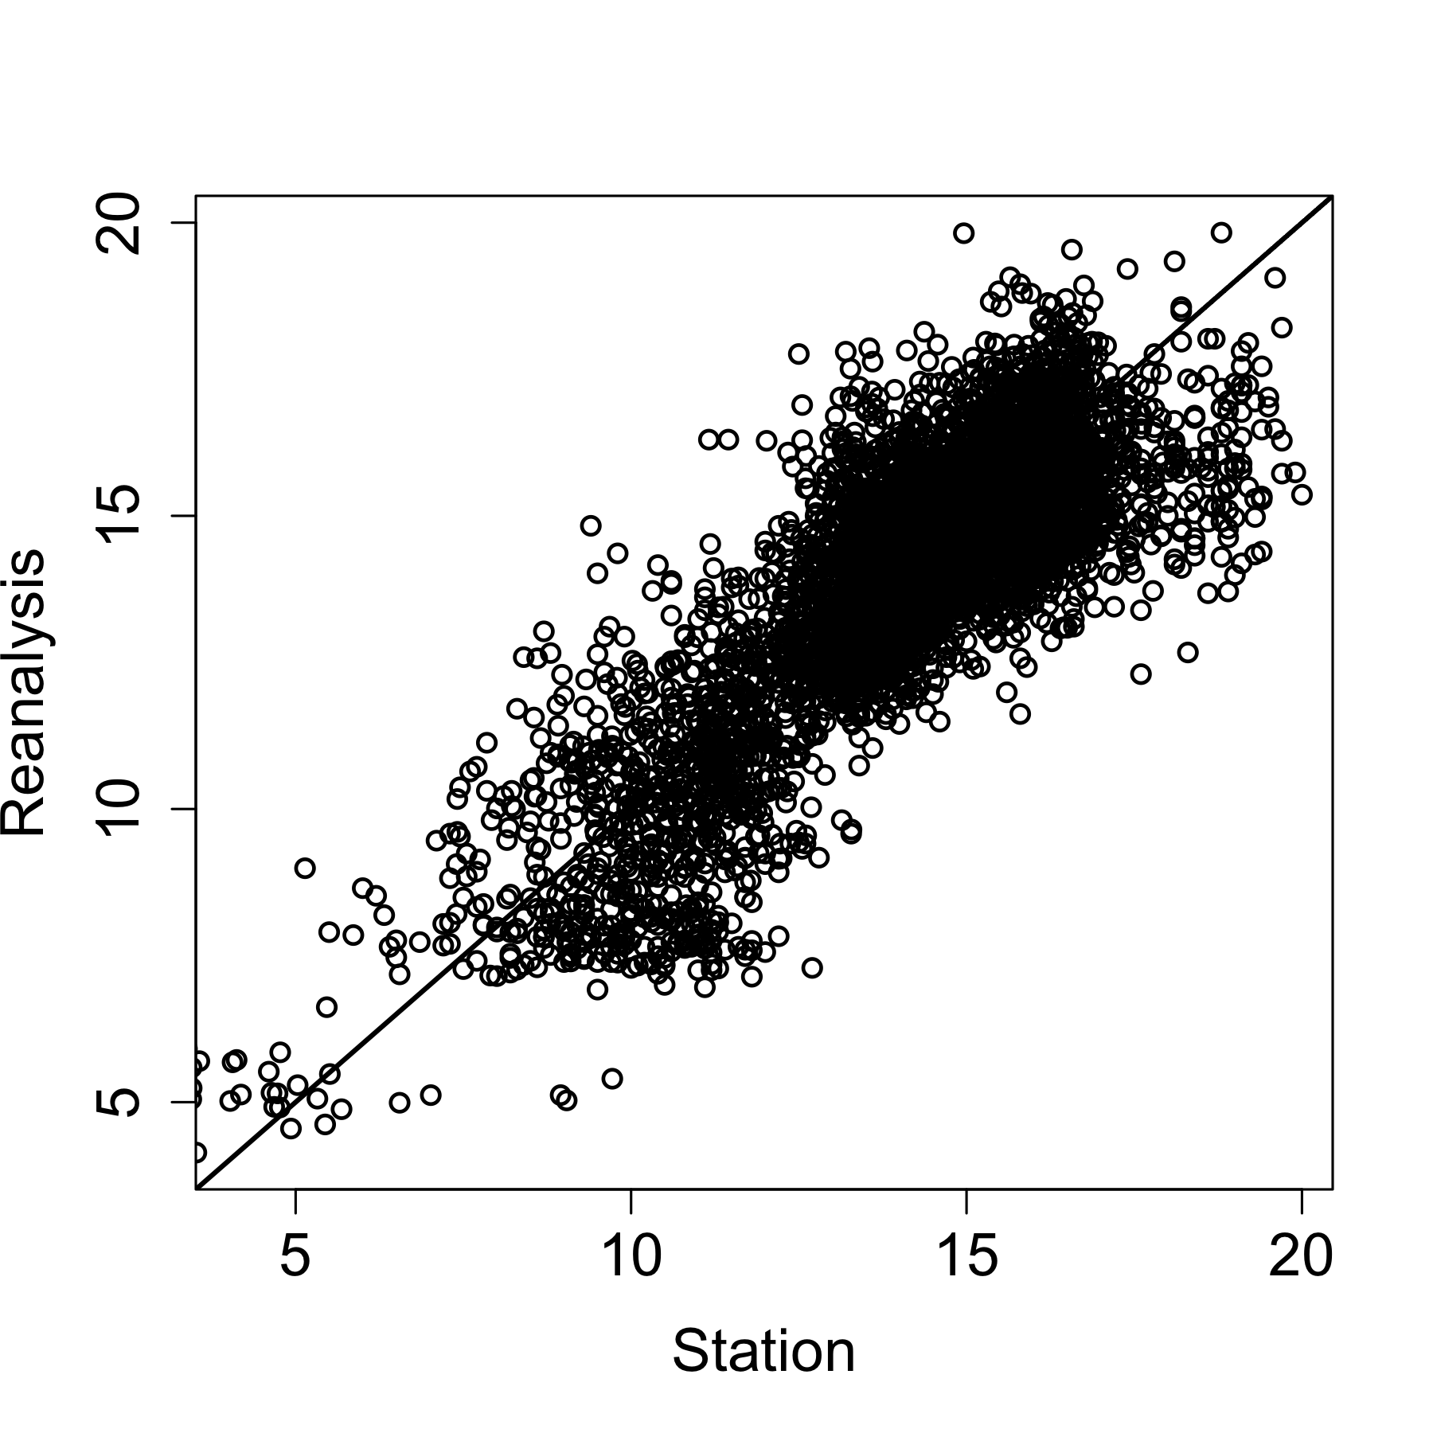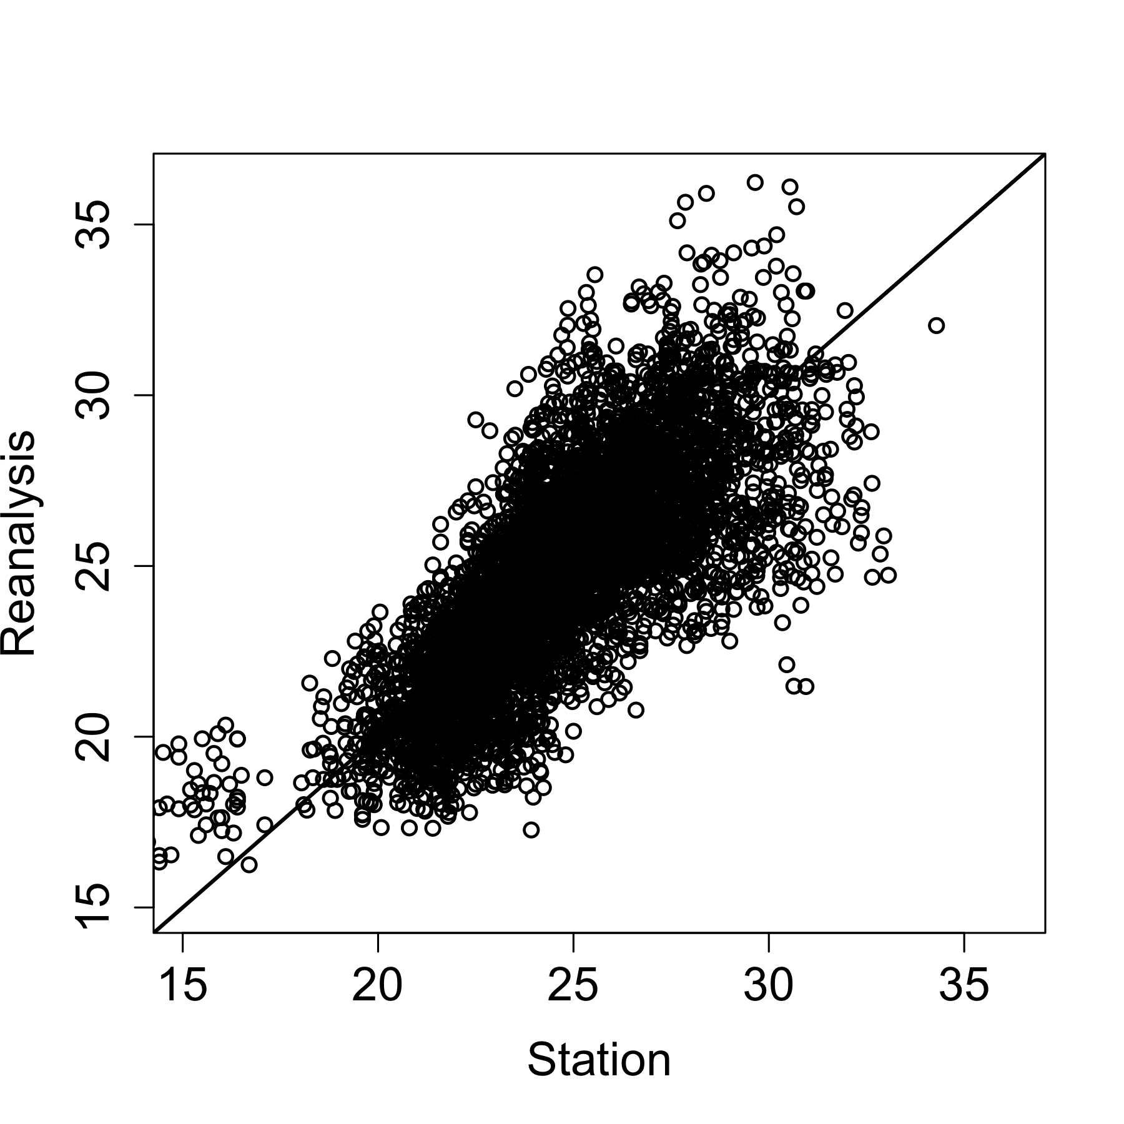

Figure Comparison of station measurements of temperature: left maximum cc 0.84; right minimum cc 0.76

# Customizing and installing the IRI Data Library at National Meteorology Agency (METEO RWANDA)

In order to be able to display the Rwanda ENACTS data and to develop products relevant to different communities the IRI Data Library is being installed on the data server at METEOS Rwanda.

The Data Library is a very powerful, computational engine that offers the opportunity to:

* Access, manage and manipulate any number of datasets;
* Analyses of data ranging from simple averaging to more advanced Empirical Orthogonal Function (EOF) analyses;
* Create multi-dimensional visual representations of data; and
* Customize and download data plots and maps in a variety of image and data formats.

It has been used for a variety of epidemiological purposes (del Corral et al. 2012).

# Products and services created for use by the Rwanda Malaria Impact Evaluation Group

## Spatial and seasonal distribution of rainfall and temperature (1st dekad of year)

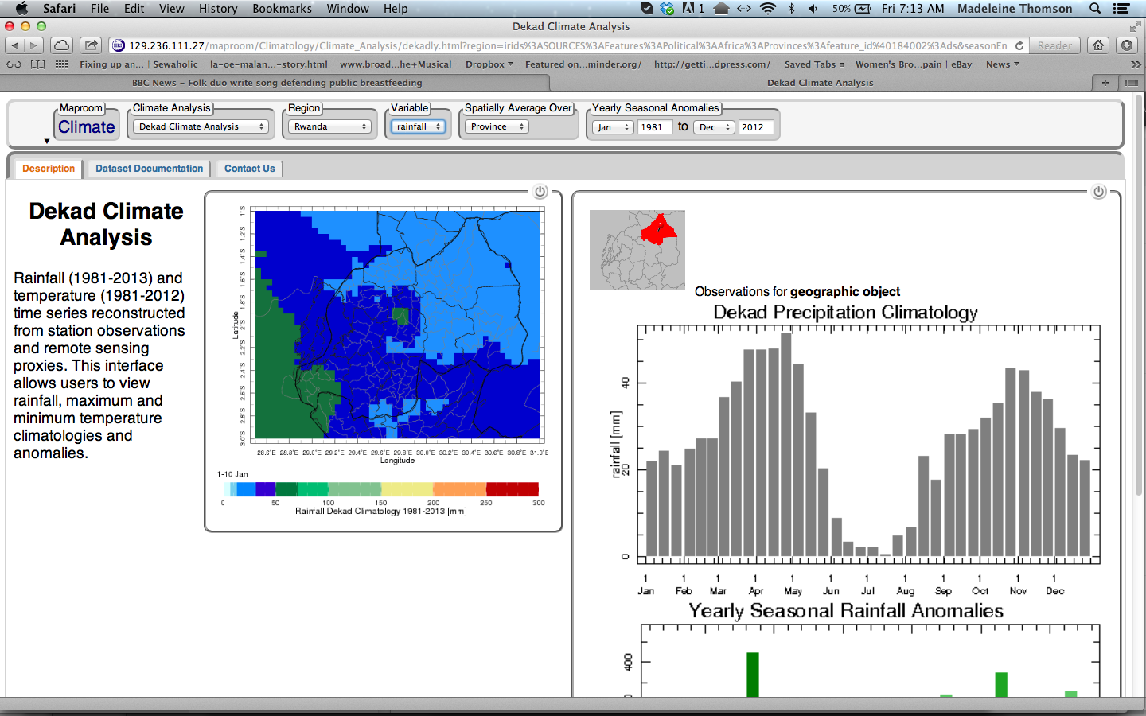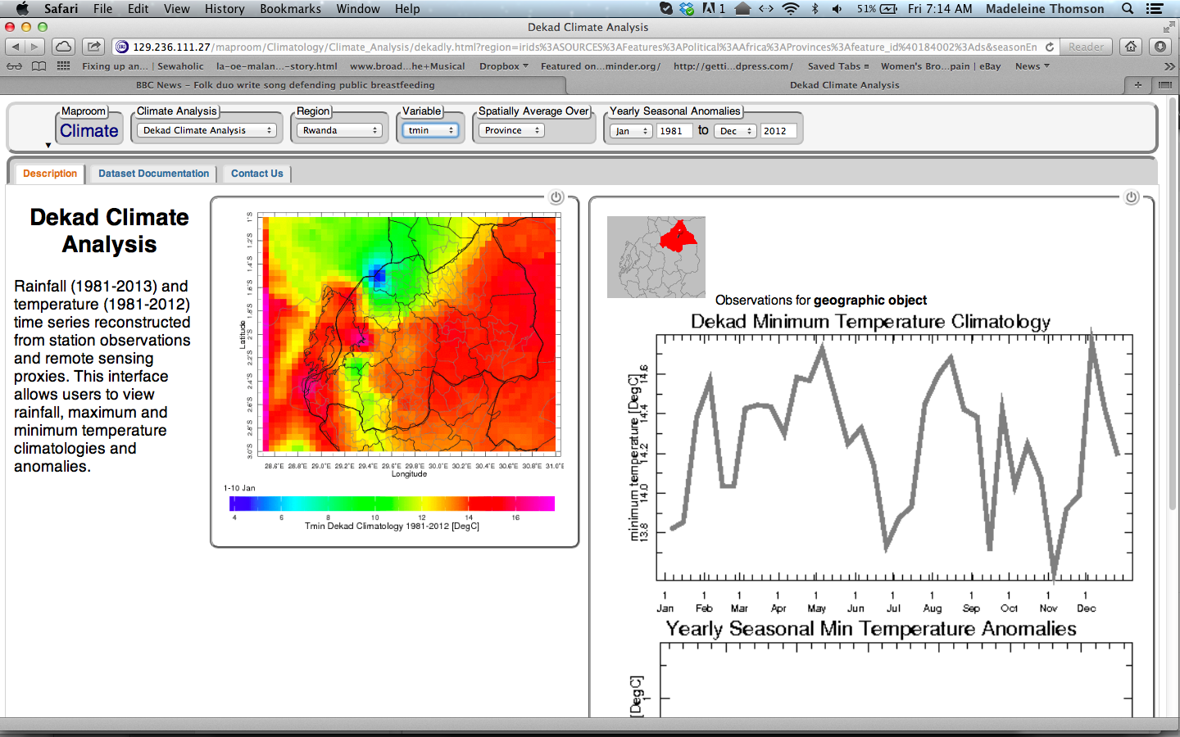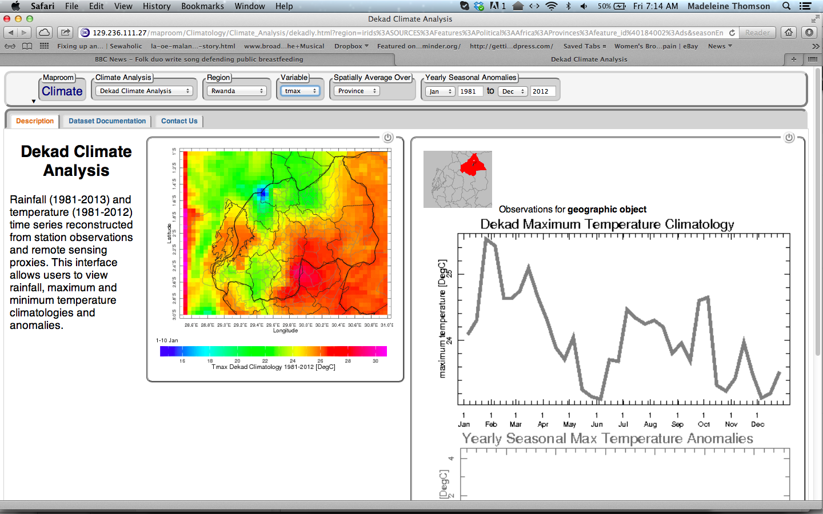

## Climate Analysis Tool (at provincial level)

Figure Annual rainfall anomalies for Byumba

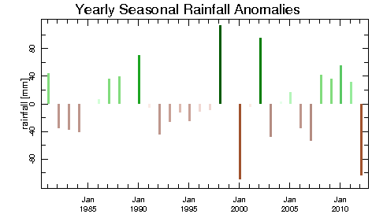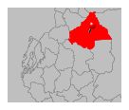

### Maximum Temperature

Figure Annual Seasonal Max Temperature Anomalies for Jan-Mar for Byumba

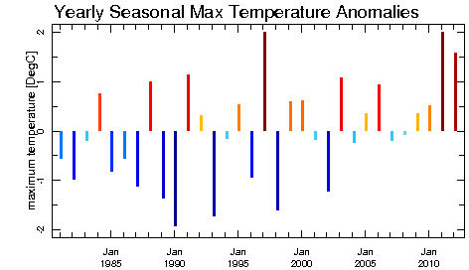

### Minimum Temperature

Anomaly for Jan-Mar only (Note El Nino impact in1998).

Figure Minimum Annual Temperature Anomalies Jan-Mar for Byumba

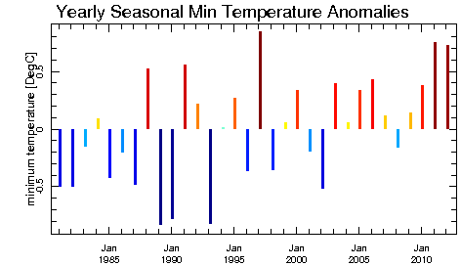

## WASP

Figure Rwanda country average WASP Index using 1996-2000 as baseline

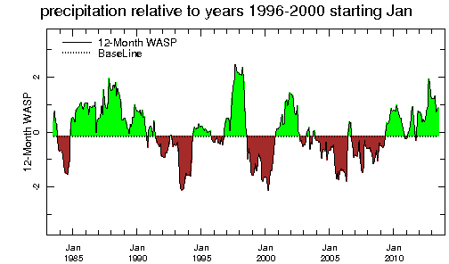

This plot shows the time series of 12-month Weighted Anomaly Standardization Precipitation (WASP) index relative to a baseline period. The purpose of this tool is to provide a simple visual means of relating averaged precipitation to a reference period of interest.

# Appendix 1 Climate section for inclusion in “Evaluation of the Impact of Malaria Control Interventions on All-Cause Mortality in Children under-five in Rwanda” MIEG, 2014.

To be written

# Acknowledgements

# References

del Corral, J., M. B. Blumenthal., G. Mantilla, P. Ceccato, S. J. Connor and M. C. Thomson (2012). "Climate Information for Public Health: the role of the IRI Climate Data Library in an Integrated Knowledge System." Geospatial Health (Supplement) **6**(3): S15-24.

Dinku, T. (2014). "Reconstructing Rwanda’s Historical Climate Data ". NewYork.

Dinku, T., A. Kanemba, B. Platzer and M. C. Thomson (2014). "Leveraging the Climate for Improved Malaria Control in Tanzania". IEEE. <http://www.earthzine.org/2014/02/15/leveraging-the-climate-for-improved-malaria-control-in-tanzania/>

RBM (2011). "A decade of Partnership and Results."

Thomson, M. C., F. Zadravecz, B. Lyon, G. Mantilla, D. Willis, P. Ceccato and T. Dinku (2012). "President’s Malaria Initiative-USAID Report: Development of Climate Analysis Section for the President’s Malaria Initiative Impact Evaluation: Reports for Ethiopia and Tanzania". IRI. 62pp. Palisades, New York.