Corrélation Laguee des Précipitations et de l’Incidence du Paludisme

Michael Bell

June 5, 2009
Traduit et adapté de l’anglais au français par Rémi Cousin
Mars, 2010

Sommaire

1. Applying Appropriate Climate/Environmental Data 3
1.1 In-situ and Remotely-Sensed Data 3
1.2 Observing Standards and Data Quality 3
1.3 Sources of Weather and Climate Data 4
1.4 Spatial Scale and Representativeness of Climate Data 5
2. Calculating Anomalies 6
2.1 Calculating Anomalies in the Data Library 8
2.2 Anomalies of Health Data by District 8
2.3 Anomalies of CMAP Gridded Precipitation Averaged over Districts 9
3. Procedure for Mapping Variables by Shape Geometry 9
4. Displaying Time Series of Climate and Malaria Incidence Data on the Same Plot 10
5. Pearson Product-Moment Correlation 10
5.1 Calculating Correlations Between Monthly Precipitation and Incidence Anomalies 11
6. Lagged Correlation 11
6.1 Using shiftdatashort to Lag a Dataset 11
6.2 Calculating Lagged Correlation 12
7. Exercises 15

1. Applying Appropriate Climate/Environmental Data

Some practical, basic criteria for choosing climate and environmental data to include in analyses integrated with health data include the scale and representativeness of the climate data in comparison to that of the health data, and a match in the length and completeness of the data records.

An obvious but important consideration is whether there is enough data for times and locations common to both the climate/environmental and disease data sets for a meaningful analysis between them to be made. One should select climate and environmental data that overlap sufficiently in space and time with the disease data being analyzed.

As shown in earlier sections, the visualization capabilities of the Data Library can help one to determine fairly quickly whether the data set one would like to use contains appropriate data.

1.1 In-situ and Remotely-Sensed Data

Meteorological and climate data can be classified into two categories based upon the method of observation -- in-situ and remotely-sensed data.

In-situ observations are collected within the medium being observed. Some examples of in-situ observations include rain-gauge measurements of precipitation, liquid-in-glass thermometer measurements of air temperature, and measurements of air pressure using a mercury barometer at surface stations. In each of these cases, the device being used to measure the quantity of interest is immersed within the medium being measured (e.g., air or water). This is the most direct means of making meteorological measurements, but each in-situ instrument will still produce measurement errors and requires some form of calibration.

Remote sensing involves making measurements of quantities from a distance. Some examples of remote sensing include radar measurements of precipitation, and satellite observations of clouds or estimation of precipitation. More detailed information on remote sensing is included in the “Introduction to Remote Sensing for Monitoring Rainfall, Vegetation, Temperature and Dust” section.

1.2 Observing Standards and Data Quality

An agency of the United Nations, the World Meteorological Organization (WMO) has a membership of 188 states and territories and establishes standards for meteorological observations and the international communication of meteorological data. Since weather and climate do not respect international boundaries, international cooperation for setting standards and communicating meteorological information is essential. The WMO sets the framework for such cooperation. You can find more information about the WMO and observing standards at the WMO website: http://www.wmo.ch

Although international standards for meteorological and climate observations exist, it should be recognized that these standards are not always followed and may represent a substantial source of observational error in some cases. The poor placement of temperature sensors in an incorrectly-ventilated enclosure, or over a paved rather than grassy surface, for instance, can lead to errors in station temperature measurements. Changes in the environment around an observing site over time can introduce artificial trends. Standards for documenting such information at observing sites will vary by country, and such information may even be non-existent or extremely difficult to obtain in many cases.

1.3 Sources of Weather and Climate Data

National meteorological, climate, water, or agricultural services are the most common original sources and providers of routine weather and climate data. The mandates of these organizations as the primary providers of meteorological and climate information will vary somewhat from country to country.

Member states of the WMO share a subset of the near-real-time data they collect internationally over the Global Telecommunications System (GTS). This is a primary means by which national meteorological services share real-time data for operational purposes. Organizations that have access to the GTS generally include the national meteorological services and a few additional regional or international meteorological centers.

Outside of the operational sharing of meteorological data over the GTS, national meteorological services from different countries have widely-ranging policies regarding the provision of data for other purposes. Depending upon the country of interest, requests for meteorological data may be met with responses ranging from free and open access to substantial charges for data or a complete lack of response. Many issues related to meteorological data availability and the mandates of national meteorological services are outlined in the document “A Gap Analysis for the Implementation of the Global Climate Observing System Programme in Africa”, which can be obtained from the IRI website. The following page at the WMO website lists home pages for the national meteorological services of individual member states: http://www.wmo.ch/pages/members/index_en.html

In addition to data routinely collected by national meteorological services, specialized observational field campaigns to conduct research into a particular aspect of the climate (often in a particular region), will include the collection of meteorological data. Although the distribution of such data may initially be limited to allow researchers involved in such research projects to have an opportunity to analyze the data, the data will often be publicly released after some time period has elapsed.

Finally, from time to time, an institution with a mandate or research agenda to collect archived data will attempt to construct comprehensive global or regional meteorological data sets by consolidating data from a variety of sources. Many of these data sets will then be made publicly available by these institutions or through some other data center. Several such centers exist, but the one with the most comprehensive collection of archived meteorological data is the U. S. National Climatic Data Center (NCDC). A list of a number of centers with substantial climate data sets is included below. In all cases data sources should be cited properly.

U. S. National Climatic Data Center: http://www.ncdc.noaa.gov
IRI Data Library: http://iridl.ldeo.columbia.edu
NOAA Earth System Research Laboratory: http://www.esrl.noaa.gov/psd/data/
KNMI Climate Explorer: http://climexp.knmi.nl
U. S. Climate Prediction Center: http://www.cpc.ncep.noaa.gov/products/MD_index.shtml
University of East Anglia Climatic Research Unit: http://www.cru.uea.ac.uk/cru/data/
U. S. National Center for Atmospheric Research: http://dss.ucar.edu/catalogs/

1.4 Spatial Scale and Representativeness of Climate Data

Station Data and Gridded Data

Station data are point measurements. The spatial representativeness of station data will depend upon several factors, including the nature of the variable being measured, the characteristics of the measurement site, and the character of the meteorological events that influence that location.

Gridded data are data that have been placed upon a network of grid cells that are regularly spaced or spaced according to a mathematical function. Gridded data may represent some interpolation of a number of point values, for example.

Two interpretations of gridded data may be possible -- a gridded value may be representative of either a point or area-average measurement. Sometimes the interpretation is integral to the data set and is explicitly stated, but often it is not. If the assumption is that the gridded value is representative of the area average of the grid box, then the measurement is meant to be representative at the scale of that grid box.

Therefore, without any additional information, it can be dangerous to spatially interpolate or regrid data to a grid spacing smaller than that of the original grid (Fig. 1). If the gridded data represent precipitation, for example, there may be important within-grid box variations of the variable under consideration that are due to orography, other aspects of the physical environment, or to the nature of the precipitation systems themselves.

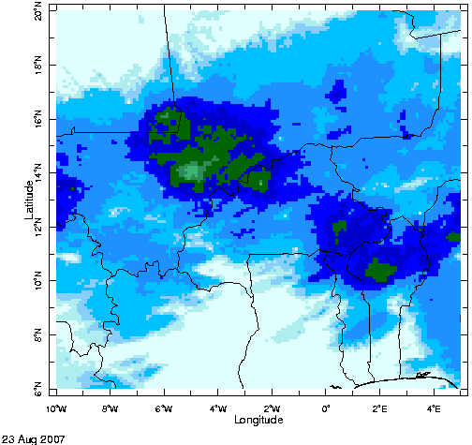  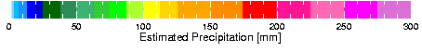  a. 0.1° lat/lon resolution | 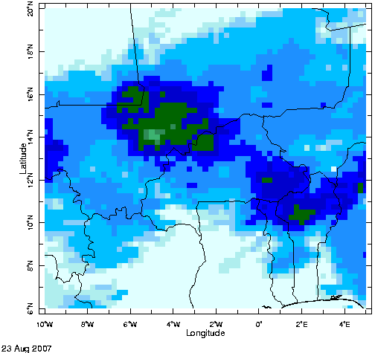  b. 0.25° lat/lon resolution | 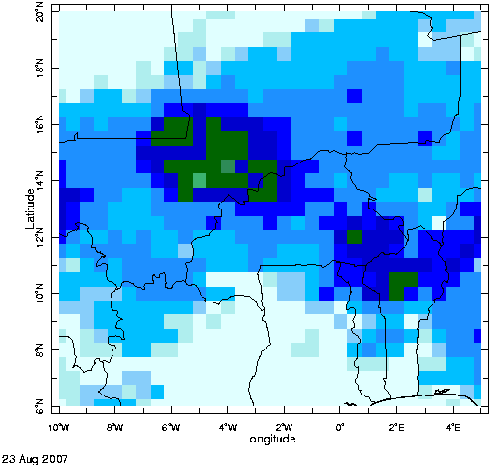  c. 0.5° lat/lon resolution
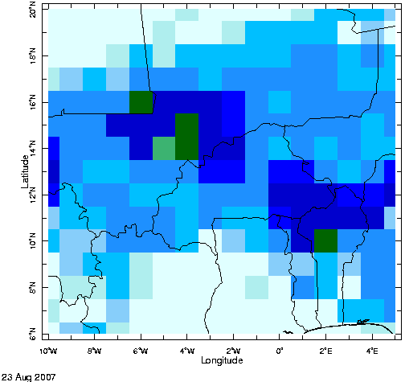  d. 1.0° lat/lon resolution | 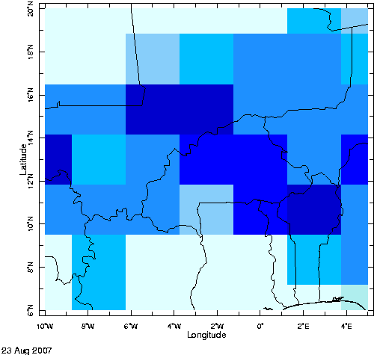  e. 2.5° lat/lon resolution | 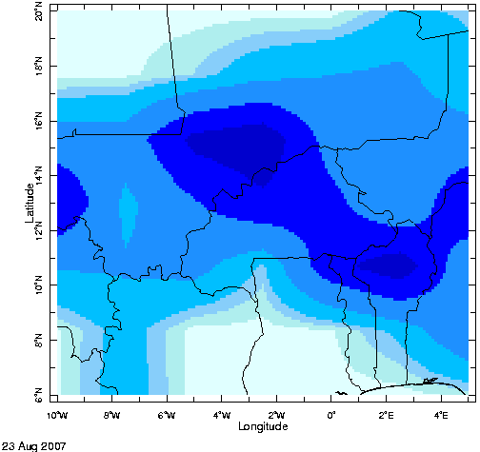  f. Linear interpolation from 2.5 deg. back to 0.1 deg. lat/lon resolution.

Fig. 1: RFEv2 satellite estimates of daily precipitation progressively degraded in spatial resolution from the original spacing of 0.1° lat/lon to 2.5° lat/lon, illustrating the loss of information about the precipitation field as the resolution becomes increasingly coarse. Without additional information, it is not possible to reverse the process and reconstruct the details of the original precipitation field from the coarser resolution precipitation data. Simple linear interpolation using data from a coarser grid to produce a finer grid (panel f.) will miss important maxima and minima and spatial variability that might actually be present (compare panel f. to the original data in panel a.).

See Exercise 1.

2. Calculating Anomalies

Climate and environmental data such as precipitation and NDVI may vary on a variety of time scales. For instance, in much of the world, and especially in the tropics, precipitation has a strong annual cycle (Fig. 2).

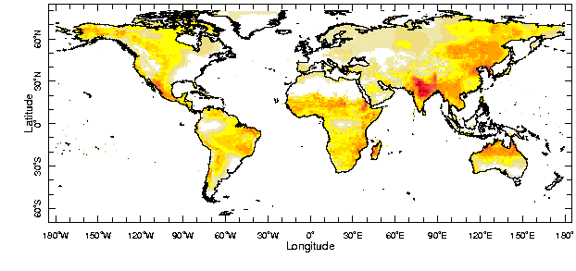

Fig. 2 Coefficient of variation (standard deviation divided by the mean) of the climatological (1971-2000 base period) annual cycle of monthly precipitation.

Some places have well-defined rainy and dry seasons that are a regular and even characteristic feature of the climate of that location. In the mid-latitudes there is typically a well-defined annual cycle in temperature that helps to mark the seasons every year. Similarly, in many locations there is often an annual cycle in the occurrence of diseases such as malaria or meningitis which is associated with the climate of the region. For instance, in West Africa meningitis is most common in the dry season. In some places, increases in malaria cases during the year may be associated with that location’s rainy seasons.

Going Beyond an Analysis of the Annual Cycle

The seasonal cycle may be extremely important. However, since it may already be a well-known factor in the relationship between climate and some diseases, for many studies it would be good to remove the influence of the seasonal cycle from climate and disease records to see what other relationships might be found. If one were to correlate full precipitation and malaria case totals with each other, for example, one may find a strong linear relationship between the two that is primarily the result of the annual cycle common to both, masking out other, more interesting relationships that might exist.

A way to remove the annual cycle from climate/environmental and disease records is to calculate anomalies. In this context, anomalies are defined as the result of the difference between the long-term average of a value, and the full value itself. Monthly anomalies, for instance, are calculated in the following way:

where i indexes over years, n is the number of years, j indexes over the 12 months of the calendar year, and x_{ij} is the full data value.

In other words, the monthly climatology is subtracted from the original data. By “monthly climatology” we mean that an average of the January values from all years is calculated to produce a climatology for January, an average of all February values is calculated to produce a climatology for February, and so on.

To produce monthly anomalies, the climatological value for January is subtracted from all the original, full January values, the climatological value for February is subtracted from all the original February values, and so on. The time series of the anomalies will be the same length as the original time series – an anomaly will have been computed for each original value.

2.1 Calculating Anomalies in the Data Library

In general, calculating monthly anomalies for monthly variables in the Data Library involves the following steps:

- Select the monthly variable for which anomalies are to be calculated
- Make any spatial and/or time selections from the data using VALUES or RANGE
- Apply the yearly-anomalies function

Use this procedure when the climatological base period you want to use matches the time range of the data for which you wish to calculate the anomalies. For example if you want to calculate anomalies for the period 1996-2003 using the same climatological base period (1996-2003) use the procedure outlined above. In climate science, 1996-2003 is a short base period. A base period of 30 years is typical.

To calculate anomalies using a base period that differs from the period for which the anomalies are being calculated use the following steps:

- Select the monthly variable for which anomalies are to be calculated
- Make any spatial selections from the data (using VALUES or RANGE)
- Make a duplicate copy of the monthly variable (using dup or the a: :a construction)
- Restrict the time range of the duplicate copy of the monthly variable to the desired base period (using RANGE)
- Calculate the monthly climatology of the duplicate copy using yearly-climatology
- Subtract the monthly climatology from the monthly variable using sub
- Restrict the time range of the result to the desired time period

In the following exercises, we will assume that we want to calculate anomalies using a climatological base period that matches the time period over which we will calculate the anomalies. The examples will differ in other ways, however, to accommodate other situations, such as the need to spatially match environmental data with health data by district.

2.2 Anomalies of Health Data by District

See Exercise 1 to calculate monthly anomalies of malaria incidence for subzobas in Eritrea.

2.3 Anomalies of CMAP Gridded Precipitation Averaged over Districts

The CPC (Climate Prediction Center) Merged Analysis of Precipitation (CMAP) data set (Xie and Arkin 1996) is a research-quality, global gridded data set of pentad and monthly precipitation estimates derived from a combination of ground-based raingauge data and microwave and infrared satellite estimates of precipitation (see earlier section for more information). Because it includes satellite-based estimates, the data set begins in 1979. Due to the amount of time needed to process the estimates and release the results, the most recently updated version of the data set typically includes estimates that are a few months old. The data are available on a 2.5 deg. latitude/longitude grid, which can be fairly coarse in relation to the scale of health districts, for example.

The goal of this section is to calculate precipitation anomalies from the CMAP precipitation data set and then create district-average values of the anomalies in order to match this measure of precipitation with district-based malaria incidence anomalies, both spatially and temporally. This will prepare the two data sets for the calculation of correlations between them later in this section.

See Exercise 2.

3. Procedure for Mapping Variables by Shape Geometry

As has been outlined in previous sections, there is a standard procedure in the Data Library for mapping data that have been associated with shape geometries of districts, states, etc., that are available as data sets in the Data Library.

In Data Library Expert Mode, mapping a variable by shape geometries requires three input streams in the following order:

- A background gridded data set with sufficient resolution to resolve shapes of the size you are using ( SOURCES .WORLDBATH .bath will typically work) and restricted to the region of interest
- The data set entry for the district geometries you are using
- The variable you want to map, which depends upon a district grid that matches the district grid in the geometries data set entry

Once you have entered these variables in the correct order in Expert Mode, click any of the Figure Viewer icons to enter the Figure Viewer. It does not matter which Figure Viewer option you choose; we will ignore the figure that is initially produced and replace it with the map we want. Once in the Figure Viewer, select the Edit Plot button. In the Edit Plot page, replace the items in the text box below the existing figure with the following text:

X Y fig: white mask fillby black thin countries_gaz :fig

The “X Y” indicates that you want to create a map in the X Y (longitude/latitude) plane, with the X grid along the horizontal axis and the Y grid along the vertical axis.

The “fig: … :fig” construction contains the attributes of the figure. Within this construction, white mask masks out continental regions in white. Upon this white background, fillby fills the district shapes with a color associated with the value of the variable associated with each district. black thin countries_gaz applies an overlay of black thin country outlines to the map.

Many of these attributes, such as boundary overlay type, line color and thickness, and the color scale to use for the variable to be mapped, can be chosen or modified on this Edit Plot page.

Use the “more options” button to return to the Figure Viewer page, where you can click and drag on the image, or modify the latitude/longitude text boxes at the edges of the page to zoom in on the region of interest.

See Exercise 3.

4. Displaying Time Series of Climate and Malaria Incidence Data on the Same Plot

In the previous sections we have worked through examples of how to begin to relate gridded precipitation data to district-level health data by averaging the gridded precipitation values over the district shapes. The result is a time series of district-average precipitation that can then be compared with time series of district health data.

The display functionality of the Data Library can be used to show graphs of two different variables on the same plot. Doing so may help to explore or illustrate possible relationships that might exist between the two variables in a simple way. For instance, it may be helpful to graph time series of precipitation anomalies and malaria incidence anomalies on the same plot to see if they may be related. One might ask if precipitation anomalies and malaria incidence anomalies both demonstrate a trend over the same time period. Are there points on the graph where the two variables peak at the same time, or does one plot peak later than (lag) the other?

The next exercise shows how to plot time series of the Eritrea subzoba-average CMAP precipitation anomalies that we have calculated in previous exercises on the same graph with anomalies of subzoba malaria incidence anomalies.

See Exercise 4.

5. Pearson Product-Moment Correlation

The Pearson Product-Moment Correlation quantifies the linearity of the relationship between two variables. If no linear relationship between the two variables exists, the value of the correlation is 0.0. If there is a perfect positive linear relationship between two variables, the value of the correlation between them is +1.0. If there is a perfect negative linear relationship between the two variables, the value of the correlation is -1.0.

A small absolute value of the correlation does not necessarily mean that there is no meaningful relationship between two variables – the relationship may just be non-linear. In other words, although a strong non-linear relationship between two variables may exist, the value of the correlation might still be small. Additionally, correlation does not imply causality. A strong correlation between two variables might exist even if no physically meaningful relationship between the two exists.

In the Data Library, the Pearson Product-Moment Correlation between two variables is calculated using the Data Library correlate function. The arguments of the correlate function are the two variables being correlated, and the grid (independent variable) over which the correlation will be calculated. The gridding of the two variables must match, and the grid over which the correlation is calculated must be continuous. If the grids of the two variables do not completely match, but if one is a sample of the other, then the correlation will be calculated for the overlapping portions of the grids in the two data sets.

5.1 Calculating Correlations Between Monthly Precipitation and Incidence Anomalies

Given a hypothesis that there is some relationship between the occurrence of precipitation and malaria incidence, for example, a sensible first step in exploring the relationship between these two variables would be to calculate the Pearson Product Moment Correlation between them to see if there is evidence of a linear relationship.

See Exercise 5.

6. Lagged Correlation

In the examples up to this point we have considered correlations for unlagged time series; the values being correlated in the two time series are contemporaneous. However, one may want to examine the two variables for relationships that are lagged in time, for example. A common finding is that outbreaks of malaria will often follow periods of heavy precipitation by approximately two months. To investigate this possibility, one can offset one variable in time with respect to the other and then calculate the correlation of the two time series to see if there is an increase or decrease in the correlation between the two series.

6.1 Using shiftdatashort to Lag a Dataset

Lagged correlations can be calculated in the Data Library by applying the shiftdatashort command, and then using the correlate command. The shiftdatashort command has the following syntax:

var
grid low step high shiftdatashort

where “var” is the variable to be shifted along a grid, “grid” is the name of the grid (independent variable) along which the variable is to be shifted, “low” is a number that designates the lower limit of the number of grid steps to lag the variable with respect to the original grid, “step” is a number designating the grid step interval to use when shifting the variable (the default value is “1”), and “high” is a number that designates the upper limit of the number of grid steps to lag the variable with respect to the original grid.

When shiftdatashort is applied to a variable, a new “lag” grid is applied to the variable which has the name grid_lag, where “grid” is the name of the grid along which the variable is being shifted. This new grid holds the values of the variable in their new positions along the original grid according to the size of the lag applied.

How shiftdatashort works is best demonstrated with an example. Consider a variable containing a series of seven numbers along a time grid “T” running from January 2001 to August 2001 (Table 1).

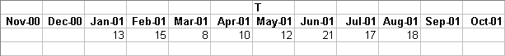

Table 1. Series #1

Now, if the command

T -2 1 2 shiftdatashort

were applied to this variable, in addition to the existing “T” grid, it would then also depend upon a new grid named “T_lag”, and would have the following structure (Table 2).

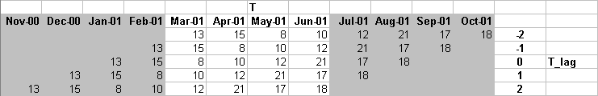

Table 2. Series #1 with -2 1 2 shiftdatashort applied

In addition, the time grid “T” for the resulting variable will be shortened to include only those time steps that have data common to all five lags (in this case, March 2001 to June 2001, the unshaded area in Table 2).

At zero lag (T_lag = 0), the variable has its original orientation along the time grid. For a positive lag of a single time step (T_lag = 1), the values of the variable are moved backward with respect to the time grid by one time step, e.g., the original value for January 2001 becomes the value for December 2000, and the January 2001 point along the time grid is assigned the value originally assigned to Feburay 2001.

For a negative lag (i.e., positive lead) of a single time step (T_lag = -1), the values of the variable are moved forward with respect to the time grid by one time step, e.g., the original value for January 2001 becomes the value for February 2001, and the January 2001 point along the time grid is assigned the value originally assigned to December 2000, etc.

6.2 Calculating Lagged Correlation

By applying the shiftdatashort command in conjunction with a calculation of the correlation, one can immediately calculate lagged correlations for multiple lags all at once. To follow upon the example illustrated by the tables in the previous section, suppose that the values for January 2001 to August 2001 of Series #1 in Table 2 are to be correlated with another time series of the same length for various lags. This second time series (Series #2) is illustrated in the following table (Table 3).

Table 3. Series #2

Because the application of shiftdatashort to Series #1 results in its time grid being shortened to the range March 2001 to June 2001 at all five lags (Table 2), when Series #1 is correlated with Series #2, and because the two series must match along the time grid, only the values for March 2001 to June 2001 in Series #2 (values 83, 47, 100, and 92) will be included in the calculation of the correlation with Series #1.

The result of the correlation between Series #2 and Series #1, to which a series of five lags has been applied (from -2 to 2 months), will be a set of five correlation coefficients, one for each lag.

For the -2 month lag applied to Series #1 (a +2 month lead of Series #1 with respect to Series #2, since a negative lag is equivalent to a lead), values from January 2001 to April 2001 in Series #1 are being matched with values from March 2001 to June 2001 in Series #2. In other words, for T_lag = -2 applied to Series #1, the values in Series #1 lead the values with which they are being correlated in Series #2 by two months.

Similarly, for the -1 month lag applied to Series #1, values from February 2001 to May 2001 in Series #1 are being correlated with values from March 2001 to June 2001 in Series #2.

The results of these correlations are shown in Table 4.

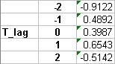

Table 4 Lagged correlations calculated from Series #1 and Series #2

For the zero lag case (T_lag = 0), values from March 2001 to June 2001 are being correlated with contemporaneous values in Series #2. The result of this correlation will differ to some extent from the contemporaneous correlation between Series #1 without shiftdatashort applied and Series #2 because the full set of data values from January 2001 to August 2001 will be included in the correlation. The difference between these two cases will be larger for shorter time series since a larger fraction of the total number of observations is being excluded.

See Exercise 6.

References:

Xie, P. and P. A. Arkin, 1996: Analyses of Global Monthly Precipitation Using Gauge Observations, Satellite Estimates, and Numerical Model Predictions. J. Climate, 9, 840 -858.

7. Exercices

Apres des instructions sommaires ou une description brève de l’exercice, chaque exercice est divisé en trois parties.

- Les “Etapes en Mode Expert (Expert Mode)” décrivent les étapes à suivre par un utilisateur en Mode Expert (Expert Mode) pour réaliser le type de calculs décrit. Ces étapes sont compatibles avec tout type de données ;
- L’“Exemple en Mode Expert (Expert Mode)” donne un exemple des opérations et commandes que l’utilisateur doit utiliser en Mode Expert (Expert Mode) pour réaliser les calculs de l’exercice. De même, ces étapes sont généralement compatibles avec tout type de données ;
- Le “Détail des Etapes pour cet Exercice” guide l’utilisateur étape après étape dans la procédure à suivre pour réaliser l’exercice en utilisant des données, localités et périodes de temps particulières, décrites dans cet exercice particulier.

Une remarque à propos polices utilisées dans les exercices :

- Dans les sections “Etapes en Mode Expert (Expert Mode)”, le texte en gras indique des noms de commande de la Data Library ;
- Dans les sections “Exemple en Mode Expert (Expert Mode)” :
  - Le texte en Arial représente des commandes de la Data Library telles qu’elles apparaitraient en Mode Expert (Expert Mode) ;
  - Le texte en Arial italique représente des indicateurs descriptifs des morceaux de commande que l’utilisateur insérerait en Mode Expert (Expert Mode), tels que des données, des constantes, etc. ;
- Dans les sections “Detail des Etapes pour cet Exercice”, tout le texte en Arial indique les commandes telles qu’elles apparaitraient en Mode Expert (Expert Mode) ;
- Dans le reste du document, du texte en italique indique des mots ou expressions en anglais présents sur les pages de la Data Library ou des concepts associés non traduits.

Ces conventions permettent de faire la différence entre des généralités et des exemples précis sur le codage en Mode Expert (Expert Mode).

Exercice 1 : Calcul d’anomalies de cas de paludisme hebdomadaires dans les Municipios de Colombie en utilisant la période complète disponible pour ces données (2000-2007) comme période de référence.

Etapes en Mode Expert (Expert Mode) :

- Sélectionner une variable de valeurs hebdomadaires d’une base de données ;
- Restreindre les domaines spatiaux et temporels à souhait ;
- Comme les semaines ne forment pas une partition de l’annee, il faut passer par le concept de pentade (ou serie de cinq jours en utilisant weeklytopentad) pour calculer une année de pentades moyenne (en utilisant pentadmean) puis la soustraire aux données (en utilisant sub) pour obtenir des anomalies et enfin re-interpoler ces données de pentades en données hebdomadaires (en utilisant [T]regridLinear).
- Remarque : il existe une commande yearly-anomalies (anomalies-annuelles) pour calculer directement les anomalies mensuelles de données mensuelles. Mais il n’existe pas une telle fonction pour les données hebdomadaires.

Exemple en Mode Expert :

expert
dataset/variable selection
time/spatial domain restriction
dup weeklytopentad
dup pentadmean sub
[T]regridLinear

Détail des Etapes en Mode Expert (Expert Mode) :

Etape 1 :

Commencer avec les cas de paludisme en Colombie :

expert
home .ciph .Colombia .malcol_weekly .total_mal

URL : http://iridl.ldeo.columbia.edu/expert/home/.ciph/.Colombia/.malcol_weekly/.total_mal/

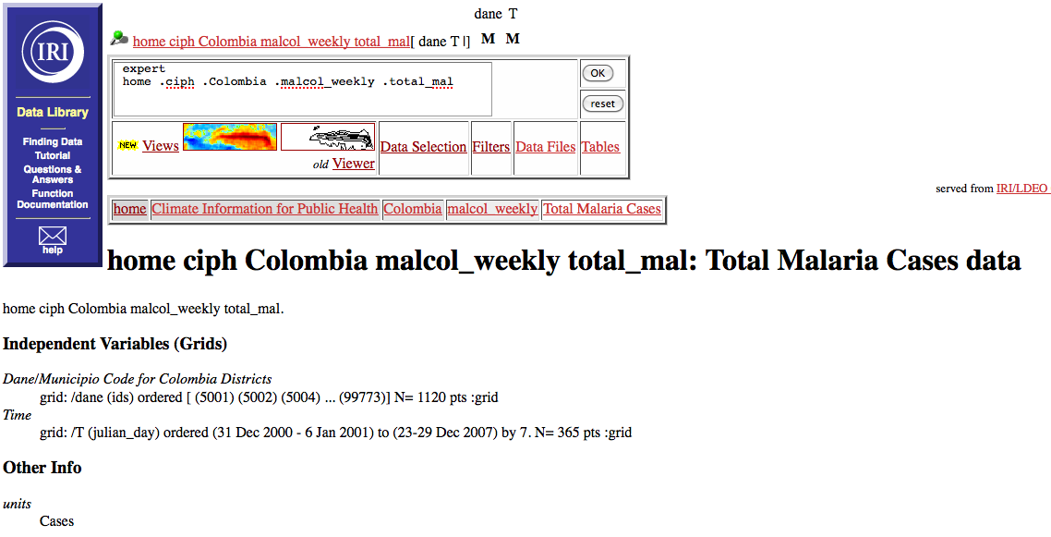

Fig. 3 Sélection des cas de paludisme en Colombie dans la Data Library

Remarque : dans ce cas, aucune restriction des domaines n’a été faite sur les données. Tous les Municipios et toutes les semaines de 2000 à 2007 sont disponibles.

Etape 2 :

Avant d’interpoler les données hebdomadaires en pentades, il faut conserver un jeu de données original hebdomadaire pour pouvoir connaître la grille temporelle hebdomadaire sur laquelle la ré-interpolation sera effectuée à la fin de l’exercice :

expert
home .ciph .Colombia .malcol_weekly .total_mal
dup weeklytopentad

URL : http://iridl.ldeo.columbia.edu/expert/home/.ciph/.Colombia/.malcol_weekly/.total_mal/dup/weeklytopentad/

Etape 3 :

Il y a maintenant deux jeux de donnees dans le stack (pile) d’objets de la Data Library (situe au-dessus de le boite du Mode Expert (Expert Mode)). Le premier est le jeu de données original (hebdomadaire), le second est son interpolation en pentades. Pour calculer les anomalies par pentades : dupliquer les données de pentades, calculer une année moyenne de pentades puis la soustraire aux données totales de pentades :

expert
home .ciph .Colombia .malcol_weekly .total_mal
dup weeklytopentad
dup pentadmean sub

URL : http://iridl.ldeo.columbia.edu/expert/home/.ciph/.Colombia/.malcol_weekly/.total_mal/dup/weeklytopentad/dup/pentadmean/sub/

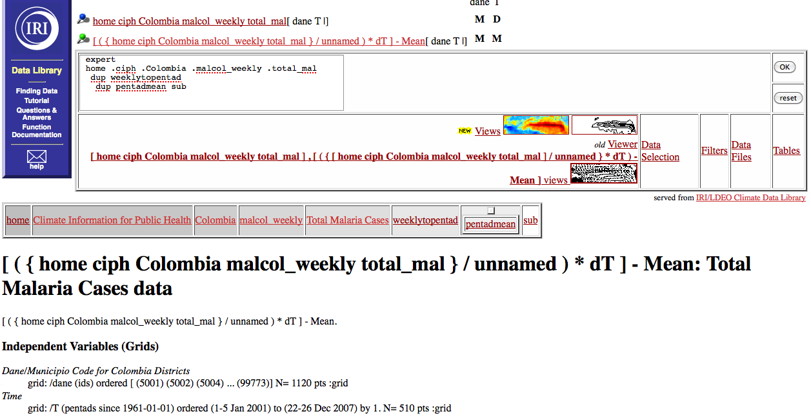

Fig. 4 calcul d’anomalies annuelles par pentades depuis des données hebdomadaires

Encadré
Pour calculer les anomalies mensuelles de données mensuelles. Un exemple avec des données D’Eritrée.
Cliquer sur le lien “Filters”.
URL: http://iridl.ldeo.columbia.edu/expert/home/.ciph/.Eritrea/.malaria/.monthly96-03/.incidence/?help+filters
La page chargée ressemblera à ca :
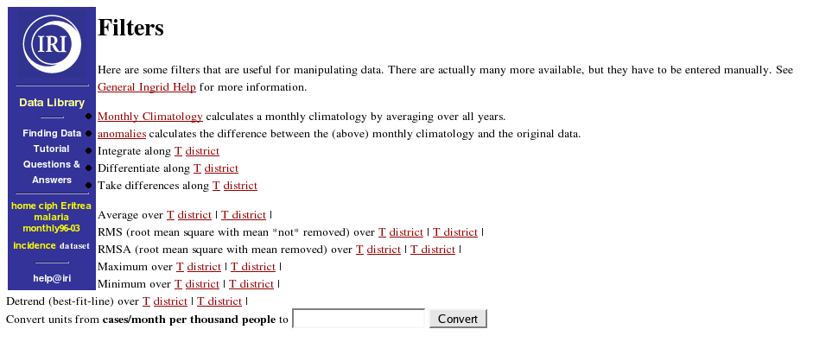
Fig. 5 Usage de la page “Filters” pour calculer des anomalies mensuelles
Cliquer simplement sur le lien “anomalies” pour calculer les anomalies mensuelles pour ces données. Cliquer sur ce lien renvoie à la page principale de ces données où les anomalies ont été calculées.
URL: http://iridl.ldeo.columbia.edu/expert/home/.ciph/.Eritrea/.malaria/.monthly96-03/.incidence/yearly-anomalies/
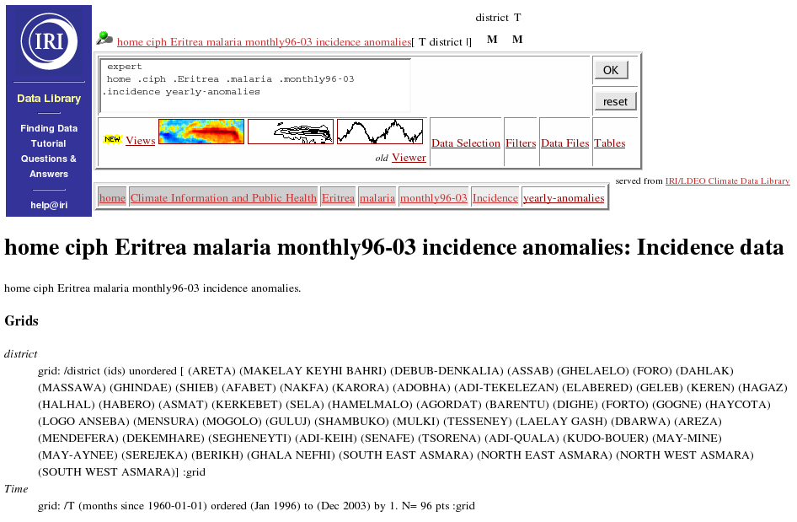
Fig. 6 yearly-anomalies est la commande du Mode Expert (Expert Mode) pour calculer les anomalies de données mensuelles.
Dans la boite du Mode Expert (Expert Mode), la commande yearly-anomalies est apparue :
expert
home .ciph .Eritrea .malaria .monthly96-03 .incidence
yearly-anomalies

Etape 4 :

Ré-interpoler les données de pentades en données hebdomadaires. [T] indique la dimension sur laquelle a lieu l’interpolation (ici le temps). regridLinear interpole le second jeu de données en fonction du premier sur la dimension indiquée :

expert
home .ciph .Colombia .malcol_weekly .total_mal
dup weeklytopentad
dup pentadmean sub
[T]regridLinear

URL : http://iridl.ldeo.columbia.edu/expert/home/.ciph/.Colombia/.malcol_weekly/.total_mal/dup/weeklytopentad/dup/pentadmean/sub%5BT%5DregridLinear/
Exercice 2 : Calcul des anomalies hebdomadaires des précipitations CMAP grillées sur la période couverte par les données de paludisme de Colombie, tout en ré-interpolant le résultat sur une grille plus fine, puis moyenner ce résultat sur les Municipios de Colombie.

Etapes en Mode Expert (Expert Mode) :

- Sélectionner les données de paludisme de Colombie ;
- Sélectionner les données de pentades de précipitations CMAP ;
- Restreindre les domaines spatiaux et temporels à souhait ;
- Calculer les anomalies annuelles par pentades utilisant la période de référence sélectionnée en étape 3 ;
- Sélectionner les données de géométries sur lesquelles la moyenne des valeurs grillées va être calculée et appliquer la commande weighted-average.

Expert Mode Template:

Expert
dataset/variable sélection (épidémiologiques)
dataset/variable sélection (climatiques)
time/spatial domain restriction
dup pentadmean sub
[T]regridLinear
dataset/variable sélection (géométriques)
[X Y]weighted-average

Détail des Etapes pour cet Exercice :

Etape 1:

Acceder aux données épidémiologiques :

expert
home .ciph .Colombia .malcol_weekly .total_mal

URL : http://iridl.ldeo.columbia.edu/expert/home/.ciph/.Colombia/.malcol_weekly/.total_mal/

Accéder aux données de NOAA NCEP CPC Merged_Analysis :

expert
home .ciph .Colombia .malcol_weekly .total_mal
SOURCES .NOAA .NCEP .CPC .Merged_Analysis

URL : http://iridl.ldeo.columbia.edu/expert/home/.ciph/.Colombia/.malcol_weekly/.total_mal/SOURCES/.NOAA/.NCEP/.CPC/.Merged_Analysis/

Sélectionner “pentad”, puis la toute dernière édition, “Version 2”, puis “CMAP estimated precipitation” :

URL : http://iridl.ldeo.columbia.edu/expert/home/.ciph/.Colombia/.malcol_weekly/.total_mal/SOURCES/.NOAA/.NCEP/.CPC/.Merged_Analysis/.pentad/.latest/.ver2/.prcp_est/

Les informations sur les dimensions (Grids – Grilles), indiquent qu’il s’agit de données de pentades qui commencent en janvier 1979 et se terminent en septembre 2009 ; et qui ont une couverture mondiale. Sous “Other Info” (Autres Infos), les unités sont indiquées en mm/day (mm/jour).

Etape 2 :

Restreindre les données dans le temps et l’espace. Les restrictions spatiales peuvent être effectuées en Mode Expert (Expert Mode), via le lien vers la page “Data Selection”, ou encore via le Data Viewer. Lors de la restriction temporelle de données de précipitations, il faut penser à considérer la période de référence utilisée pour les anomalies. L’option retenue ici est de calculer les anomalies de précipitations en utilisant la période de référence qui correspond à celle utilisée pour calculer les anomalies de cas de paludime.

En Mode Expert (Expert Mode), les restrictions spatiales et temporelles devraient ressembler à ca :

expert
home .ciph .Colombia .malcol_weekly .total_mal
SOURCES .NOAA .NCEP .CPC .Merged_Analysis .pentad .latest .ver2 .prcp_est
X -80 -65 RANGEEDGES
Y -5 13 RANGEEDGES
T (31 Dec 2000) (29 Dec 2007) RANGEEDGES

URL : http://iridl.ldeo.columbia.edu/expert/home/.ciph/.Colombia/.malcol_weekly/.total_mal/SOURCES/.NOAA/.NCEP/.CPC/.Merged_Analysis/.pentad/.latest/.ver2/.prcp_est/X/-80/-65/RANGEEDGES/Y/-5/13/RANGEEDGES/T/%2831 Dec 2000%29%2829 Dec 2007%29RANGEEDGES/

Etape 3 :

En Mode Expert (Expert Mode), calculer les anomalies annuelles de pentades comme dans l’exercice 1 :

expert
home .ciph .Colombia .malcol_weekly .total_mal
SOURCES .NOAA .NCEP .CPC .Merged_Analysis .pentad .latest .ver2 .prcp_est
X -80 -65 RANGEEDGES
Y -5 13 RANGEEDGES
T (31 Dec 2000) (29 Dec 2007) RANGEEDGES
dup pentadmean sub

URL : A ce stade, les URL sont trop longues ; copier et coller les commandes du Mode Expert (Expert Mode) dans la boite Mode Expert de la Data Library.

Etape 4 :

Interpoler les données de pentades de précipitations sur la dimension hebdomadaire des données épidémiologiques comme dans l’exercice 1 :

expert
home .ciph .Colombia .malcol_weekly .total_mal
SOURCES .NOAA .NCEP .CPC .Merged_Analysis .pentad .latest .ver2 .prcp_est
X -80 -65 RANGEEDGES
Y -5 13 RANGEEDGES
T (31 Dec 2000) (29 Dec 2007) RANGEEDGES
dup pentadmean sub
[T]regridLinear

En cliquant sur l’icône du Data Viewer représentant “colors with coasts” (couleurs et côtes), la carte des anomalies de précipitations sur la Colombie apparaît. Puis sélectionner dans le menu déroulant “draw … countries” (tracer les frontières des pays), vous verrez alors notamment le rapport entre la résolution de la base de données de précipitations avec la taille des Municipios colombiens.

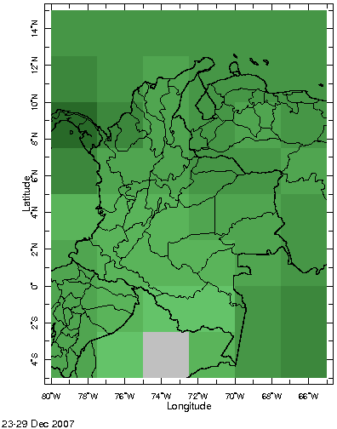
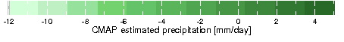
Fig. 7 L’échelle spatiale des précipitations CMAP comparée aux limites administratives de Colombie

Cette carte illustre le fait que la résolution de la grille spatiale des précipitations est bien plus faible que la taille des districts administratifs colombiens. Tenter de calculer des valeurs moyennes des précipitations par Municipios échouera dans beaucoup des districts de petites tailles à cause de cette inadéquation des échelles spatiales.

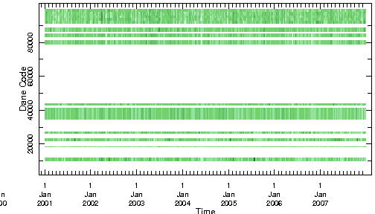
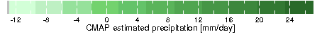
Fig. 8 Municipios par rapport au Temps : les anomalies de précipitations CMAP montrent en blanc les données manquantes résultant de la tentative de calculer des moyennes par districts qui sont plus petits que la résolution 2.5° lat/lon des données CMAP originales.

Etape 4:

Afin de passer cette difficulté, les anomalies de précipitations CMAP peuvent être interpolées plus finement avant de calculer la moyenne par Municipios. Pour ce faire, la commande GRID peut être appliquée à la longitude “X” et à la latitude “Y”. Pour regriller depuis une résolution faible vers une résolution plus fine, la commande GRID utilise une simple interpolation linéaire.

Cependant, les précipitations interpolées ainsi ne représenteront pas nécessairement les précipitations à cette échelle plus fine. Cette interpolation ne prend pas en compte la topographie et tout autre phénomène de plus petite échelle et est source d’erreurs.

Dans ce cas, regriller a une résolution de 0.125° lat/lon devrait être suffisant pour passer cette difficulté. La commande GRID en Mode Expert (Expert Mode) s’applique de la sorte :

expert
home .ciph .Colombia .malcol_weekly .total_mal
SOURCES .NOAA .NCEP .CPC .Merged_Analysis .pentad .latest .ver2 .prcp_est
X -80 -65 RANGEEDGES
Y -5 13 RANGEEDGES
T (31 Dec 2000) (29 Dec 2007) RANGEEDGES
dup pentadmean sub
[T]regridLinear
X -80 0.125 -65 GR

Etape 5:

L’étape finale consiste à indiquer les données de géométries des Municipios puis de moyenner spatialement les anomalies de précipitations sur ces géométries. Les géométries des Municipios se trouvent en de multiples locations de la Data Library. Allons les chercher à leur source :

expert
home .ciph .Colombia .malcol_weekly .total_mal
SOURCES .NOAA .NCEP .CPC .Merged_Analysis .pentad .latest .ver2 .prcp_est
X -80 -65 RANGEEDGES
Y -5 13 RANGEEDGES
T (31 Dec 2000) (29 Dec 2007) RANGEEDGES
dup pentadmean sub
[T]regridLinear
X -80 0.125 -65 GRID
Y -5 0.125 13 GRID
SOURCES .Features .Political .Colombia .Districts .the_geom

A ce point, les deux derniers objets référencés dans le stack (pile) de la Data Library sont : les anomalies de précipitations CMAP, qui dépendent du temps, de la latitude et de la longitude ; et les districts colombiens, qui dépendent simplement d’un identifiant appelé dane. Pour combiner l’information de ces deux variables et produire des données de précipitations moyennées par district, appliquer la fonction weighted-average comme suit :

expert
home .ciph .Colombia .malcol_weekly .total_mal
SOURCES .NOAA .NCEP .CPC .Merged_Analysis .pentad .latest .ver2 .prcp_est
X -80 -65 RANGEEDGES
Y -5 13 RANGEEDGES
T (31 Dec 2000) (29 Dec 2007) RANGEEDGES
dup pentadmean sub
[T]regridLinear
X -80 0.125 -65 GRID
Y -5 0.125 13 GRID
SOURCES .Features .Political .Colombia .Districts .the_geom
[X Y] weighted-average

Ici, le premier argument de la fonction weighted-average est la variable grillée qui doit être moyennée. Le second argument est le jeu de données des géométries. Dans la commande weighted-average les grilles X et Y entre crochets indiquent les dimensions sur lesquelles le calcul de la moyenne doit se faire.

Le résultat est un jeu de données d’anomalies de précipitations qui sont fonction des 1120 Municipios du 31 décembre 2000 au 29 décembre 2007, hebdomadairement.

Exercice 3: Cartographier les anomalies de cas de paludisme hebdomadaires en Colombie de 2000 à 2007

Etapes en Mode Expert (Expert Mode) :

- Sélectionner un jeu de données de résolution spatiale suffisamment fine par rapport aux districts (typiquement SOURCES .WORLDBATH .bath) ;
- Restreindre le domaine spatial de ces données à la zone d’étude ;
- Sélectionner les données géométriques des districts correspondant aux données à cartographier ;
- Sélectionner les données épidémiologiques hebdomadaires et calculer leurs anomalies comme dans l’exercice 1 (ces données devraient dépendre des mêmes districts que les données géométriques sélectionnées en étape 3) ;
- Appliquer la commande qui permet de dresser la carte des données épidémiologiques par géométries sur le domaine spatial sélectionné : X Y fig: mask fillby black thin countries_gaz :fig

Exemple en Mode Expert (Expert Mode) :

expert
background gridded dataset/variable selection used to define mapping grid
time/spatial domain restriction
selection of variable of shape geometries
selection of variable you wish to map
time/spatial domain restriction
dup weeklytopentad
dup pentadmean sub
[T]regridLinear nip
/scale_symmetric true def
X Y fig: white mask fillby black thin countries_gaz :fig

Detail des Etapes pour cet Exercice :

Etapes 1-2:

Pour dresser une carte dont les coordonnées sont la longitude et la latitude, nous avons besoin de données grillées qui dépendent de ces coordonnées, et de résolution suffisamment fine pour appréhender les Municipios colombiens (telles que WORLDBATH) ; les restreindre à la région étudiée ; puis pour simplifier les calculs, masquer les données continentales (en l’occurrence la topographie) qui ne nous intéresse pas et qui seront recouvertes de toute façon par les données épidémiologiques. En Mode Expert (Expert Mode) :

expert
SOURCES .WORLDBATH .bath
X -80 -65 RANGEEDGES
Y -5 13 RANGEEDGES

Etape 3:

Sélectionner les données de géométrie des districts de Colombie.
expert
SOURCES .WORLDBATH .bath
X -80 -65 RANGEEDGES
Y -5 13 RANGEEDGES
SOURCES .Features .Political .Colombia .Districts .the_geom

Etape 4 :

Un des exercices précédents traitait le calcul d’anomalies de cas hebdomadaires de paludisme par Municipios colombiens.

expert
SOURCES .WORLDBATH .bath
X -80 -65 RANGEEDGES
Y -5 13 RANGEEDGES
SOURCES .Features .Political .Colombia .Districts .the_geom
home .ciph .Colombia .malcol_weekly .total_mal
dup weeklytopentad
dup pentadmean sub
[T]regridLinear
nip

URL : http://iridl.ldeo.columbia.edu/expert/SOURCES/.WORLDBATH/.bath/X/-80/-65/RANGEEDGES/Y/-5/13/RANGEEDGES/SOURCES/.Features/.Political/.Colombia/.Districts/.the_geom/home/.ciph/.Colombia/.malcol_weekly/.total_mal/dup/weeklytopentad/dup/pentadmean/sub%5BT%5DregridLinear/nip/

Remarque : un nip apparaît à la fin de la commande. Il permet de supprimer l’avant dernier élément du stack (pile). Cet élément référençait les données hebdomadaires totales de cas de paludisme qui devaient être conservées jusqu’alors pour permettre d’appliquer la commande regridLinear. Cet élément n’est plus désirable dans le stack (pile) et sa suppression permet d’avoir les arguments nécessaires à la cartographie.

Etape 5 :

Ainsi, les variables appropriées sont maintenant en ordre pour appliquer la procédure de cartographie.

expert
SOURCES .WORLDBATH .bath
X -80 -65 RANGEEDGES
Y -5 13 RANGEEDGES
SOURCES .Features .Political .Colombia .Districts .the_geom
home .ciph .Colombia .malcol_weekly .total_mal
dup weeklytopentad
dup pentadmean sub
[T]regridLinear
nip /scale_symmetric true def
X Y fig: white mask fillby black thin countries_gaz :fig

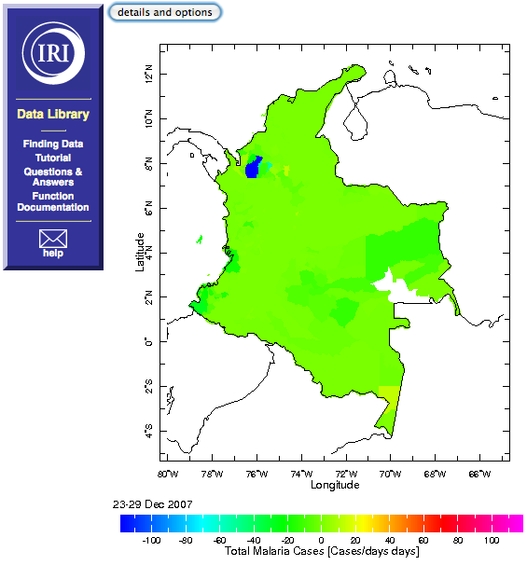
Fig. 9 Carte des anomalies de cas de paludisme par Municipios pour la dernière semaine de données disponible

“X Y” indique que la figure créée est une figure en deux dimension dont les axes sont la longitude et la latitude, c’est à dire une carte.

La construction “fig: … :fig” contient les attributs de la figure. A l’intérieur de cette construction, white mask (masquer en blanc) masque les régions continentales en blanc. Par dessus ce fond blanc, fillby (remplir par) remplit les géométries des districts par une couleur associée a la valeur de la variable associée a chaque district. black thin countries_gaz (frontières des pays en noir fin) dessine les frontières des pays avec un trait noir et fin. La carte apparaissant montre les Municipios colombiens colorés selon les anomalies de paludisme.

Lorsque la carte apparaît, la boite de commande du Mode Expert (Expert Mode) est réduite mais elle peut être redéployée en cliquant sur le bouton details and options. La commande /scale_symmetric true def ajoutée avant la commande de cartographie est optionnelle et permet simplement de s’assurer que l’échelle des couleurs sera centrée sur zéro, ce qui est pertinent pour des anomalies. scale_symmetric (échelle symétrique) est un attribut des bases de données et peut être activé en le définissant comme true (vai) ou le désactiver en le définissant comme false (faux).

Nombre de ces attributs tels que le type de frontières, leur couleur et épaisseur, et l’échelle de couleur utilisée, peut être choisi ou modifie dans le menu Edit Plot (Editer le Dessin) du Data Viewer (Visionneur de Données).

Une fois que ces attributs optionnels sont sélectionnés dans le menu Edit Plot (Editer le Dessin), cliquer sur le bouton “more options” (plus d’options) pour retourner a la page principale du Data Viewer.

Sur la page du Data Viewer, les bornes de l’échelle de couleurs peuvent être changées. La boite de dialogue et le bouton au-dessus de la figure permet de sélectionner différentes semaines ou de déclencher des animations en choisissant des dates qui couvrent plus qu’une seule semaine.

Encadré
Commande plus sophistiquée pour dessiner une carte plus agréable au regard, avec la topographie des continents dans une échelle de gris et la bathymétrie des océans dans une échelle de bleu.
expert
home .ciph .Colombia .malcol_weekly .total_mal
dup weeklytopentad
dup pentadmean sub
[T]regridLinear
SOURCES .WORLDBATH .bath
X -80 -65 RANGEEDGES
Y -5 13 RANGEEDGES
dup
0 masklt
halfgreyscale
SOURCES .Features .Political .Colombia .Districts .the_geom
3 index
/scale_symmetric true def
X Y fig: colors colors || fillby black thin countries_gaz :fig
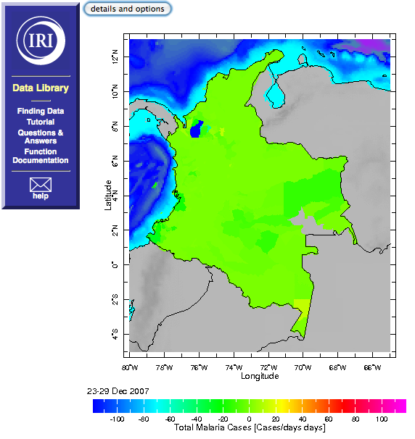

Exercice 4 : Utiliser la commande de figure twolines (deux courbe) pour tracer un graphe comprenant deux séries temporelles : une des anomalies de précipitations CMAP hebdomadaires moyennées par Municipios colombien ; l’autre des anomalies de cas de paludisme pour ces mêmes districts.

En fonction de la nature des deux variables à tracer sur un même graphe, plusieurs étapes peuvent s’avérer nécessaires afin de faire correspondre les grilles temporelles et spatiales de ces données, avant d’utiliser la commande de figure twolines pour créer le graphe. Dans un cas simple, les deux variables à tracer viennent du même jeu de données et dépendent des mêmes grilles temporelles et spatiales. Dans l’exemple de l’exercice, les dimensions des précipitations doivent être changées selon les districts colombiens et l’échelle de temps hebdomadaire.

Etapes en Mode Expert (Expert Mode) :

- Sélectionner la variable 1 ;
- Calculer les anomalies ;
- Transformer et/ou restreindre les domaines temporels/spatiaux pour correspondre à la variable 2 ;
- Sélectionner la variable 2 ;
- Calculer les anomalies ;
- Transformer et /ou restreindre les domaines temporel/spatiaux pour correspondre à la variable 1 ;
- Appliquer la commande qui permet de tracer un graphe à deux courbes : T fig: twolines :fig

Exemple en Mode Expert (Expert Mode) :

expert
dataset/variable 1
time/spatial domain restriction/transformation to match that of variable 2
dataset/variable 2
time/spatial domain restriction/transformation to match that of variable 1
grid fig: twolines :fig

Détail des Etapes de cet Exercice :

A part la commande finale pour réaliser le graphe en lui-même, toutes les autres étapes ont été traitées au cours des exercices précédents.

Etape 1-3 :

Sélectionner, restreindre et calculer les anomalies des données épidémiologiques.

expert
home .ciph .Colombia .malcol_weekly .total_mal
dup weeklytopentad
dup pentadmean sub
[T]regridLinear

Etape 4-6:

Selectionner, transformer et calculer les anomalies des données de précipitations.

expert
home .ciph .Colombia .malcol_weekly .total_mal
dup weeklytopentad
dup pentadmean sub
[T]regridLinear
SOURCES .NOAA .NCEP .CPC .Merged_Analysis .pentad .latest .ver2 .prcp_est
X -80 -65 RANGEEDGES
Y -5 13 RANGEEDGES
T (31 Dec 2000) (29 Dec 2007) RANGEEDGES
dup pentadmean sub
[T]regridLinear
X -80 0.125 -65 GRID
Y -5 0.125 13 GRID
SOURCES .Features .Political .Colombia .Districts .the_geom
[X Y]weighted-average

Etape 7:

Appliquer la commande de traçage du graphe :

expert
home .ciph .Colombia .malcol_weekly .total_mal
dup weeklytopentad
dup pentadmean sub
[T]regridLinear
SOURCES .NOAA .NCEP .CPC .Merged_Analysis .pentad .latest .ver2 .prcp_est
X -80 -65 RANGEEDGES
Y -5 13 RANGEEDGES
T (31 Dec 2000) (29 Dec 2007) RANGEEDGES
dup pentadmean sub
[T]regridLinear
X -80 0.125 -65 GRID
Y -5 0.125 13 GRID
SOURCES .Features .Political .Colombia .Districts .the_geom
[X Y]weighted-average
T fig: twolines :fig

Le graphe montre les séries temporelles hebdomadaires de 2000 à 2007 des anomalies de cas de paludisme pour un Municipio donné en noir et des anomalies de précipitations CMAP en rouge. Dans le Data Viewer, ce sont cette fois les différents districts qui sont sélectionnables par le control situé au dessus du graphe.

Exercice 5 : Calculer les corrélations entre les anomalies hebdomadaires des précipitations CMAP et les anomalies de cas de paludisme par Municipio colombien.

Etapes en Mode Expert (Expert Mode) :

- Sélectionner la variable 1 ;
- Calculer les anomalies ;
- Transformer et/ou restreindre les domaines temporels/spatiaux pour correspondre à la variable 2 ;
- Sélectionner la variable 2 ;
- Calculer les anomalies ;
- Transformer et /ou restreindre les domaines temporel/spatiaux pour correspondre à la variable 1 ;
- Corréler les deux variables en appliquant correlate.

Exemple en Mode Expert (Expert Mode) :

expert
dataset/variable 1
time/spatial domain restriction/transformation to match that of variable 2
dataset/variable 2
time/spatial domain restriction/transformation to match that of variable 1
[grid]correlate

Détail des Etapes de cet Exercice :

Etapes 1-6:

Les exercices précédents ont déjà traite du calcul des anomalies et de la transfomartion des données pour qu’elles correspondent et puissent être comparées. Ayant soustrait le cycle annuel des deux variables, il est possible d’explorer les possibles co-variances linéaires en calculant la corrélation de leurs valeurs hebdomadaires.

expert
home .ciph .Colombia .malcol_weekly .total_mal
dup weeklytopentad
dup pentadmean sub
[T]regridLinear
SOURCES .NOAA .NCEP .CPC .Merged_Analysis .pentad .latest .ver2 .prcp_est
X -80 -65 RANGEEDGES
Y -5 13 RANGEEDGES
T (31 Dec 2000) (29 Dec 2007) RANGEEDGES
dup pentadmean sub
[T]regridLinear
X -80 0.125 -65 GRID
Y -5 0.125 13 GRID
SOURCES .Features .Political .Colombia .Districts .the_geom
[X Y]weighted-average

URL : http://iridl.ldeo.columbia.edu/expert/home/.ciph/.Colombia/.malcol_weekly/.total_mal/dup/weeklytopentad/dup/pentadmean/sub%5BT%5DregridLinear/SOURCES/.NOAA/.NCEP/.CPC/.Merged_Analysis/.pentad/.latest/.ver2/.prcp_est/X/-80/-65/RANGEEDGES/Y/-5/13/RANGEEDGES/T/%2831%20Dec%202000%29%2829%20Dec%202007%29RANGEEDGES/dup/pentadmean/sub%5BT%5DregridLinear/X/-80/0.125/-65/GRID/Y/-5/0.125/13/GRID/SOURCES/.Features/.Political/.Colombia/.Districts/.the_geom%5BX/Y%5Dweighted-average/

Remarque : les deux derniers objets du stack (pile) de la Data Library ont des grilles dane et T qui correspondent.

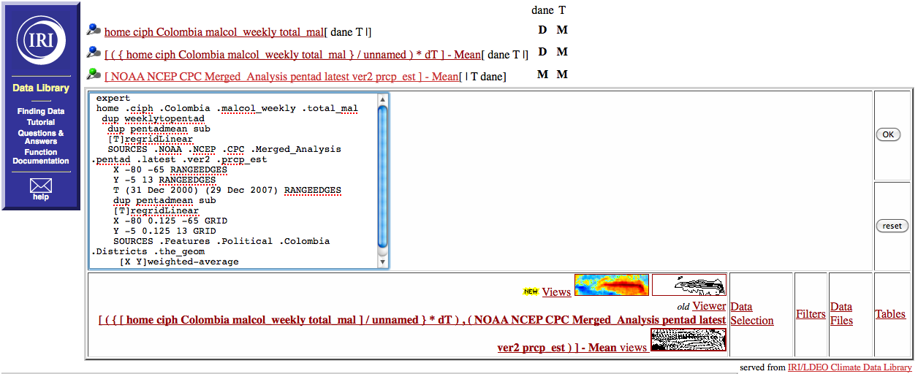

Fig. 10 Avant de calculer les corrélations entre deux variables dans la Data Library, il faut s’assurer que leurs grilles (ou dimensions ou variables indépendantes) correspondent (ou que l’une soit un échantillon de l’autre).

Etape 7:

Pour corréler ces deux variables selon le temps, ajouter simplement la commande suivante en Mode Expert (Expert Mode) :

expert
home .ciph .Colombia .malcol_weekly .total_mal
dup weeklytopentad
dup pentadmean sub
[T]regridLinear
SOURCES .NOAA .NCEP .CPC .Merged_Analysis .pentad .latest .ver2 .prcp_est
X -80 -65 RANGEEDGES
Y -5 13 RANGEEDGES
T (31 Dec 2000) (29 Dec 2007) RANGEEDGES
dup pentadmean sub
[T]regridLinear
X -80 0.125 -65 GRID
Y -5 0.125 13 GRID
SOURCES .Features .Political .Colombia .Districts .the_geom
[X Y]weighted-average
[T]correlate

URL : http://iridl.ldeo.columbia.edu/expert/home/.ciph/.Colombia/.malcol_weekly/.total_mal/dup/weeklytopentad/dup/pentadmean/sub%5BT%5DregridLinear/SOURCES/.NOAA/.NCEP/.CPC/.Merged_Analysis/.pentad/.latest/.ver2/.prcp_est/X/-80/-65/RANGEEDGES/Y/-5/13/RANGEEDGES/T/%2831%20Dec%202000%29%2829%20Dec%202007%29RANGEEDGES/dup/pentadmean/sub%5BT%5DregridLinear/X/-80/0.125/-65/GRID/Y/-5/0.125/13/GRID/SOURCES/.Features/.Political/.Colombia/.Districts/.the_geom%5BX/Y%5Dweighted-average%5BT%5Dcorrelate/

La dimension pour laquelle les corrélations sont calculées est inscrite entre crochets, suivi de la commande correlate.

Le résultat de ce calcul est une série de coefficients de corrélation qui ne dépendent plus que des districts seulement. Cliquer sur le lien “Tables” puis sur lien “columnar table” (table par colonnes) sur la page résultante, permet d’examiner les valeurs de ces corrélations pour chaque Municipio.

Remarque : Aucun décalage n’a été appliqué au calcul de ces corrélations.

Exercise 6: Use shiftdatashort to calculate the lagged correlation between CMAP precipitation anomalies and malaria incidence anomalies by subzoba in Eritrea for 1996-2003 and then map the result.

Expert Mode Steps:

- Select variable 1
- Calculate anomalies
- Transform and/or restrict time/spatial domain to match that of variable 2
- Select variable 2
- Calculate anomalies
- Transform and/or restrict time/spatial domain to match that of variable 1
- Apply shiftdatashort to the second variable to shift it in time at various lags with respect to the first variable
- Correlate the two variables by applying correlate

Expert Mode Template:

expert
dataset/variable 1
time/spatial domain restriction/transformation to match that of variable 2
dataset/variable 2
time/spatial domain restriction/transformation to match that of variable 1
grid low step high shiftdatashort
[grid]correlate

Steps in Detail for this Exercise:

Steps 1-7:

Applying shiftdatashort to find the lagged correlation between CMAP precipitation anomalies and malaria incidence anomalies for Eritrea requires only a small modification of our previous example (refer to Expert Mode Ingrid code above). To examine correlations between malaria incidence anomalies and CMAP precipitation anomalies leading and lagging by up to four months, simply include the command

T -4 1 4 shiftdatashort

Step 8:

just before the use of the correlation function in Expert Mode, as in the following:

expert
home .ciph .Eritrea .malaria .monthly96-03 .incidence
yearly-anomalies
SOURCES .NOAA .NCEP .CPC .Merged_Analysis .monthly .v0703 .ver2 .prcp_est
X 35. 45. RANGEEDGES
Y 10. 20. RANGEEDGES
T (Jan 1996) (Dec 2003) RANGE
yearly-anomalies
X 35. 0.125 45. GRID
Y 10. 0.125 20. GRID
home .ciph .Eritrea .malaria .monthly96-03 .MOH_SubZobas .the_geom
[X Y]weighted-average
T -4 1 4 shiftdatashort
[T] correlate

URL: http://iridl.ldeo.columbia.edu/expert/home/.ciph/.Eritrea/.malaria/.monthly96-03/.incidence/yearly-anomalies/SOURCES/.NOAA/.NCEP/.CPC/.Merged_Analysis/.monthly/.v0703/.ver2/.prcp_est/X/35./45./RANGEEDGES/Y/10./20./RANGEEDGES/T/%28Jan%201996%29%28Dec%202003%29RANGE/yearly-anomalies/X/35./0.125/45./GRID/Y/10./0.125/20./GRID/home/.ciph/.Eritrea/.malaria/.monthly96-03/.MOH_SubZobas/.the_geom%5BX/Y%5Dweighted-average/T/-4/1/4/shiftdatashort%5BT%5Dcorrelate/

To quickly visualize the result of this calculation, click on the “colors” Data Viewer icon:

which will display the following figure (Fig. 11):

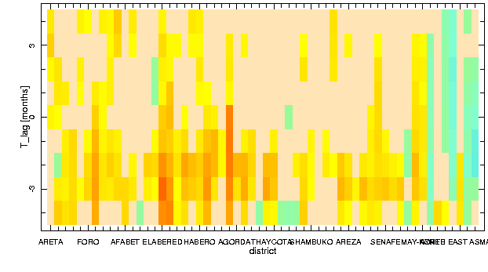
Fig. 11 Color plot of subzoba (district) vs. lag (-4 to +4 months) showing Pearson Product-Moment correlations between CMAP estimated precipitation anomalies by subzoba and Eritrea subzoba malaria incidence anomalies for the period 1996 to 2003. Negative lags on the vertical axis indicate the number of months by which CMAP estimated precipitation anomaly values lead malaria incidence anomaly values. Positive lags indicate the number of months by which precipitation lags malaria incidence.

Fig. 11 displays correlation values (colors from yellow to red are increasingly positive correlations; colors from light green to blue are increasingly negative correlations) by Eritrea subzoba (x-axis) and lag (y-axis) from -4 to +4 months. Since shiftdatashort was applied to the CMAP estimated precipitation anomalies, negative lags signify precipitation leading malaria incidence, and positive lags signify precipitation lagging malaria incidence.

In examining Fig. 11, the sometimes modest but increasingly positive correlations for many subzobas in the -2 and -3 month lags appear to support the idea that positive (negative) precipitation anomalies tend to lead by two to three months positive (negative) malaria incidence anomalies in many subzobas in Eritrea during 1996 to 2003. To examine the correlations more carefully by subzoba, click on the “Tables” link to see the values of the correlations.

To map the result, follow the procedure outlined before. Namely, start by cutting and pasting the Expert Mode entries for the WORLDBATH gridded data and the Eritrea geometries above the code used to calculate the lagged correlations, as in the following:

expert
SOURCES .WORLDBATH .bath
X 35. 45. RANGEEDGES
Y 10. 20. RANGEEDGES
home .ciph .Eritrea .malaria .monthly96-03 .MOH_SubZobas .the_geom
home .ciph .Eritrea .malaria .monthly96-03 .incidence yearly-anomalies
SOURCES .NOAA .NCEP .CPC .Merged_Analysis .monthly .v0703 .ver2 .prcp_est
X 35. 45. RANGEEDGES
Y 10. 20. RANGEEDGES
T (Jan 1996) (Dec 2003) RANGE
yearly-anomalies
X 35. 0.125 45. GRID
Y 10. 0.125 20. GRID
home .ciph .Eritrea .malaria .monthly96-03 .MOH_SubZobas .the_geom
[X Y]weighted-average
T -4 1 4 shiftdatashort
[T]correlate

URL: http://iridl.ldeo.columbia.edu/expert/SOURCES/.WORLDBATH/.bath/X/35./45./RANGEEDGES/Y/10./20./RANGEEDGES/home/.ciph/.Eritrea/.malaria/.monthly96-03/.MOH_SubZobas/.the_geom/home/.ciph/.Eritrea/.malaria/.monthly96-03/.incidence/yearly-anomalies/SOURCES/.NOAA/.NCEP/.CPC/.Merged_Analysis/.monthly/.v0703/.ver2/.prcp_est/X/35./45./RANGEEDGES/Y/10./20./RANGEEDGES/T/%28Jan%201996%29%28Dec%202003%29RANGE/yearly-anomalies/X/35./0.125/45./GRID/Y/10./0.125/20./GRID/home/.ciph/.Eritrea/.malaria/.monthly96-03/.MOH_SubZobas/.the_geom%5BX/Y%5Dweighted-average/T/-4/1/4/shiftdatashort%5BT%5Dcorrelate/

Then, enter the Figure Viewer and select the “Edit Plot” option.

Then replace the text in the figure options text box below the map with the following:

X Y fig: white mask fillby black thin countries_gaz :fig

and click “more options” to return to the Figure Viewer. Note that at the top of the page there is an option to select maps for different lags (Fig. 12).

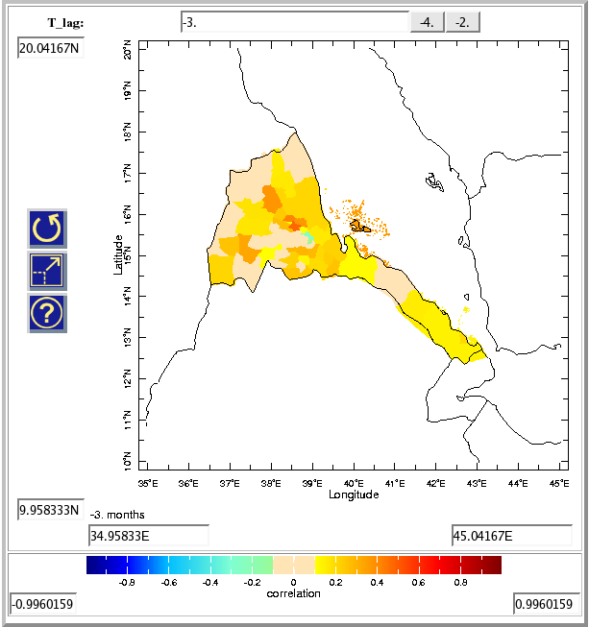

Fig. 12 Map of lagged correlation between CMAP precipitation and malaria incidence anomaly by subzoba in Eritrea for 1996-2003.

