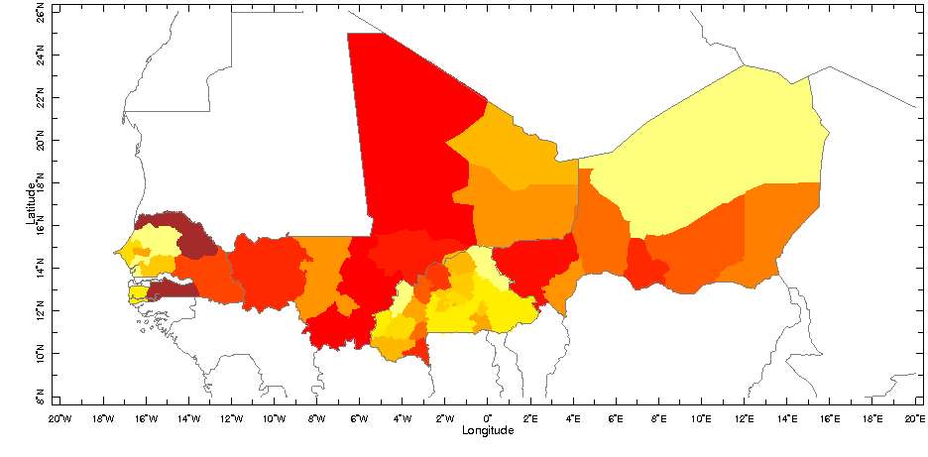
http://iridl.ldeo.columbia.edu/expert/SOURCES/.CIESIN/.GPWv3/.grid2p5arcmin/.adjusted/.density/X/-20/20/RANGE/Y/8/26/RANGE/T/%281990%20%29VALUES/T/removeGRID/home/.jdcorral/.Ale/.region_proj_num/.the_geom/home/.jdcorral/.Ale/.region_proj_num/.total/startcolormap/0/500/RANGEEDGES/null/white/yellow/0/value/orange/100/VALUE/OrangeRed/200/VALUE/red/300/VALUE/DarkRed/400/VALUE/brown/endcolormap/DATA/0/20/RANGE/X/Y/fig:/white/mask/fillby/grey/solid/countries_gaz/:fig/
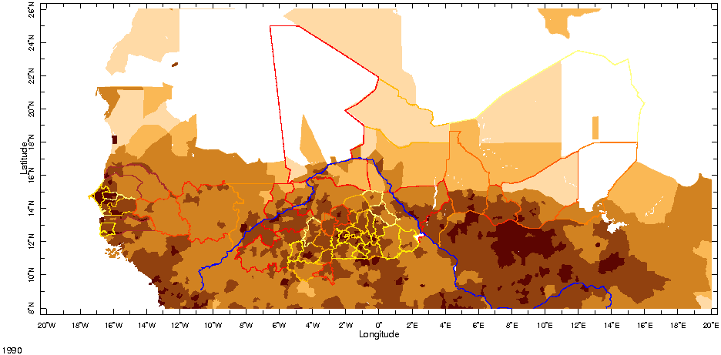
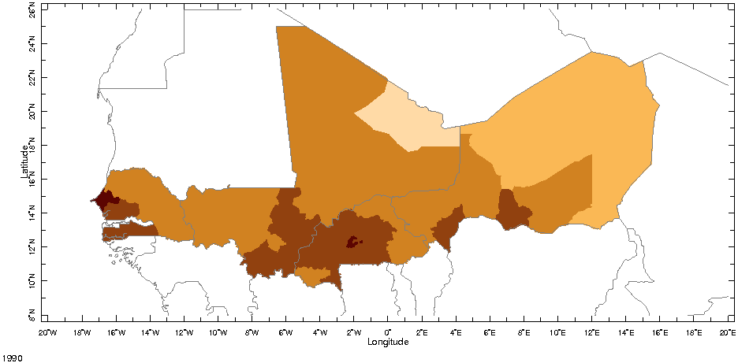
http://iridl.ldeo.columbia.edu/expert/SOURCES/.CIESIN/.GPWv3/.grid2p5arcmin/.adjusted/.density/X/-20/20/RANGE/Y/8/26/RANGE/T/%281990%20%29VALUES/SOURCES/.Features/.Political/.Africa/.Provinces/.the_geom/feature_id/%28133001%29%28133002%29%28133003%29%28133004%29%28133005%29%28133006%29%28133007%29%28133008%29%28158001%29%28158002%29%28158003%29%28158004%29%28158005%29%28158006%29%28158007%29%28195001%29%28195002%29%28195003%29%28195004%29%28195005%29%28195006%29%28195007%29%28195008%29%28195009%29%28195010%29%28233001%29%28233002%29%28233003%29%28233004%29%28233005%29%28233006%29%28233007%29%28233008%29%28233009%29%28233010%29%28233011%29%28233012%29%28233013%29%28233014%29%28233015%29%28233016%29%28233017%29%28233018%29%28233019%29%28233020%29%28233021%29%28233022%29%28233023%29%28233024%29%28233025%29%28233026%29%28233027%29%28233028%29%28233029%29%28233030%29VALUES/home/.alesall/.tmp/.region_popd1990gt500_featureid2.cdf/.density/feature/%28feature_id%29renameGRID/X/Y/fig:/white/mask/fillby/grey/solid/countries_gaz/:fig//density/0/100/plotrange/

http://iridl.ldeo.columbia.edu/expert/SOURCES/.CIESIN/.GPWv3/.grid2p5arcmin/.adjusted/.density/X/-20/20/RANGE/Y/8/26/RANGE/home/.jdcorral/.Ale/.region_proj_num/.the_geom/home/.jdcorral/.Ale/.region_proj_num/.total/startcolormap/0/500/RANGEEDGES/null/white/yellow/0/value/orange/100/VALUE/OrangeRed/200/VALUE/red/300/VALUE/DarkRed/400/VALUE/brown/endcolormap/DATA/0/20/RANGE/X/Y/fig:/colors/||/strokeby/grey/thinnish/blue/rivers/:fig//density/0/100/plotrange/
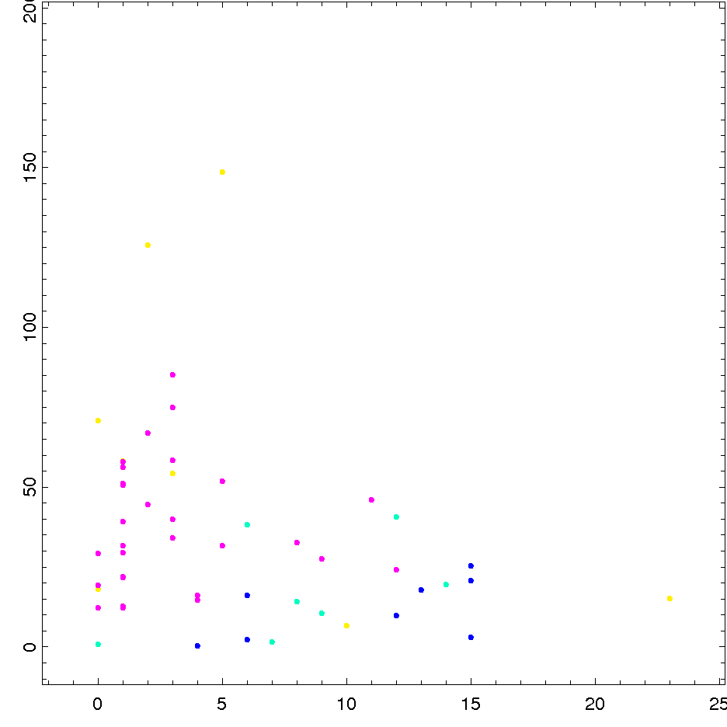

Magenta is Burkina Faso, blue is Mali, light blue is Niger and yellow is Senegal. Two regions are not included, because their average population densities are higher than 200 people/sq. km: Kadiogo, the region that contains Ouagadougou, the capital of Burkina Faso, and Cap-Vert, the region that contains Dakar, the capital of Senegal.

http://iridl.ldeo.columbia.edu/expert/home/.jdcorral/.Ale/.region_proj_num/.total/featureid/%28feature%29renameGRID/DATA/-2/25/RANGE/home/.alesall/.tmp/.region_popd1990gt500_featureid2.cdf/.density/DATA/-10/200/RANGE/feature/rainbowcolorscale/fig://XOVY/1/def//fntsze/30/def/scattercolor/:fig//feature/133000/234000/plotrange/
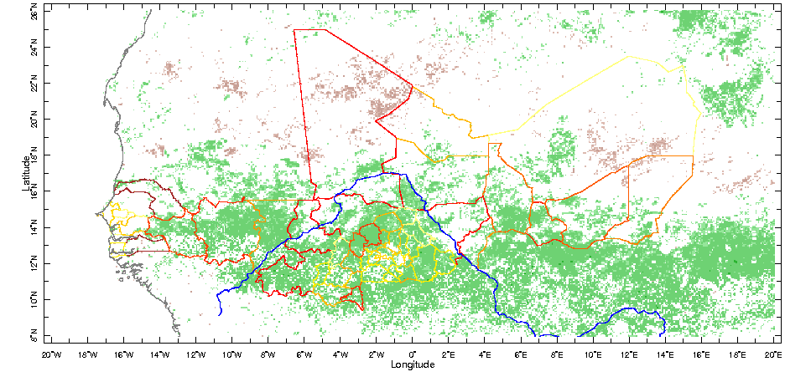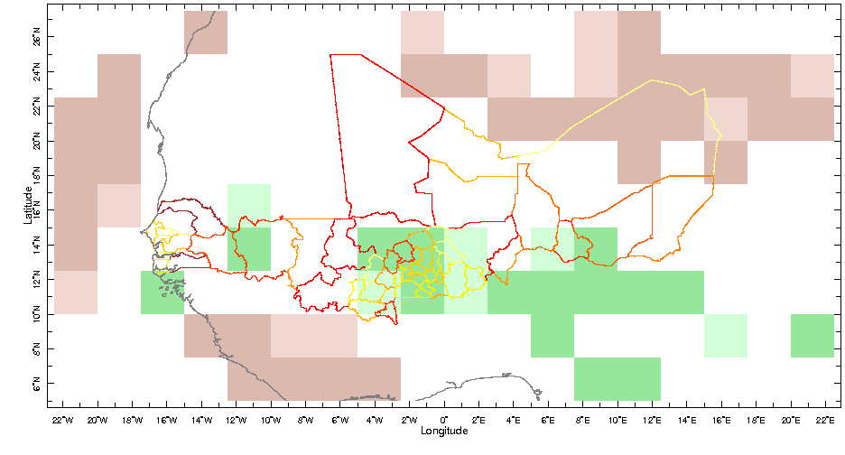
http://iridl.ldeo.columbia.edu/expert/SOURCES/.UMD/.GLCF/.GIMMS/.NDVIg/.global/.ndvi/X/-20/20/RANGE/Y/8/26/RANGE/T/1/monthlyAverage/T/(Jan 1982)(Dec 2003)RANGE/T/12/boxAverage/T/12/STEP/dup[T]detrend-bfl/sub/dup/T/last/VALUE/exch/T/first/VALUE/sub/22/div/SOURCES/.UMD/.GLCF/.GIMMS/.NDVIg/.global/.ndvi/X/-20/20/RANGE/Y/8/26/RANGE/T/1/monthlyAverage/T/(Jan 1982)(Dec 2003)RANGE/T/12/boxAverage/T/12/STEP/dup[T]rmsaover/exch/T/first/last/sub/12/div/dup/mul/12/div/sqrt/nip/nip/div/21/sqrt/div/div/-2.1/2.1/maskrange/prcp_anomaly/home/.jdcorral/.Ale/.region_proj_num/.the_geom/home/.jdcorral/.Ale/.region_proj_num/.total/startcolormap/0/500/RANGEEDGES/null/white/yellow/0/value/orange/100/VALUE/OrangeRed/200/VALUE/red/300/VALUE/DarkRed/400/VALUE/brown/endcolormap/DATA/0/20/RANGE/X/Y/fig:/colors/||/strokeby/grey/thinnish/coasts_gaz/blue/rivers/:fig//ratio/-10/10/plotrange/

http://iridl.ldeo.columbia.edu/expert/SOURCES/.NASA/.GPCP/.V2/.satellite-gauge/.prcp/T/%28Jan%201981%29%28Dec%202003%29RANGE/T/12/boxAverage/T/12/STEP/X/-20/40/RANGE/Y/0/30/RANGE/dup%5BT%5Ddetrend-bfl/sub/dup/T/last/VALUE/exch/T/first/VALUE/sub/prcp_anomaly/23/div/SOURCES/.NASA/.GPCP/.V2/.satellite-gauge/.prcp/T/%28Jan%201981%29%28Dec%202003%29RANGE/T/12/boxAverage/T/12/STEP/X/-20/40/RANGE/Y/0/30/RANGE/dup%5BT%5Drmsaover/exch/T/first/last/sub/12/div/dup/mul/12/div/sqrt/nip/nip/div/22/sqrt/div/div/X/-20/20/RANGE/Y/8/26/RANGE/-1.7/1.7/maskrange/prcp_anomaly/home/.jdcorral/.Ale/.region_proj_num/.the_geom/home/.jdcorral/.Ale/.region_proj_num/.total/startcolormap/0/500/RANGEEDGES/null/white/yellow/0/value/orange/100/VALUE/OrangeRed/200/VALUE/red/300/VALUE/DarkRed/400/VALUE/brown/endcolormap/DATA/0/20/RANGE/X/Y/fig:/colors/||/strokeby/grey/thinnish/coasts_gaz/:fig//prcp/-10/10/plotrange/
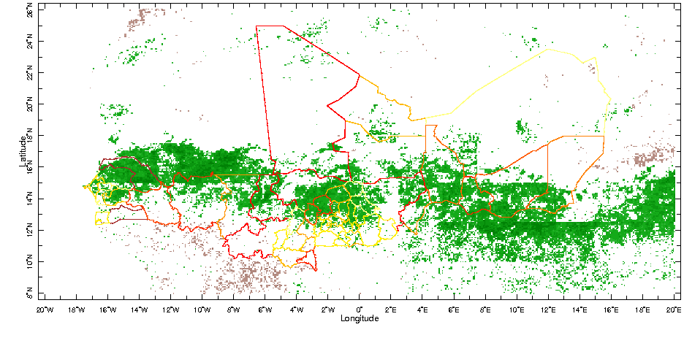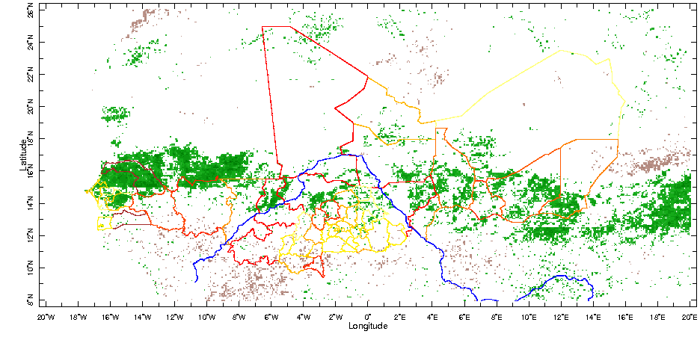
http://iridl.ldeo.columbia.edu/expert/SOURCES/.UMD/.GLCF/.GIMMS/.NDVIg/.global/.ndvi/T/%28Jan%201982%29%28Dec%202003%29RANGE/T/1/monthlyAverage/T/12/boxAverage/T/12/STEP/X/-20/20/RANGE/Y/8/26/RANGE/SOURCES/.NASA/.GPCP/.V2/.satellite-gauge/.prcp/T/%28Jan%201982%29%28Dec%202003%29RANGE/T/12/boxAverage/T/12/STEP/X/-20/20/RANGE/Y/8/26/RANGE%5BX/Y%5DregridAverage%5BT%5Dcorrelate/-0.444/0.444/maskrange/prcp_anomaly/home/.jdcorral/.Ale/.region_proj_num/.the_geom/home/.jdcorral/.Ale/.region_proj_num/.total/startcolormap/0/500/RANGEEDGES/null/white/yellow/0/value/orange/100/VALUE/OrangeRed/200/VALUE/red/300/VALUE/DarkRed/400/VALUE/brown/endcolormap/DATA/0/20/RANGE/X/Y/fig:/colors/||/strokeby/grey/thinnish/:fig//correlation/-1/1/plotrange/

http://iridl.ldeo.columbia.edu/expert/SOURCES/.UMD/.GLCF/.GIMMS/.NDVIg/.global/.ndvi/T/(Jan 1982)(Dec 2003)RANGE/T/1/monthlyAverage/T/12/boxAverage/T/12/STEP/X/-20/20/RANGE/Y/8/26/RANGE[T]detrend-bfl/SOURCES/.NASA/.GPCP/.V2/.satellite-gauge/.prcp/T/(Jan 1982)(Dec 2003)RANGE/T/12/boxAverage/T/12/STEP/X/-20/20/RANGE/Y/8/26/RANGE[T]detrend-bfl[X/Y]regridAverage[T]correlate/-0.444/0.444/maskrange/prcp_anomaly/home/.jdcorral/.Ale/.region_proj_num/.the_geom/home/.jdcorral/.Ale/.region_proj_num/.total/startcolormap/0/500/RANGEEDGES/null/white/yellow/0/value/orange/100/VALUE/OrangeRed/200/VALUE/red/300/VALUE/DarkRed/400/VALUE/brown/endcolormap/DATA/0/20/RANGE/X/Y/fig:/colors/||/strokeby/grey/thinnish/blue/rivers/:fig//correlation/-1/1/plotrange/
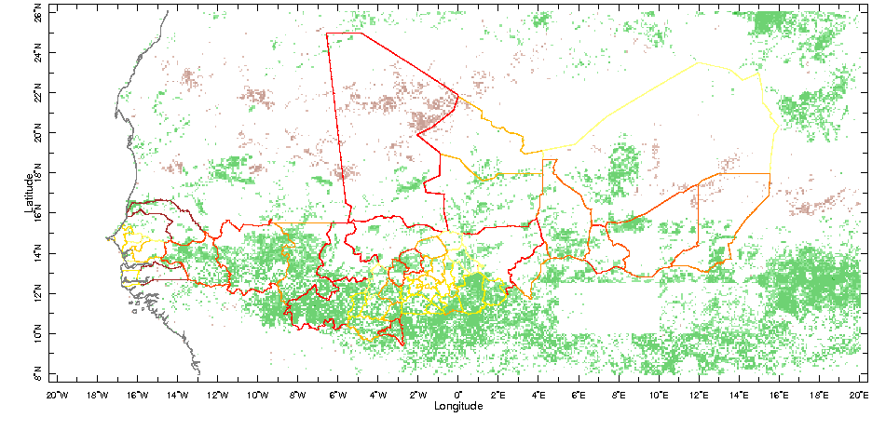
http://iridl.ldeo.columbia.edu/expert/home/.alesall/.tmp/.residual_ndvig-prcp_anom_8km_annual.cdf/.adif/X/-20/20/RANGE/Y/8/26/RANGE/dup%5BT%5Ddetrend-bfl/sub/dup/T/last/VALUE/exch/T/first/VALUE/sub/22/div/home/.alesall/.tmp/.residual_ndvig-prcp_anom_8km_annual.cdf/.adif/X/-20/20/RANGE/Y/8/26/RANGE/dup%5BT%5Drmsaover/exch/T/first/last/sub/12/div/dup/mul/12/div/sqrt/nip/nip/div/21/sqrt/div/div/-2.1/2.1/maskrange/prcp_anomaly/home/.jdcorral/.Ale/.region_proj_num/.the_geom/home/.jdcorral/.Ale/.region_proj_num/.total/startcolormap/0/500/RANGEEDGES/null/white/yellow/0/value/orange/100/VALUE/OrangeRed/200/VALUE/red/300/VALUE/DarkRed/400/VALUE/brown/endcolormap/DATA/0/20/RANGE/X/Y/fig:/colors/||/strokeby/grey/thinnish/coasts_gaz/:fig//adif/-10/10/plotrange/

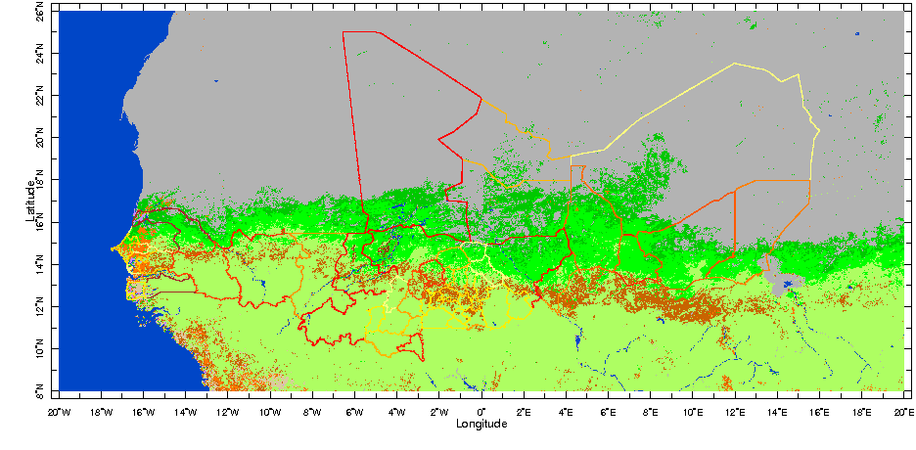
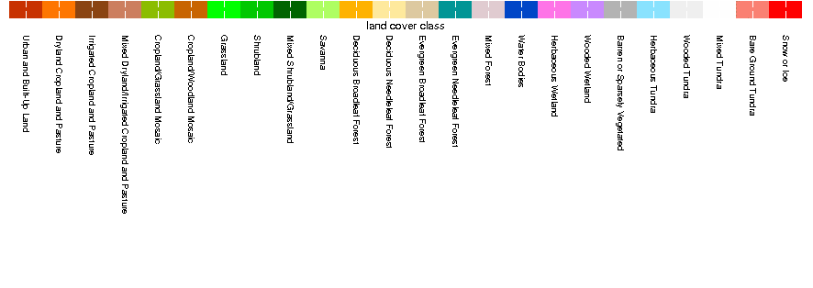
http://iridl.ldeo.columbia.edu/expert/SOURCES/.USGS/.EROS/.LandCover/.GLCCDB/.V2p0/.class/X/-20/20/RANGE/Y/8/26/RANGE/home/.jdcorral/.Ale/.region_proj_num/.the_geom/home/.jdcorral/.Ale/.region_proj_num/.total/startcolormap/0/500/RANGEEDGES/null/white/yellow/0/value/orange/100/VALUE/OrangeRed/200/VALUE/red/300/VALUE/DarkRed/400/VALUE/brown/endcolormap/DATA/0/20/RANGE/X/Y/fig:/colors/||/strokeby/grey/thinnish/:fig/

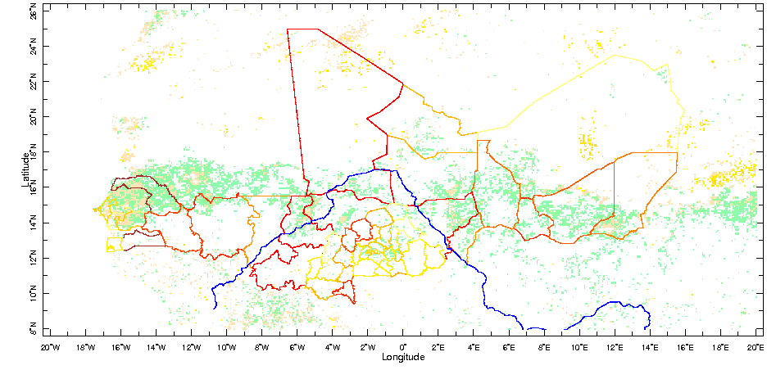
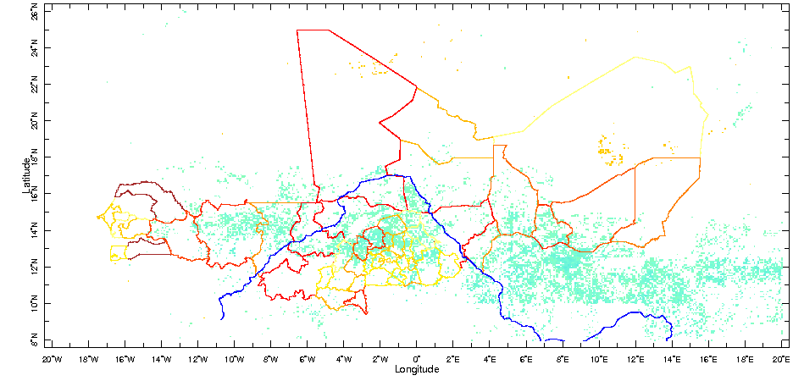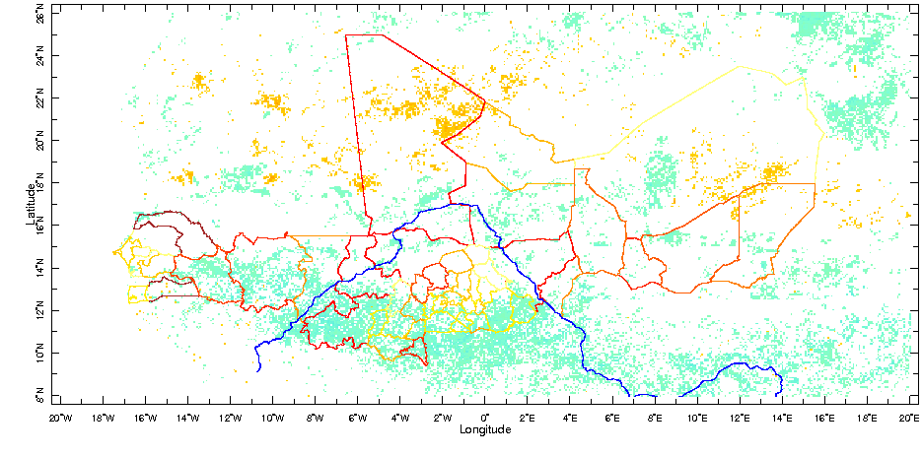
http://iridl.ldeo.columbia.edu/expert/home/.alesall/.tmp/.trend_ndvig_8km_annual.cdf/.adif/home/.alesall/.tmp/.rms_trend_ndvig_8km_annual.cdf/.ndvi/div/-2.1/2.1/masknotrange/home/.alesall/.tmp/.corr-prcp-ndvi_annual_8km.cdf/.correlation/-0.4/0.4/maskrange/0/mul/1/add/mul/-1/mul/X/-20/20/RANGE/Y/8/26/RANGE/correlationcolorscale/home/.jdcorral/.Ale/.region_proj_num/.the_geom/home/.jdcorral/.Ale/.region_proj_num/.total/startcolormap/0/500/RANGEEDGES/null/white/yellow/0/value/orange/100/VALUE/OrangeRed/200/VALUE/red/300/VALUE/DarkRed/400/VALUE/brown/endcolormap/DATA/0/20/RANGE/X/Y/fig:/colors/||/strokeby/grey/thinnish/blue/rivers/:fig//aprod/-10/10/plotrange/

http://iridl.ldeo.columbia.edu/expert/home/.alesall/.tmp/.trend_ndvig_8km_annual.cdf/.adif/home/.alesall/.tmp/.rms_trend_ndvig_8km_annual.cdf/.ndvi/div/-2.1/2.1/maskrange/home/.alesall/.tmp/.corr-prcp-ndvi_annual_8km.cdf/.correlation/-0.4/0.4/maskrange/0/mul/1/add/mul/home/.alesall/.tmp/.corr-prcp-ndvi_detrend-annual_8km.cdf/.correlation/-0.4/0.4/masknotrange/0/mul/1/add/mul/-1/mul/X/-20/20/RANGE/Y/8/26/RANGE/correlationcolorscale/home/.jdcorral/.Ale/.region_proj_num/.the_geom/home/.jdcorral/.Ale/.region_proj_num/.total/startcolormap/0/500/RANGEEDGES/null/white/yellow/0/value/orange/100/VALUE/OrangeRed/200/VALUE/red/300/VALUE/DarkRed/400/VALUE/brown/endcolormap/DATA/0/20/RANGE/X/Y/fig:/colors/||/strokeby/grey/thinnish/blue/rivers/:fig//aprod/-10/10/plotrange/

http://iridl.ldeo.columbia.edu/expert/home/.alesall/.tmp/.trend_ndvig_8km_annual.cdf/.adif/home/.alesall/.tmp/.rms_trend_ndvig_8km_annual.cdf/.ndvi/div/-2.1/2.1/maskrange/home/.alesall/.tmp/.corr-prcp-ndvi_annual_8km.cdf/.correlation/-0.4/0.4/masknotrange/0/mul/1/add/mul/-1/mul/X/-20/20/RANGE/Y/8/26/RANGE/correlationcolorscale/home/.jdcorral/.Ale/.region_proj_num/.the_geom/home/.jdcorral/.Ale/.region_proj_num/.total/startcolormap/0/500/RANGEEDGES/null/white/yellow/0/value/orange/100/VALUE/OrangeRed/200/VALUE/red/300/VALUE/DarkRed/400/VALUE/brown/endcolormap/DATA/0/20/RANGE/X/Y/fig:/colors/||/strokeby/grey/thinnish/blue/rivers/:fig//aprod/-10/10/plotrange/

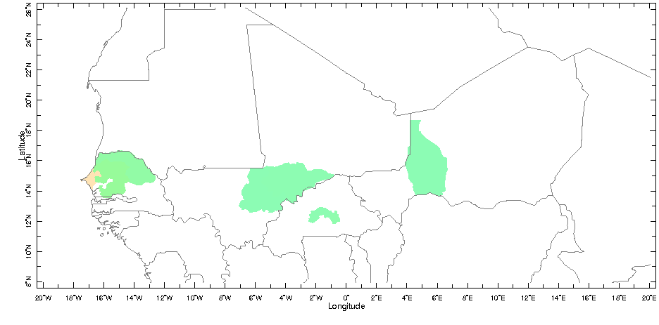
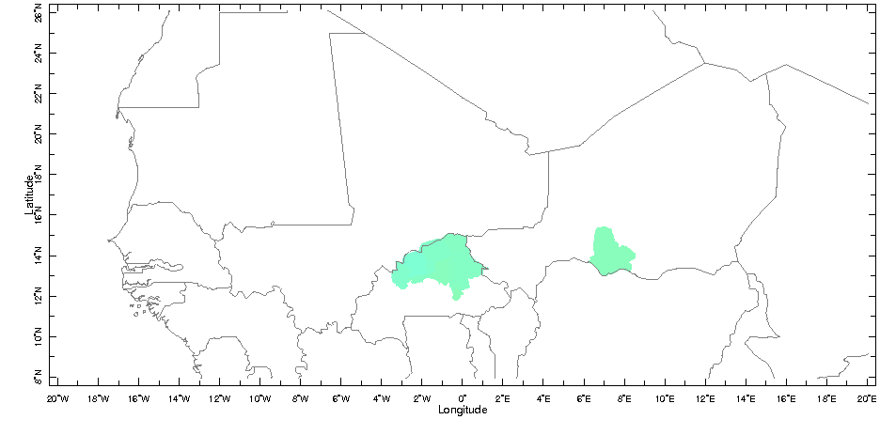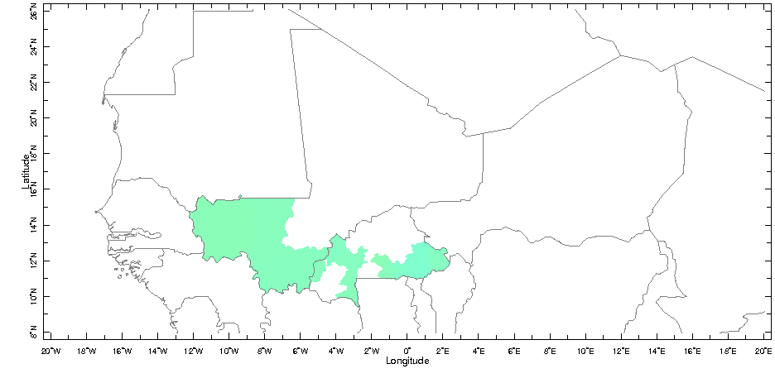
http://iridl.ldeo.columbia.edu/expert/home/.alesall/.tmp/.trend_ndvig_8km_annual.cdf/.adif/X/-20/20/RANGE/Y/8/26/RANGE/home/.jdcorral/.Ale/.region_proj_num/.the_geom/home/.alesall/.tmp/.region_tval_trend_ndvig_8km_annual_popd1990gt500.cdf/.aprod/feature/%28featureid%29renameGRID/-2.1/2.1/masknotrange/home/.alesall/.tmp/.region_corr_ndvig_8km-prcp_gpcp_annual_popd1990gt500.cdf/.aprod/feature/%28featureid%29renameGRID/-0.4/0.4/maskrange/0/mul/1/add/mul/-1/mul/correlationcolorscale/X/Y/fig:/white/mask/fillby/grey/solid/countries_gaz/:fig//aprod/-10/10/plotrange/

http://iridl.ldeo.columbia.edu/expert/home/.alesall/.tmp/.trend_ndvig_8km_annual.cdf/.adif/X/-20/20/RANGE/Y/8/26/RANGE/home/.jdcorral/.Ale/.region_proj_num/.the_geom/home/.alesall/.tmp/.region_tval_trend_ndvig_8km_annual_popd1990gt500.cdf/.aprod/feature/%28featureid%29renameGRID/-2.1/2.1/maskrange/home/.alesall/.tmp/.region_corr_ndvig_8km-prcp_gpcp_annual_popd1990gt500.cdf/.aprod/feature/%28featureid%29renameGRID/-0.4/0.4/maskrange/0/mul/1/add/mul/home/.alesall/.tmp/.region_corr-prcp-ndvi_detrend-annual_8km_popd1990gt500.cdf/.aprod/feature/%28featureid%29renameGRID/-0.4/0.4/masknotrange/0/mul/1/add/mul/-1/mul/correlationcolorscale/X/Y/fig:/white/mask/fillby/grey/solid/countries_gaz/:fig//aprod/-10/10/plotrange/

http://iridl.ldeo.columbia.edu/expert/home/.alesall/.tmp/.trend_ndvig_8km_annual.cdf/.adif/X/-20/20/RANGE/Y/8/26/RANGE/home/.jdcorral/.Ale/.region_proj_num/.the_geom/home/.alesall/.tmp/.region_tval_trend_ndvig_8km_annual_popd1990gt500.cdf/.aprod/feature/%28featureid%29renameGRID/-2.1/2.1/maskrange/home/.alesall/.tmp/.region_corr_ndvig_8km-prcp_gpcp_annual_popd1990gt500.cdf/.aprod/feature/%28featureid%29renameGRID/-0.4/0.4/masknotrange/0/mul/1/add/mul/-1/mul/correlationcolorscale/X/Y/fig:/white/mask/fillby/grey/solid/countries_gaz/:fig//aprod/-10/10/plotrange/

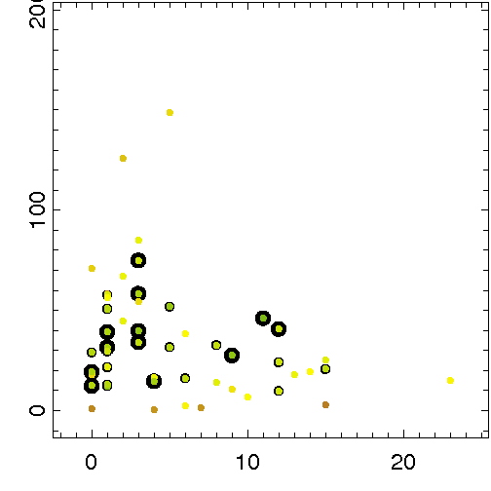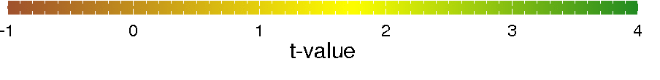
http://iridl.ldeo.columbia.edu/expert/home/.jdcorral/.Ale/.region_proj_num/.total/DATA/-2/25/RANGE/home/.alesall/.tmp/.region_popd1990gt500_featureid2.cdf/.density/feature/%28featureid%29renameGRID/DATA/-10/200/RANGE/home/.alesall/.tmp/.region_cluster2_YEStrend_YEScorr_NOdetrendcorr.cdf/.flag/2/div/3/mul/home/.alesall/.tmp/.region_cluster1_NOtrend_YEScorr.cdf/.flag/add/home/.alesall/.tmp/.region_cluster3_YEStrend_NOcorr.cdf/.flag/3/div/2/mul/add/feature/%28featureid%29renameGRID/home/.jdcorral/.Ale/.region_proj_num/.total/DATA/-2/25/RANGE/home/.alesall/.tmp/.region_popd1990gt500_featureid2.cdf/.density/feature/%28featureid%29renameGRID/DATA/-10/200/RANGE/home/.alesall/.tmp/.region_tval_trend_ndvig_8km_annual_popd1990gt500.cdf/.aprod//long_name/%28NDVI%20t-value%29def/feature/%28featureid%29renameGRID/fig://XOVY/1/def//fntsze/30/def/scattersized/scattercolor/:fig//flag/1/3/plotrange//aprod/-1/4/plotrange/

SUPPLEMENTAL FIGURES –

VARIANCE IN NDVI:
- Annual maximum
- Jul-Oct average
- May-Oct average
- Jan-Dec average
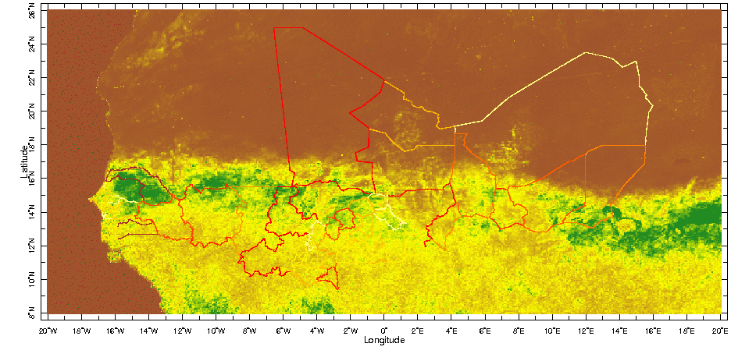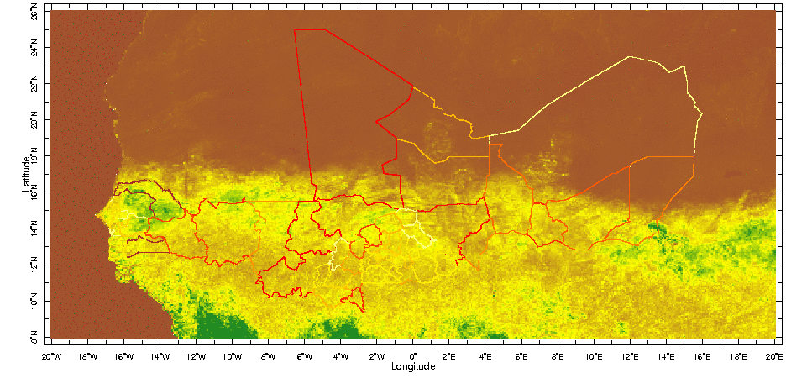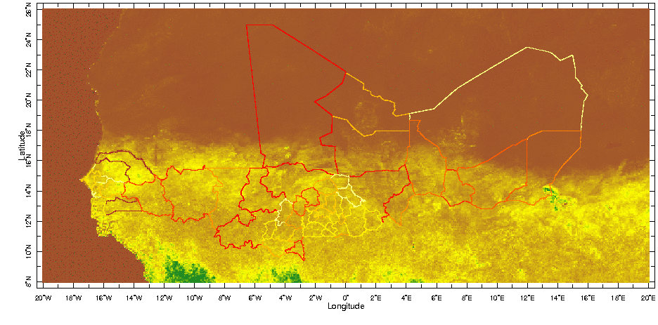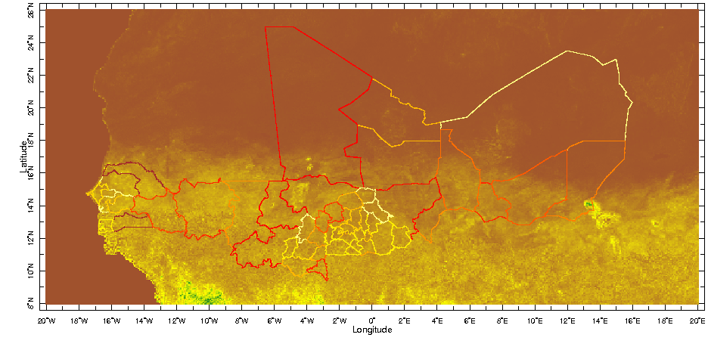
VARIANCE IN NDVI:
- Annual maximum
- Jul-Oct average
- May-Oct average
- Annual mean

http://iridl.ldeo.columbia.edu/expert/SOURCES/.UMD/.GLCF/.GIMMS/.NDVIg/.global/.ndvi/T/(Jan 1982)(Dec 2003)RANGE/T/1/monthlyAverage/X/-20/20/RANGE/Y/8/26/RANGE/T/(Jan 1982)(Dec 2003)RANGE/T/12/splitstreamgrid[T]maxover/T2//T/renameGRID[T]rmsaover/home/.jdcorral/.Ale/.region_proj_num/.the_geom/home/.jdcorral/.Ale/.region_proj_num/.total/startcolormap/0/500/RANGEEDGES/null/white/yellow/0/value/orange/100/VALUE/OrangeRed/200/VALUE/red/300/VALUE/DarkRed/400/VALUE/brown/endcolormap/DATA/0/20/RANGE/X/Y/fig:/colors/||/strokeby/grey/thinnish/:fig//max/0/0.1/plotrange/

http://iridl.ldeo.columbia.edu/expert/SOURCES/.UMD/.GLCF/.GIMMS/.NDVIg/.global/.ndvi/T/%28Jan%201982%29%28Dec%202003%29RANGE/T/1/monthlyAverage/T/%28Jul%201982%29%28Oct%202003%29RANGE/T/4/boxAverage/T/12/STEP/X/-20/20/RANGE/Y/8/26/RANGE%5BT%5Drmsaover/prcp_anomaly/home/.jdcorral/.Ale/.region_proj_num/.the_geom/home/.jdcorral/.Ale/.region_proj_num/.total/startcolormap/0/500/RANGEEDGES/null/white/yellow/0/value/orange/100/VALUE/OrangeRed/200/VALUE/red/300/VALUE/DarkRed/400/VALUE/brown/endcolormap/DATA/0/20/RANGE/X/Y/fig:/colors/||/strokeby/grey/thinnish/:fig//ndvi/0/0.1/plotrange/

http://iridl.ldeo.columbia.edu/expert/SOURCES/.UMD/.GLCF/.GIMMS/.NDVIg/.global/.ndvi/T/%28Jan%201982%29%28Dec%202003%29RANGE/T/1/monthlyAverage/T/%28May%201982%29%28Oct%202003%29RANGE/T/6/boxAverage/T/12/STEP/X/-20/20/RANGE/Y/8/26/RANGE%5BT%5Drmsaover/prcp_anomaly/home/.jdcorral/.Ale/.region_proj_num/.the_geom/home/.jdcorral/.Ale/.region_proj_num/.total/startcolormap/0/500/RANGEEDGES/null/white/yellow/0/value/orange/100/VALUE/OrangeRed/200/VALUE/red/300/VALUE/DarkRed/400/VALUE/brown/endcolormap/DATA/0/20/RANGE/X/Y/fig:/colors/||/strokeby/grey/thinnish/:fig//ndvi/0/0.1/plotrange/

http://iridl.ldeo.columbia.edu/expert/SOURCES/.UMD/.GLCF/.GIMMS/.NDVIg/.global/.ndvi/T/%28Jan%201982%29%28Dec%202003%29RANGE/T/1/monthlyAverage/T/12/boxAverage/T/12/STEP/X/-20/20/RANGE/Y/8/26/RANGE%5BT%5Drmsaover/prcp_anomaly/home/.jdcorral/.Ale/.region_proj_num/.the_geom/home/.jdcorral/.Ale/.region_proj_num/.total/startcolormap/0/500/RANGEEDGES/null/white/yellow/0/value/orange/100/VALUE/OrangeRed/200/VALUE/red/300/VALUE/DarkRed/400/VALUE/brown/endcolormap/DATA/0/20/RANGE/X/Y/fig:/colors/||/strokeby/grey/thinnish/:fig//ndvi/0/0.1/plotrange/

NDVI TRENDS GIVEN DIFFERENT TEMPORAL AVERAGES:
1) maximum annual NDVI
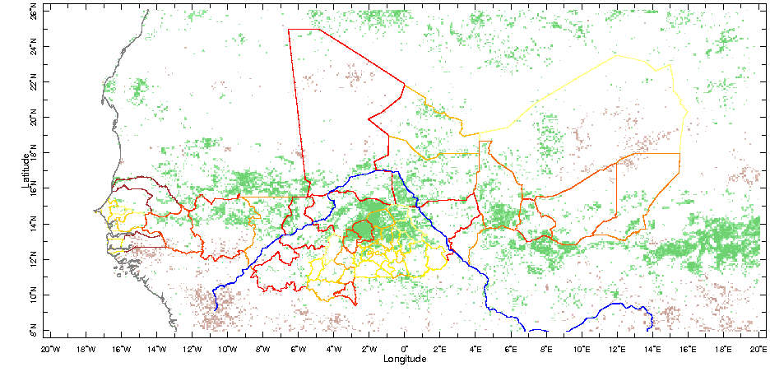
1) trend in maximum annual NDVI
http://iridl.ldeo.columbia.edu/expert/SOURCES/.UMD/.GLCF/.GIMMS/.NDVIg/.global/.ndvi/X/-20/20/RANGE/Y/8/26/RANGE/T/(Jan 1982)(Dec 2003)RANGE/T/1/monthlyAverage/T/(Jan 1982)(Dec 2003)RANGE/T/12/splitstreamgrid[T]maxover/T2//T/renameGRID/dup[T]detrend-bfl/sub/dup/T/last/VALUE/exch/T/first/VALUE/sub/22/div/SOURCES/.UMD/.GLCF/.GIMMS/.NDVIg/.global/.ndvi/X/-20/20/RANGE/Y/8/26/RANGE/T/(Jan 1982)(Dec 2003)RANGE/T/1/monthlyAverage/T/(Jan 1982)(Dec 2003)RANGE/T/12/splitstreamgrid[T]maxover/T2//T/renameGRID/dup[T]rmsaover/exch/T/first/last/sub/12/div/dup/mul/12/div/sqrt/nip/nip/div/21/sqrt/div/div/-2.1/2.1/maskrange/prcp_anomaly/home/.jdcorral/.Ale/.region_proj_num/.the_geom/home/.jdcorral/.Ale/.region_proj_num/.total/startcolormap/0/500/RANGEEDGES/null/white/yellow/0/value/orange/100/VALUE/OrangeRed/200/VALUE/red/300/VALUE/DarkRed/400/VALUE/brown/endcolormap/DATA/0/20/RANGE/X/Y/fig:/colors/||/strokeby/grey/thinnish/coasts_gaz/blue/rivers/:fig//ratio/-10/10/plotrange/figviewer.html?my.help=more+options&map.Y.units=degree_north&map.Y.plotlast=26.09565N&map.here.x=0&map.here.y=0&map.u

DE-TRENDED CORRELATIONS AT DIFFERENT TIME SCALES

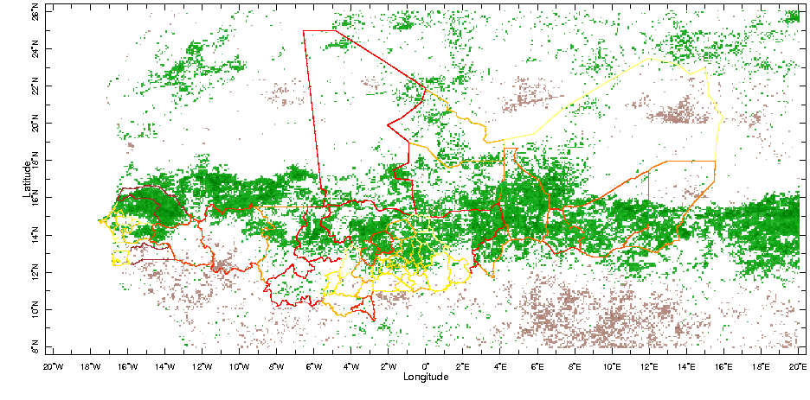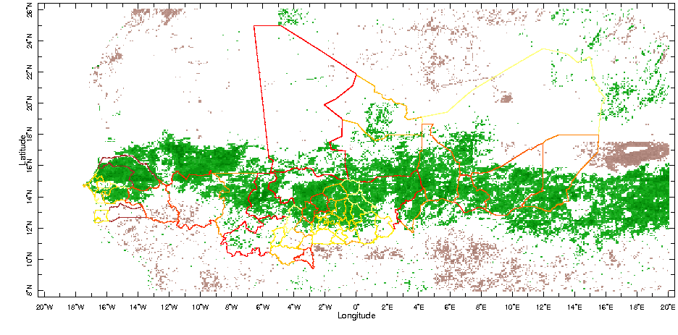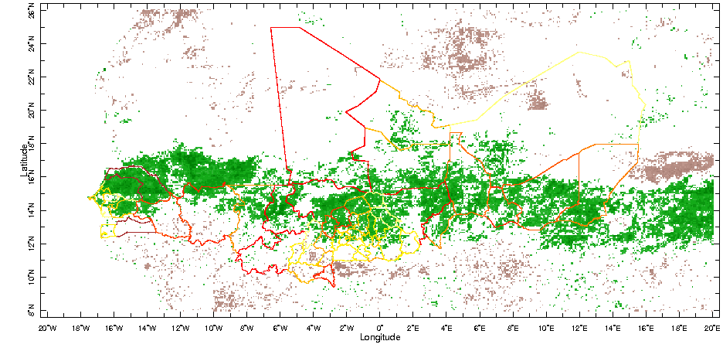
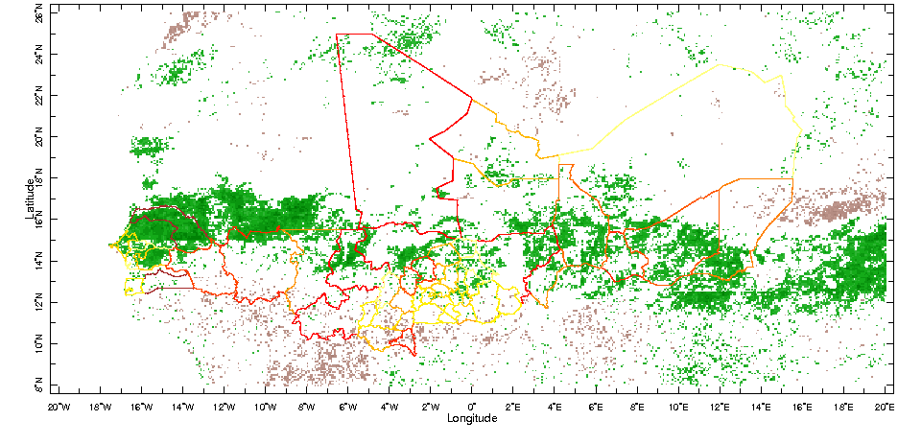
CORRELATIONS BETWEEN DETRENDED NDVI AND PRECIPITATION:
- Maximum NDVI and May-Oct precipitation
- Jul-Oct average of NDVI and May-Oct precipitation
- May-Oct average
- Jan-Dec average

http://iridl.ldeo.columbia.edu/expert/SOURCES/.UMD/.GLCF/.GIMMS/.NDVIg/.global/.ndvi/T/%28Jan%201982%29%28Dec%202003%29RANGE/T/1/monthlyAverage/T/%28Jan%201982%29%28Dec%202003%29RANGE/X/-20/20/RANGE/Y/8/26/RANGE/T/12/splitstreamgrid%5BT%5Dmaxover/T2//T/renameGRID%5BT%5Ddetrend-bfl/SOURCES/.NASA/.GPCP/.V2/.satellite-gauge/.prcp/T/%28May%201982%29%28Oct%202003%29RANGE/T/6/boxAverage/T/12/STEP/T/1/shiftGRID/X/-20/20/RANGE/Y/8/26/RANGE%5BT%5Ddetrend-bfl/T/-2/shiftGRID%5BX/Y%5DregridAverage%5BT%5Dcorrelate/-0.4/0.4/maskrange/prcp_anomaly/home/.jdcorral/.Ale/.region_proj_num/.the_geom/home/.jdcorral/.Ale/.region_proj_num/.total/startcolormap/0/500/RANGEEDGES/null/white/yellow/0/value/orange/100/VALUE/OrangeRed/200/VALUE/red/300/VALUE/DarkRed/400/VALUE/brown/endcolormap/DATA/0/20/RANGE/X/Y/fig:/colors/||/strokeby/grey/thinnish/:fig//correlation/-1/1/plotrange/

http://iridl.ldeo.columbia.edu/expert/SOURCES/.UMD/.GLCF/.GIMMS/.NDVIg/.global/.ndvi/T/%28Jan%201982%29%28Dec%202003%29RANGE/T/1/monthlyAverage/T/%28Jul%201982%29%28Oct%202003%29RANGE/T/4/boxAverage/T/12/STEP/X/-20/20/RANGE/Y/8/26/RANGE%5BT%5Ddetrend-bfl/SOURCES/.NASA/.GPCP/.V2/.satellite-gauge/.prcp/T/%28May%201982%29%28Oct%202003%29RANGE/T/6/boxAverage/T/12/STEP/T/1/shiftGRID/X/-20/20/RANGE/Y/8/26/RANGE%5BT%5Ddetrend-bfl%5BX/Y%5DregridAverage%5BT%5Dcorrelate/-0.4/0.4/maskrange/prcp_anomaly/home/.jdcorral/.Ale/.region_proj_num/.the_geom/home/.jdcorral/.Ale/.region_proj_num/.total/startcolormap/0/500/RANGEEDGES/null/white/yellow/0/value/orange/100/VALUE/OrangeRed/200/VALUE/red/300/VALUE/DarkRed/400/VALUE/brown/endcolormap/DATA/0/20/RANGE/X/Y/fig:/colors/||/strokeby/grey/thinnish/:fig//correlation/-1/1/plotrange/

http://iridl.ldeo.columbia.edu/expert/SOURCES/.UMD/.GLCF/.GIMMS/.NDVIg/.global/.ndvi/T/%28Jan%201982%29%28Dec%202003%29RANGE/T/1/monthlyAverage/T/%28May%201982%29%28Oct%202003%29RANGE/T/6/boxAverage/T/12/STEP/X/-20/20/RANGE/Y/8/26/RANGE%5BT%5Ddetrend-bfl/SOURCES/.NASA/.GPCP/.V2/.satellite-gauge/.prcp/T/%28May%201982%29%28Oct%202003%29RANGE/T/6/boxAverage/T/12/STEP/X/-20/20/RANGE/Y/8/26/RANGE%5BT%5Ddetrend-bfl%5BX/Y%5DregridAverage%5BT%5Dcorrelate/-0.4/0.4/maskrange/prcp_anomaly/home/.jdcorral/.Ale/.region_proj_num/.the_geom/home/.jdcorral/.Ale/.region_proj_num/.total/startcolormap/0/500/RANGEEDGES/null/white/yellow/0/value/orange/100/VALUE/OrangeRed/200/VALUE/red/300/VALUE/DarkRed/400/VALUE/brown/endcolormap/DATA/0/20/RANGE/X/Y/fig:/colors/||/strokeby/grey/thinnish/:fig//correlation/-1/1/plotrange/

http://iridl.ldeo.columbia.edu/expert/SOURCES/.UMD/.GLCF/.GIMMS/.NDVIg/.global/.ndvi/T/%28Jan%201982%29%28Dec%202003%29RANGE/T/1/monthlyAverage/T/12/boxAverage/T/12/STEP/X/-20/20/RANGE/Y/8/26/RANGE%5BT%5Ddetrend-bfl/SOURCES/.NASA/.GPCP/.V2/.satellite-gauge/.prcp/T/%28Jan%201982%29%28Dec%202003%29RANGE/T/12/boxAverage/T/12/STEP/X/-20/20/RANGE/Y/8/26/RANGE%5BT%5Ddetrend-bfl%5BX/Y%5DregridAverage%5BT%5Dcorrelate/-0.4/0.4/maskrange/prcp_anomaly/home/.jdcorral/.Ale/.region_proj_num/.the_geom/home/.jdcorral/.Ale/.region_proj_num/.total/startcolormap/0/500/RANGEEDGES/null/white/yellow/0/value/orange/100/VALUE/OrangeRed/200/VALUE/red/300/VALUE/DarkRed/400/VALUE/brown/endcolormap/DATA/0/20/RANGE/X/Y/fig:/colors/||/strokeby/grey/thinnish/:fig//correlation/-1/1/plotrange/

FULL CORRELATIONS:
MAXIMUM NDVI AND MAY-OCT PRECIPITATION
JUL-OCT NDVI AND MAY-OCT PRCP
MAY-OCT NDVI AND PRCP
ANNUAL NDVI AND PRCP
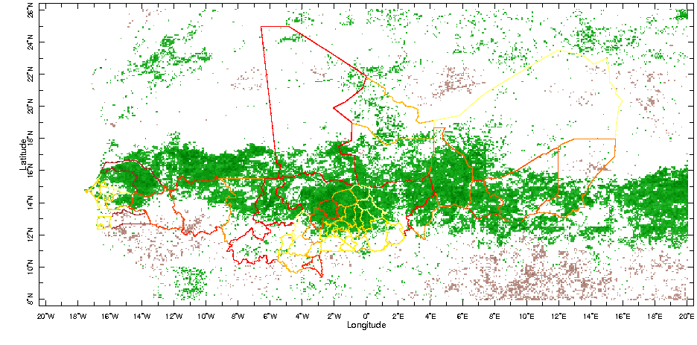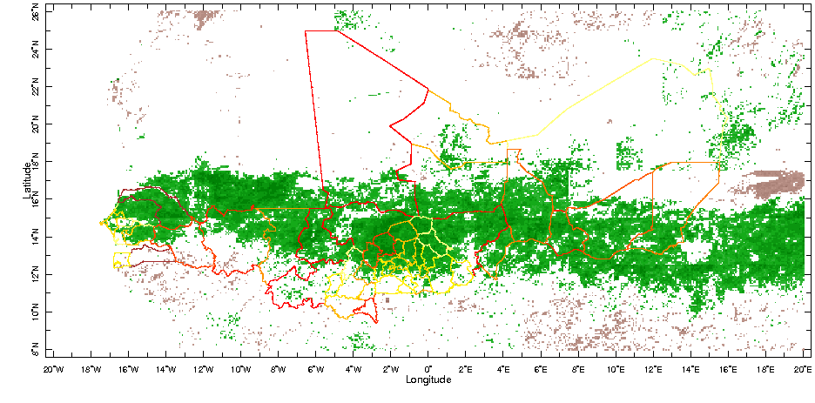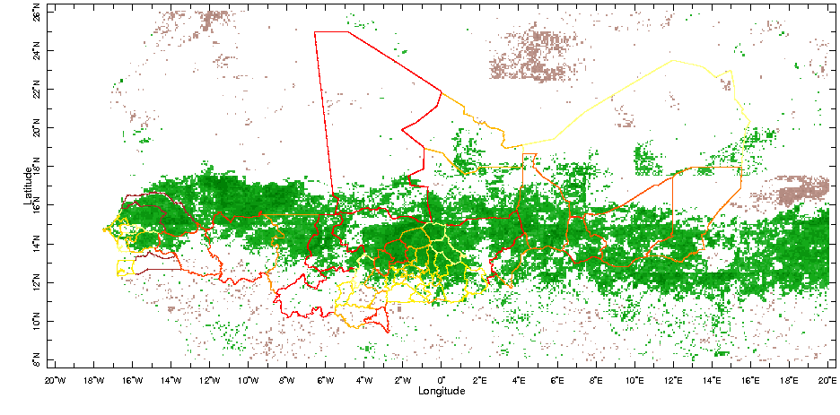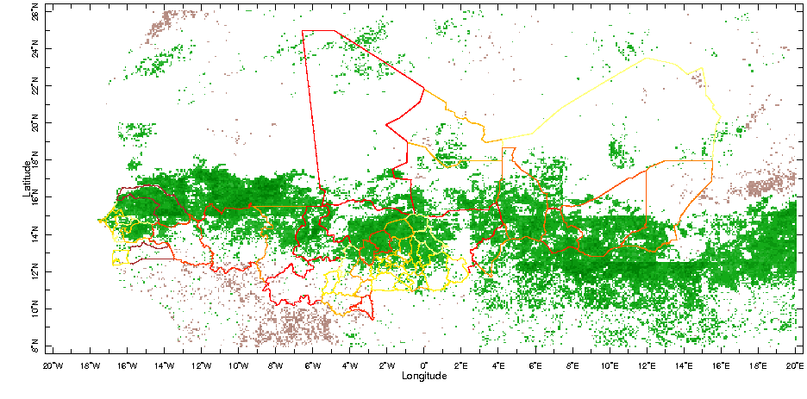
CORRELATIONS BETWEEN NDVI AND PRECIPITATION (no detrending):
- Maximum NDVI and May-Oct precipitation
- Jul-Oct average of NDVI and May-Oct average of precipitation
- May-Oct average
- Jan-Dec average

http://iridl.ldeo.columbia.edu/expert/SOURCES/.UMD/.GLCF/.GIMMS/.NDVIg/.global/.ndvi/T/%28Jan%201982%29%28Dec%202003%29RANGE/T/1/monthlyAverage/T/%28Jan%201982%29%28Dec%202003%29RANGE/X/-20/20/RANGE/Y/8/26/RANGE/T/12/splitstreamgrid%5BT%5Dmaxover/T2//T/renameGRID/SOURCES/.NASA/.GPCP/.V2/.satellite-gauge/.prcp/T/%28May%201982%29%28Oct%202003%29RANGE/T/6/boxAverage/T/12/STEP/T/1/shiftGRID/X/-20/20/RANGE/Y/8/26/RANGE/T/-2/shiftGRID%5BX/Y%5DregridAverage%5BT%5Dcorrelate/-0.4/0.4/maskrange/prcp_anomaly/home/.jdcorral/.Ale/.region_proj_num/.the_geom/home/.jdcorral/.Ale/.region_proj_num/.total/startcolormap/0/500/RANGEEDGES/null/white/yellow/0/value/orange/100/VALUE/OrangeRed/200/VALUE/red/300/VALUE/DarkRed/400/VALUE/brown/endcolormap/DATA/0/20/RANGE/X/Y/fig:/colors/||/strokeby/grey/thinnish/:fig//correlation/-1/1/plotrange/

http://iridl.ldeo.columbia.edu/expert/SOURCES/.UMD/.GLCF/.GIMMS/.NDVIg/.global/.ndvi/T/%28Jan%201982%29%28Dec%202003%29RANGE/T/1/monthlyAverage/T/%28Jul%201982%29%28Oct%202003%29RANGE/T/4/boxAverage/T/12/STEP/X/-20/20/RANGE/Y/8/26/RANGE/SOURCES/.NASA/.GPCP/.V2/.satellite-gauge/.prcp/T/%28May%201982%29%28Oct%202003%29RANGE/T/6/boxAverage/T/12/STEP/T/1/shiftGRID/X/-20/20/RANGE/Y/8/26/RANGE%5BX/Y%5DregridAverage%5BT%5Dcorrelate/-0.4/0.4/maskrange/prcp_anomaly/home/.jdcorral/.Ale/.region_proj_num/.the_geom/home/.jdcorral/.Ale/.region_proj_num/.total/startcolormap/0/500/RANGEEDGES/null/white/yellow/0/value/orange/100/VALUE/OrangeRed/200/VALUE/red/300/VALUE/DarkRed/400/VALUE/brown/endcolormap/DATA/0/20/RANGE/X/Y/fig:/colors/||/strokeby/grey/thinnish/:fig//correlation/-1/1/plotrange/

http://iridl.ldeo.columbia.edu/expert/SOURCES/.UMD/.GLCF/.GIMMS/.NDVIg/.global/.ndvi/T/%28Jan%201982%29%28Dec%202003%29RANGE/T/1/monthlyAverage/T/%28May%201982%29%28Oct%202003%29RANGE/T/6/boxAverage/T/12/STEP/X/-20/20/RANGE/Y/8/26/RANGE/SOURCES/.NASA/.GPCP/.V2/.satellite-gauge/.prcp/T/%28May%201982%29%28Oct%202003%29RANGE/T/6/boxAverage/T/12/STEP/X/-20/20/RANGE/Y/8/26/RANGE%5BX/Y%5DregridAverage%5BT%5Dcorrelate/-0.4/0.4/maskrange/prcp_anomaly/home/.jdcorral/.Ale/.region_proj_num/.the_geom/home/.jdcorral/.Ale/.region_proj_num/.total/startcolormap/0/500/RANGEEDGES/null/white/yellow/0/value/orange/100/VALUE/OrangeRed/200/VALUE/red/300/VALUE/DarkRed/400/VALUE/brown/endcolormap/DATA/0/20/RANGE/X/Y/fig:/colors/||/strokeby/grey/thinnish/:fig//correlation/-1/1/plotrange/

http://iridl.ldeo.columbia.edu/expert/SOURCES/.UMD/.GLCF/.GIMMS/.NDVIg/.global/.ndvi/T/%28Jan%201982%29%28Dec%202003%29RANGE/T/1/monthlyAverage/T/12/boxAverage/T/12/STEP/X/-20/20/RANGE/Y/8/26/RANGE/SOURCES/.NASA/.GPCP/.V2/.satellite-gauge/.prcp/T/%28Jan%201982%29%28Dec%202003%29RANGE/T/12/boxAverage/T/12/STEP/X/-20/20/RANGE/Y/8/26/RANGE%5BX/Y%5DregridAverage%5BT%5Dcorrelate/-0.4/0.4/maskrange/prcp_anomaly/home/.jdcorral/.Ale/.region_proj_num/.the_geom/home/.jdcorral/.Ale/.region_proj_num/.total/startcolormap/0/500/RANGEEDGES/null/white/yellow/0/value/orange/100/VALUE/OrangeRed/200/VALUE/red/300/VALUE/DarkRed/400/VALUE/brown/endcolormap/DATA/0/20/RANGE/X/Y/fig:/colors/||/strokeby/grey/thinnish/:fig//correlation/-1/1/plotrange/
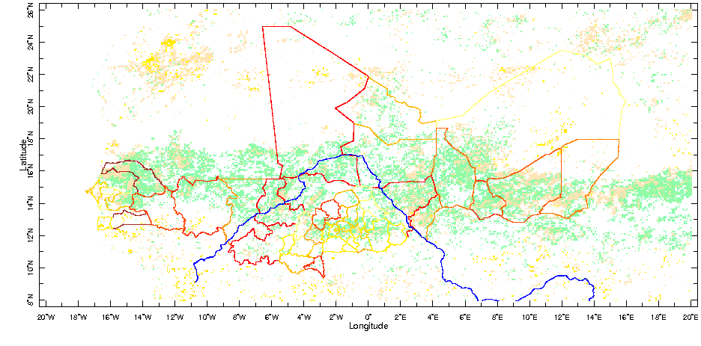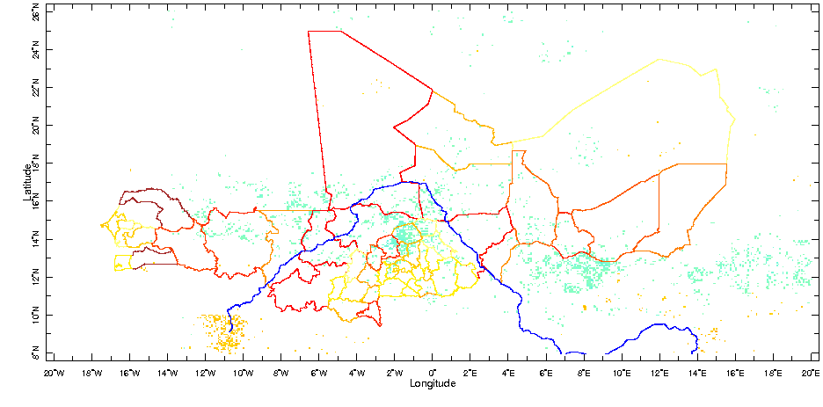
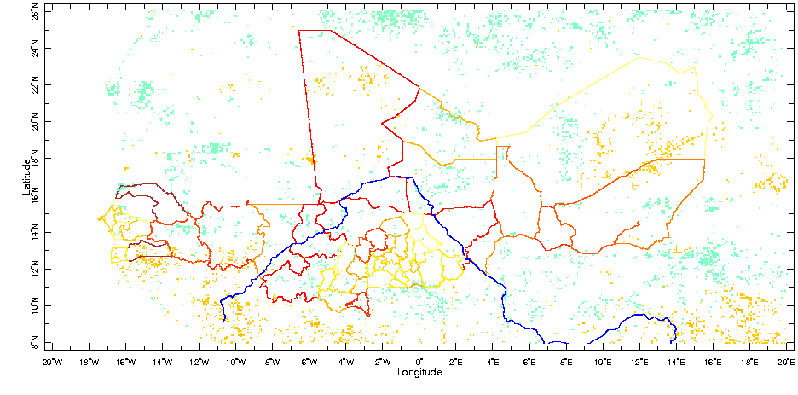
same as figure 6, but using maximum NDVI value and July-September precipitation

http://iridl.ldeo.columbia.edu/expert/home/.alesall/.tmp/.trend_maxndvig_8km.cdf/.adif/home/.alesall/.tmp/.rms_trend_maxndvig_8km.cdf/.Max/div/-2.1/2.1/masknotrange/home/.alesall/.tmp/.corr_maxndvig_8km-prcp_gpcp_jas.cdf/.correlation/-0.4/0.4/maskrange/0/mul/1/add/mul/-1/mul/X/-20/20/RANGE/Y/8/26/RANGE/correlationcolorscale/home/.jdcorral/.Ale/.region_proj_num/.the_geom/home/.jdcorral/.Ale/.region_proj_num/.total/startcolormap/0/500/RANGEEDGES/null/white/yellow/0/value/orange/100/VALUE/OrangeRed/200/VALUE/red/300/VALUE/DarkRed/400/VALUE/brown/endcolormap/DATA/0/20/RANGE/X/Y/fig:/colors/||/strokeby/grey/thinnish/blue/rivers/:fig//aprod/-10/10/plotrange/

http://iridl.ldeo.columbia.edu/expert/home/.alesall/.tmp/.trend_maxndvig_8km.cdf/.adif/home/.alesall/.tmp/.rms_trend_maxndvig_8km.cdf/.Max/div/-2.1/2.1/maskrange/home/.alesall/.tmp/.corr_maxndvig_8km-prcp_gpcp_jas.cdf/.correlation/-0.4/0.4/maskrange/0/mul/1/add/mul/home/.alesall/.tmp/.corr-detrend_maxndvig_8km-prcp_gpcp_jas.cdf/.correlation/-0.4/0.4/masknotrange/0/mul/1/add/mul/-1/mul/X/-20/20/RANGE/Y/8/26/RANGE/correlationcolorscale/home/.jdcorral/.Ale/.region_proj_num/.the_geom/home/.jdcorral/.Ale/.region_proj_num/.total/startcolormap/0/500/RANGEEDGES/null/white/yellow/0/value/orange/100/VALUE/OrangeRed/200/VALUE/red/300/VALUE/DarkRed/400/VALUE/brown/endcolormap/DATA/0/20/RANGE/X/Y/fig:/colors/||/strokeby/grey/thinnish/blue/rivers/:fig//aprod/-10/10/plotrange/

http://iridl.ldeo.columbia.edu/expert/home/.alesall/.tmp/.trend_maxndvig_8km.cdf/.adif/home/.alesall/.tmp/.rms_trend_maxndvig_8km.cdf/.Max/div/-2.1/2.1/maskrange/home/.alesall/.tmp/.corr_maxndvig_8km-prcp_gpcp_jas.cdf/.correlation/-0.4/0.4/masknotrange/0/mul/1/add/mul/-1/mul/X/-20/20/RANGE/Y/8/26/RANGE/correlationcolorscale/home/.jdcorral/.Ale/.region_proj_num/.the_geom/home/.jdcorral/.Ale/.region_proj_num/.total/startcolormap/0/500/RANGEEDGES/null/white/yellow/0/value/orange/100/VALUE/OrangeRed/200/VALUE/red/300/VALUE/DarkRed/400/VALUE/brown/endcolormap/DATA/0/20/RANGE/X/Y/fig:/colors/||/strokeby/grey/thinnish/blue/rivers/:fig//aprod/-10/10/plotrange/

FROM HERE ON ARE EXTRAS, FIGURES USED TO BUILD FINAL FIGURES

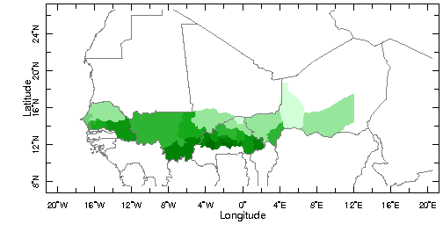
This is the rainfall mask, used to exclude provinces in Mali (133), Niger (158), Senegal (195) and Burkina Faso (233) whose annual rainfall does not fall in the 400-800 mm range – there are a total of 55 provinces in these 4 countries – 16 provinces are excluded based on rainfall climatology.

SOURCES .UEA .CRU .TS2p1 .climatology .c7100 .prcp
[T]average
X -20 20 RANGE
Y 8 26 RANGE
12 mul
400 800 masknotrange
/units (mm/yr) def
dup SOURCES .Features .Political .Africa .Provinces .the_geom
feature_id (133001) (133002) (133003) (133004) (133005) (133006) (133007) (133008) (158001) (158002) (158003) (158004) (158005) (158006) (158007) (195001) (195002) (195003) (195004) (195005) (195006) (195007) (195008) (195009) (195010) (233001) (233002) (233003) (233004) (233005) (233006) (233007) (233008) (233009) (233010) (233011) (233012) (233013) (233014) (233015) (233016) (233017) (233018) (233019) (233020) (233021) (233022) (233023) (233024) (233025) (233026) (233027) (233028) (233029) (233030) VALUES
[X Y]weighted-average
precip_colors
SOURCES .Features .Political .Africa .Provinces .the_geom exch
X Y fig: white mask fillby grey solid countries_gaz :fig
/prcp 400 800 plotrange
In the previous page I first masked rainfall to keep only gridpoints w/ climatology between 400 and 800 mm/yr, then computed the regional averages >> kept all regions w/ at least one gridpoint falling within that rainfall interval. Here, I first compute the regional average, then mask out regions whose climatology does not fall within the 400-800 mm/yr interval.

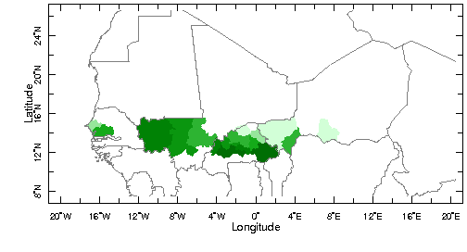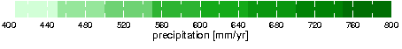
SOURCES .UEA .CRU .TS2p1 .climatology .c7100 .prcp [T]average
X -20 20 RANGE Y 8 26 RANGE 12 mul
dup SOURCES .Features .Political .Africa .Provinces .the_geom
feature_id (133001) (133002) (133003) (133004) (133005) (133006) (133007) (133008) (158001) (158002) (158003) (158004) (158005) (158006) (158007) (195001) (195002) (195003) (195004) (195005) (195006) (195007) (195008) (195009) (195010) (233001) (233002) (233003) (233004) (233005) (233006) (233007) (233008) (233009) (233010) (233011) (233012) (233013) (233014) (233015) (233016) (233017) (233018) (233019) (233020) (233021) (233022) (233023) (233024) (233025) (233026) (233027) (233028) (233029) (233030) VALUES
[X Y]weighted-average
400 800 masknotrange
/units (mm/yr) def
precip_colors
SOURCES .Features .Political .Africa .Provinces .the_geom exch
X Y fig: white mask fillby grey solid countries_gaz :fig
/prcp 400 800 plotrange
This is the total number of projects

a) Total number of projects per province

b) Same as above, but provinces with less than the median number of projects (3) are masked

This is the total number of projects

home .alesall .tmp .residual_ndvig-prcp_anom_8km.cdf .adif
X -20 20 RANGE
Y 8 26 RANGE
home .jdcorral .Ale .region_proj_num .the_geom
home .jdcorral .Ale .region_proj_num .total
SOURCES .UEA .CRU .TS2p1 .climatology .c7100 .prcp
[T]average
X -20 20 RANGE
Y 8 26 RANGE
12 mul
400 800 masknotrange
0 mul
1 add
SOURCES .Features .Political .Africa .Provinces .the_geom
[X Y]weighted-average
feature_id (featureid) renameGRID
mul
3 masklt
startcolormap 0 20 RANGE LightGrey LightGrey 0 value LemonChiffon LemonChiffon 1 value yellow 2 value orange 3 value DeepPink 4 value red 5 value firebrick 6 value DarkFirebrick endcolormap
DATA 0 20 RANGE
X Y fig: white mask fillby grey solid countries_gaz :fig
This is population density (people/sq km)

a) Population density per province (grid points greater than 500 were masked in computing province averages)

b) Same as above, but provinces with less than the median population density (32 people/sq km) are masked

This is population density (people/sq km)

SOURCES .CIESIN .GPWv3 .grid2p5arcmin .adjusted .density
X -20 20 RANGE Y 8 26 RANGE
T (1990 ) VALUES
500 maskgt T removeGRID
dup SOURCES .Features .Political .Africa .Provinces .the_geom
feature_id (133001) (133002) (133003) (133004) (133005) (133006) (133007) (133008) (158001) (158002) (158003) (158004) (158005) (158006) (158007) (195001) (195002) (195003) (195004) (195005) (195006) (195007) (195008) (195009) (195010) (233001) (233002) (233003) (233004) (233005) (233006) (233007) (233008) (233009) (233010) (233011) (233012) (233013) (233014) (233015) (233016) (233017) (233018) (233019) (233020) (233021) (233022) (233023) (233024) (233025) (233026) (233027) (233028) (233029) (233030) VALUES
[X Y]weighted-average
SOURCES .UEA .CRU .TS2p1 .climatology .c7100 .prcp [T]average
X -20 20 RANGE Y 8 26 RANGE
12 mul 400 800 masknotrange 0 mul 1 add
SOURCES .Features .Political .Africa .Provinces .the_geom
[X Y]weighted-average mul
32 masklt
SOURCES .Features .Political .Africa .Provinces .the_geom exch
X Y fig: white mask fillby grey solid countries_gaz :fig
/aprod 0 500 plotrange

This is the calculation to compute the average population density by region/province excluding gridpoints where pop dens (1990) > 150 (500)

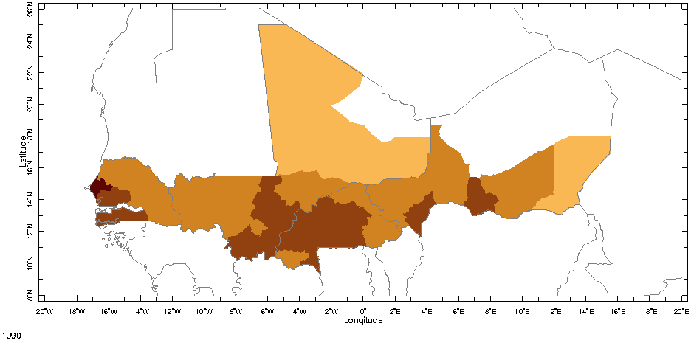

SOURCES .CIESIN .GPWv3 .grid2p5arcmin .adjusted .density
X -20 20 RANGE
Y 8 26 RANGE
T (1990 ) VALUES
150 maskgt
dup SOURCES .Features .Political .Africa .Provinces .the_geom
feature_id (133001) (133002) (133003) (133004) (133005) (133006) (133007) (133008) (158001) (158002) (158003) (158004) (158005) (158006) (158007) (195001) (195002) (195003) (195004) (195005) (195006) (195007) (195008) (195009) (195010) (233001) (233002) (233003) (233004) (233005) (233006) (233007) (233008) (233009) (233010) (233011) (233012) (233013) (233014) (233015) (233016) (233017) (233018) (233019) (233020) (233021) (233022) (233023) (233024) (233025) (233026) (233027) (233028) (233029) (233030) VALUES
[X Y]weighted-average
SOURCES .Features .Political .Africa .Provinces .the_geom exch
X Y fig: white mask fillby grey solid countries_gaz :fig
This is the trend in residual NDVI

a) Trend in residual NDVI normalized by climatological NDVI (1982-2003)

b) Same as above, but provinces with less than the median “re-greening” trend (0.09 or 9% of climatological NDVI) are masked
This is the trend in residual NDVI

home .alesall .tmp .residual_ndvig-prcp_anom_8km_annual.cdf .adif
home .alesall .tmp .clim_ndvig_8km_annual.cdf .ndvi div
X -20 20 RANGE
Y 8 26 RANGE
dup prcp_anomaly
SOURCES .Features .Political .Africa .Provinces .the_geom
feature_id (133001) (133002) (133003) (133004) (133005) (133006) (133007) (133008) (158001) (158002) (158003) (158004) (158005) (158006) (158007) (195001) (195002) (195003) (195004) (195005) (195006) (195007) (195008) (195009) (195010) (233001) (233002) (233003) (233004) (233005) (233006) (233007) (233008) (233009) (233010) (233011) (233012) (233013) (233014) (233015) (233016) (233017) (233018) (233019) (233020) (233021) (233022) (233023) (233024) (233025) (233026) (233027) (233028) (233029) (233030) VALUES
[X Y]weighted-average
SOURCES .UEA .CRU .TS2p1 .climatology .c7100 .prcp [T]average
X -20 20 RANGE Y 8 26 RANGE
12 mul 400 800 masknotrange
0 mul 1 add
SOURCES .Features .Political .Africa .Provinces .the_geom
[X Y]weighted-average
mul
0.09 masklt
SOURCES .Features .Political .Africa .Provinces .the_geom exch
X Y fig: white mask fillby grey solid countries_gaz :fig
/aprod -0.3 0.3 plotrange
Residual trend in NDVI averaged after masking gridpoints where population density in 1990 was greater than 150 ppl/km2

home .alesall .tmp .residual_ndvig-prcp_anom_8km_annual.cdf .adif
X -20 20 RANGE Y 8 26 RANGE
SOURCES .CIESIN .GPWv3 .grid2p5arcmin .adjusted .density
X -20 20 RANGE Y 8 26 RANGE
T (1990 ) VALUES 150 maskgt [X Y]regridAverage
0 mul 1 add mul
dup SOURCES .Features .Political .Africa .Provinces .the_geom
feature_id (133001) (133002) (133003) (133004) (133005) (133006) (133007) (133008) (158001) (158002) (158003) (158004) (158005) (158006) (158007) (195001) (195002) (195003) (195004) (195005) (195006) (195007) (195008) (195009) (195010) (233001) (233002) (233003) (233004) (233005) (233006) (233007) (233008) (233009) (233010) (233011) (233012) (233013) (233014) (233015) (233016) (233017) (233018) (233019) (233020) (233021) (233022) (233023) (233024) (233025) (233026) (233027) (233028) (233029) (233030) VALUES
[X Y]weighted-average
SOURCES .Features .Political .Africa .Provinces .the_geom exch prcp_anomaly
X Y fig: white mask fillby grey solid countries_gaz :fig
/aprod -0.1 0.1 plotrange
X = # proj, Y = pop density, color = trend in res NDVI (normalized by climatology)

home .jdcorral .Ale .region_proj_num .total
DATA -2 25 RANGE
home .alesall .tmp .region_popd1990_featureid2.cdf .density
feature (133001) (133002) (133003) (133004) (133005) (133006) (133007) (133008) (158001) (158002) (158003) (158004) (158005) (158006) (158007) (195001) (195002) (195003) (195004) (195005) (195006) (195007) (195008) (195009) (195010) (233001) (233002) (233003) (233004) (233005) (233006) (233007) (233008) (233009) (233010) (233011) (233012) (233013) (233014) (233015) (233016) (233017) (233018) (233019) (233020) (233021) (233022) (233023) (233024) (233025) (233026) (233027) (233028) (233029) (233030) VALUES
feature (featureid) renameGRID DATA -10 200 RANGE
home .alesall .tmp .region_restrend_featureid2.cdf .aprod
feature (133001) (133002) (133003) (133004) (133005) (133006) (133007) (133008) (158001) (158002) (158003) (158004) (158005) (158006) (158007) (195001) (195002) (195003) (195004) (195005) (195006) (195007) (195008) (195009) (195010) (233001) (233002) (233003) (233004) (233005) (233006) (233007) (233008) (233009) (233010) (233011) (233012) (233013) (233014) (233015) (233016) (233017) (233018) (233019) (233020) (233021) (233022) (233023) (233024) (233025) (233026) (233027) (233028) (233029) (233030) VALUES
feature (featureid) renameGRID NDVIcolorscale [precip_colors]
fig: /XOVY 1 def /fntsze 30 def scattercolor :fig
/aprod -0.09 0.18 plotrange [/aprod 0.05 0.15 plotrange]

X = # proj, Y = pop density, color = province # (~country: dark blue is Mali, light blue is Niger, yellow is Senegal, pink is Burkina Faso)

home .jdcorral .Ale .region_proj_num .total
DATA -2 25 RANGE
home .alesall .tmp .region_popd1990_featureid2.cdf .density
feature (133001) (133002) (133003) (133004) (133005) (133006) (133007) (133008) (158001) (158002) (158003) (158004) (158005) (158006) (158007) (195001) (195002) (195003) (195004) (195005) (195006) (195007) (195008) (195009) (195010) (233001) (233002) (233003) (233004) (233005) (233006) (233007) (233008) (233009) (233010) (233011) (233012) (233013) (233014) (233015) (233016) (233017) (233018) (233019) (233020) (233021) (233022) (233023) (233024) (233025) (233026) (233027) (233028) (233029) (233030) VALUES
feature (featureid) renameGRID
DATA -10 200 RANGE
featureid rainbowcolorscale
fig: /XOVY 1 def /fntsze 30 def scattercolor :fig
/featureid 133000 234000 plotrange

This is masking on rainfall (400-800 mm/yr) AFTER computing the regional/province average climatological rainfall, and masking all points w/ pop dens > 500 pp/km2 in computations of BOTH average pop density and average residual “re-greening” trend [There are 2 points above 200 ppl/km2]

home .jdcorral .Ale .region_proj_num .total
featureid (feature) renameGRID DATA -2 25 RANGE
home .alesall .tmp .region_popd1990gt500_featureid2.cdf .density
DATA -10 200 RANGE
home .alesall .tmp .region_pcntrestrend_popgt500_featureid2.cdf .aprod
home .alesall .tmp .region_prcpTs2p1-anncli_featureid2.cdf .prcp
400 800 masknotrange 0 mul 1 add mul NDVIcolorscale
fig: /XOVY 1 def /fntsze 30 def scattercolor :fig
/aprod -0.09 0.18 plotrange
home .jdcorral .Ale .region_proj_num .total
featureid (feature) renameGRID DATA -2 25 RANGE
home .alesall .tmp .region_popd1990gt500_featureid2.cdf .density
home .alesall .tmp .region_prcpTs2p1-anncli_featureid2.cdf .prcp
400 800 masknotrange 0 mul 1 add mul
DATA -10 200 RANGE
feature rainbowcolorscale
fig: /XOVY 1 def /fntsze 30 def scattercolor :fig
/feature 133000 234000 plotrange

[one point, Kadiogo, is way off the chart, at 4 projects and 371 ppl/km2]

home .jdcorral .Ale .region_proj_num .total
featureid (feature) renameGRID DATA -2 25 RANGE
home .alesall .tmp .region_popd1990gt500_featureid2.cdf .density
DATA -10 200 RANGE
home .alesall .tmp .region_pcntrestrend_popgt500_featureid2.cdf .aprod
home .alesall .tmp .region_prcpTs2p1-anncli_featureid2.cdf .prcp
400 800 masknotrange 0 mul 1 add mul
feature (233001) (233002) (233003) (233004) (233005) (233006) (233007) (233008) (233009) (233010) (233011) (233012) (233013) (233014) (233015) (233016) (233017) (233018) (233019) (233020) (233021) (233022) (233023) (233024) (233025) (233026) (233027) (233028) (233029) (233030) VALUES
NDVIcolorscale
fig: /XOVY 1 def /fntsze 30 def scattercolor :fig
/aprod -0.09 0.18 plotrange
10 December 2010 – Burkina Faso: all provinces in 400-800 mm/yr range

http://iridl.ldeo.columbia.edu/expert/home/.alesall/.tmp/.residual_ndvig-prcp_anom_8km.cdf/.adif/X/-6/3/RANGE/Y/9/16/RANGE/home/.jdcorral/.Ale/.bk_proj_num/.the_geom/home/.jdcorral/.Ale/.bk_proj_num/.total/SOURCES/.UEA/.CRU/.TS2p1/.climatology/.c7100/.prcp%5BT%5Daverage/X/-6/3/RANGE/Y/9/16/RANGE/12/mul/400/800/masknotrange/0/mul/1/add/SOURCES/.Features/.Political/.Africa/.Provinces/.the_geom%5BX/Y%5Dweighted-average/feature_id/%28featureid%29renameGRID/mul/2/maskle/startcolormap/0/500/RANGEEDGES/null/white/yellow/0/value/orange/100/VALUE/OrangeRed/200/VALUE/red/300/VALUE/DarkRed/400/VALUE/brown/endcolormap/DATA/0/20/RANGE/X/Y/fig:/white/mask/fillby/grey/solid/countries_gaz/:fig/

http://iridl.ldeo.columbia.edu/expert/SOURCES/.CIESIN/.GPWv3/.grid2p5arcmin/.adjusted/.density/X/-6/3/RANGE/Y/9/16/RANGE/T/%281990%20%29VALUES/500/maskgt/T/removeGRID/dup/SOURCES/.Features/.Political/.Africa/.Provinces/.the_geom/feature_id/%28233001%29%28233002%29%28233003%29%28233004%29%28233005%29%28233006%29%28233007%29%28233008%29%28233009%29%28233010%29%28233011%29%28233012%29%28233013%29%28233014%29%28233015%29%28233016%29%28233017%29%28233018%29%28233019%29%28233020%29%28233021%29%28233022%29%28233023%29%28233024%29%28233025%29%28233026%29%28233027%29%28233028%29%28233029%29%28233030%29VALUES%5BX/Y%5Dweighted-average/SOURCES/.UEA/.CRU/.TS2p1/.climatology/.c7100/.prcp%5BT%5Daverage/X/-6/3/RANGE/Y/9/16/RANGE/12/mul/400/800/masknotrange/0/mul/1/add/SOURCES/.Features/.Political/.Africa/.Provinces/.the_geom%5BX/Y%5Dweighted-average/mul/39/maskle/SOURCES/.Features/.Political/.Africa/.Provinces/.the_geom/exch/X/Y/fig:/white/mask/fillby/grey/solid/countries_gaz/:fig//aprod/39/195/plotrange/

http://iridl.ldeo.columbia.edu/expert/home/.alesall/.tmp/.residual_ndvig-prcp_anom_8km_annual.cdf/.adif/home/.alesall/.tmp/.clim_ndvig_8km_annual.cdf/.ndvi/div/X/-6/3/RANGE/Y/9/16/RANGE/dup/prcp_anomaly/SOURCES/.Features/.Political/.Africa/.Provinces/.the_geom/feature_id/%28233001%29%28233002%29%28233003%29%28233004%29%28233005%29%28233006%29%28233007%29%28233008%29%28233009%29%28233010%29%28233011%29%28233012%29%28233013%29%28233014%29%28233015%29%28233016%29%28233017%29%28233018%29%28233019%29%28233020%29%28233021%29%28233022%29%28233023%29%28233024%29%28233025%29%28233026%29%28233027%29%28233028%29%28233029%29%28233030%29VALUES%5BX/Y%5Dweighted-average/SOURCES/.UEA/.CRU/.TS2p1/.climatology/.c7100/.prcp%5BT%5Daverage/X/-6/3/RANGE/Y/9/16/RANGE/12/mul/400/800/masknotrange/0/mul/1/add/SOURCES/.Features/.Political/.Africa/.Provinces/.the_geom%5BX/Y%5Dweighted-average/mul/0.09/maskle/SOURCES/.Features/.Political/.Africa/.Provinces/.the_geom/exch/X/Y/fig:/white/mask/fillby/grey/solid/countries_gaz/:fig//aprod/-0.3/0.3/plotrange/
http://iridl.ldeo.columbia.edu/expert/home/.jdcorral/.Ale/.region_proj_num/.total/DATA/-2/25/RANGE/home/.alesall/.tmp/.region_popd1990_featureid2.cdf/.density/feature/%28233001%29%28233002%29%28233003%29%28233004%29%28233005%29%28233006%29%28233007%29%28233008%29%28233009%29%28233010%29%28233011%29%28233012%29%28233013%29%28233014%29%28233015%29%28233016%29%28233017%29%28233018%29%28233019%29%28233020%29%28233021%29%28233022%29%28233023%29%28233024%29%28233025%29%28233026%29%28233027%29%28233028%29%28233029%29%28233030%29VALUES/feature/%28featureid%29renameGRID/DATA/-10/200/RANGE/home/.alesall/.tmp/.region_restrend_featureid2.cdf/.aprod/feature/%28233001%29%28233002%29%28233003%29%28233004%29%28233005%29%28233006%29%28233007%29%28233008%29%28233009%29%28233010%29%28233011%29%28233012%29%28233013%29%28233014%29%28233015%29%28233016%29%28233017%29%28233018%29%28233019%29%28233020%29%28233021%29%28233022%29%28233023%29%28233024%29%28233025%29%28233026%29%28233027%29%28233028%29%28233029%29%28233030%29VALUES/feature/%28featureid%29renameGRID/precip_colors/fig://XOVY/1/def//fntsze/30/def/scattercolor/:fig//aprod/0.05/0.15/plotrange/
Linear trends in rainfall 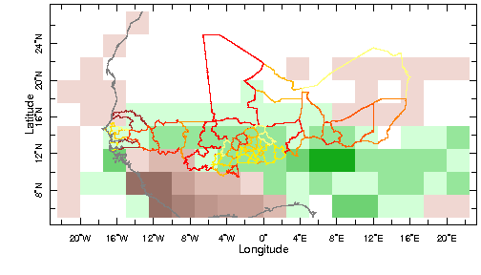
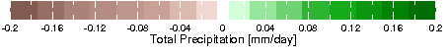 http://iridl.ldeo.columbia.edu/expert/SOURCES/.NASA/.GPCP/.V2/.satellite-gauge/.prcp/T/%28May%201981%29%28Oct%202003%29RANGE/T/6/boxAverage/T/12/STEP/X/-20/20/RANGE/Y/8/26/RANGE/dup%5BT%5Ddetrend-bfl/sub/dup/T/last/VALUE/exch/T/first/VALUE/sub/prcp_anomaly/23/div/DATA/-0.2/0.2/RANGE/home/.jdcorral/.Ale/.region_proj_num/.the_geom/home/.jdcorral/.Ale/.region_proj_num/.total/startcolormap/0/500/RANGEEDGES/null/white/yellow/0/value/orange/100/VALUE/OrangeRed/200/VALUE/red/300/VALUE/DarkRed/400/VALUE/brown/endcolormap/DATA/0/20/RANGE/X/Y/fig:/colors/||/strokeby/grey/thinnish/coasts_gaz/:fig/
Top is 1981-2003, bottom is 1951-1990 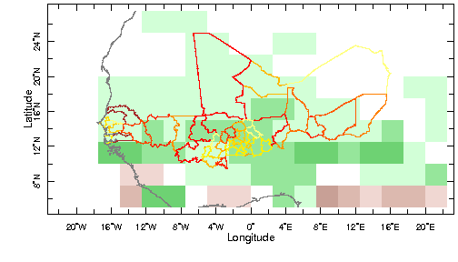 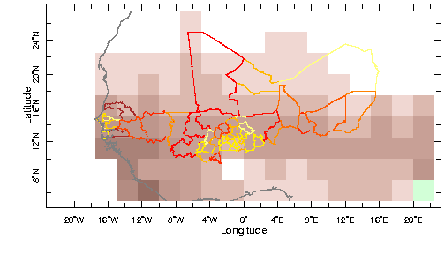 http://iridl.ldeo.columbia.edu/expert/SOURCES/.WCRP/.GCOS/.GPCC/.FDP/.version4/.2p5/.prcp/30/div/T/%28May%201981%29%28Oct%202003%29RANGE/T/6/boxAverage/T/12/STEP/X/-20/20/RANGE/Y/8/26/RANGE/dup%5BT%5Ddetrend-bfl/sub/dup/T/last/VALUE/exch/T/first/VALUE/sub/prcp_anomaly/23/div/DATA/-0.2/0.2/RANGE/home/.jdcorral/.Ale/.region_proj_num/.the_geom/home/.jdcorral/.Ale/.region_proj_num/.total/startcolormap/0/500/RANGEEDGES/null/white/yellow/0/value/orange/100/VALUE/OrangeRed/200/VALUE/red/300/VALUE/DarkRed/400/VALUE/brown/endcolormap/DATA/0/20/RANGE/X/Y/fig:/colors/||/strokeby/grey/thinnish/coasts_gaz/:fig/

1951-2000 climatology (WCRP/GPCC version 4)

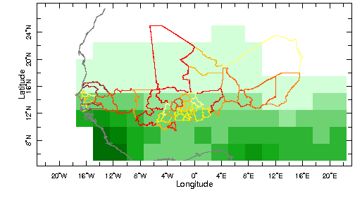
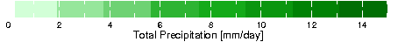
http://iridl.ldeo.columbia.edu/expert/SOURCES/.WCRP/.GCOS/.GPCC/.FDP/.version4/.2p5/.prcp/30/div/T/%28May%201951%29%28Oct%202000%29RANGE/T/6/boxAverage/T/12/STEP/X/-20/20/RANGE/Y/8/26/RANGE%5BT%5Daverage//units/%28mm/day%29def/precip_colors/DATA/0/15/RANGE/home/.jdcorral/.Ale/.region_proj_num/.the_geom/home/.jdcorral/.Ale/.region_proj_num/.total/startcolormap/0/500/RANGEEDGES/null/white/yellow/0/value/orange/100/VALUE/OrangeRed/200/VALUE/red/300/VALUE/DarkRed/400/VALUE/brown/endcolormap/DATA/0/20/RANGE/X/Y/fig:/colors/||/strokeby/grey/thinnish/coasts_gaz/:fig/
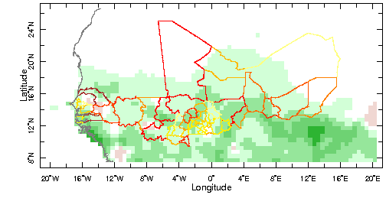 TS2p1 prcp linear trend 1982-2002
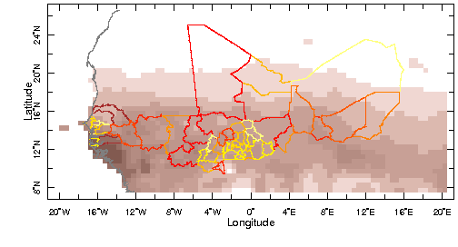 TS2p1 prcp linear trend 1951-1990

http://iridl.ldeo.columbia.edu/expert/SOURCES/.UEA/.CRU/.TS2p1/.monthly/.prcp/30/div/T/%28May%201951%29%28Oct%201990%29RANGE/T/6/boxAverage/T/12/STEP/X/-20/20/RANGE/Y/8/26/RANGE/dup%5BT%5Ddetrend-bfl/sub/dup/T/last/VALUE/exch/T/first/VALUE/sub/prcp_anomaly/23/div/DATA/-0.2/0.2/RANGE/home/.jdcorral/.Ale/.region_proj_num/.the_geom/home/.jdcorral/.Ale/.region_proj_num/.total/startcolormap/0/500/RANGEEDGES/null/white/yellow/0/value/orange/100/VALUE/OrangeRed/200/VALUE/red/300/VALUE/DarkRed/400/VALUE/brown/endcolormap/DATA/0/20/RANGE/X/Y/fig:/colors/||/strokeby/grey/thinnish/coasts_gaz/:fig/
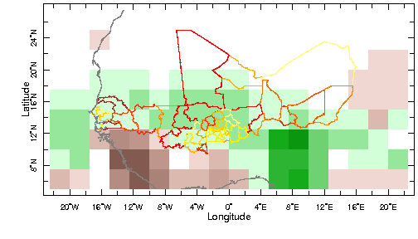 CMAP prcp_est linear trend 1981-2003

http://iridl.ldeo.columbia.edu/expert/SOURCES/.NOAA/.NCEP/.CPC/.Merged_Analysis/.monthly/.latest/.ver1/.prcp_est/T/%28May%201981%29%28Oct%202003%29RANGE/T/6/boxAverage/T/12/STEP/X/-20/20/RANGE/Y/8/26/RANGE/dup%5BT%5Ddetrend-bfl/sub/dup/T/last/VALUE/exch/T/first/VALUE/sub/prcp_anomaly/23/div/DATA/-0.2/0.2/RANGE/home/.jdcorral/.Ale/.region_proj_num/.the_geom/home/.jdcorral/.Ale/.region_proj_num/.total/startcolormap/0/500/RANGEEDGES/null/white/yellow/0/value/orange/100/VALUE/OrangeRed/200/VALUE/red/300/VALUE/DarkRed/400/VALUE/brown/endcolormap/DATA/0/20/RANGE/X/Y/fig:/colors/||/strokeby/grey/thinnish/coasts_gaz/:fig/
Full trend in NDVI

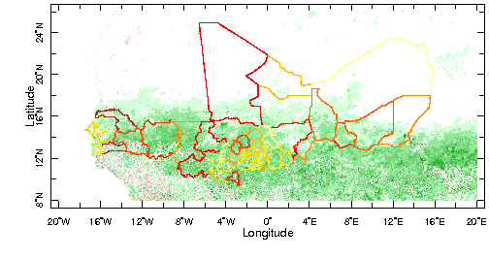
SOURCES .UMD .GLCF .GIMMS .NDVIg .global .ndvi
X -20 20 RANGE Y 8 26 RANGE T 1 monthlyAverage
T (Jan 1982) (Dec 2003) RANGE T 12 boxAverage T 12 STEP
dup [T]detrend-bfl sub dup T last VALUE exch T first VALUE sub
22 div
prcp_anomaly X Y fig: colors grey thinnish countries_gaz :fig
/adif -0.01 0.01 plotrange

this is the computation of the error/sigma in the slope/trend
SOURCES .UMD .GLCF .GIMMS .NDVIg .global .ndvi
X -20 20 RANGE Y 8 26 RANGE
T 1 monthlyAverage T (Jan 1982) (Dec 2003) RANGE
T 12 boxAverage T 12 STEP
dup [T]rmsaover
exch
T first last sub 12 div dup mul 12 div sqrt
nip nip
div 21 sqrt div
prcp_anomaly
X Y fig: colors grey thinnish countries_gaz :fig
/ndvi -0.001 0.001 plotrange

the line:
T first last sub 12 div dup mul 12 div sqrt
is computation of the sigma of time, in years, that is why I divide by 12

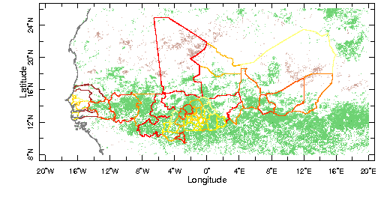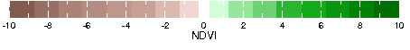
% t-value for the trend
% this is the trend
SOURCES .UMD .GLCF .GIMMS .NDVIg .global .ndvi
X -20 20 RANGE Y 8 26 RANGE T 1 monthlyAverage
T (Jan 1982) (Dec 2003) RANGE T 12 boxAverage T 12 STEP
dup [T]detrend-bfl sub dup
T last VALUE exch T first VALUE sub 22 div
% this is significance in the trend
SOURCES .UMD .GLCF .GIMMS .NDVIg .global .ndvi
X -20 20 RANGE Y 8 26 RANGE T 1 monthlyAverage
T (Jan 1982) (Dec 2003) RANGE T 12 boxAverage T 12 STEP
dup [T]rmsaover exch
T first last sub 12 div dup mul 12 div sqrt
nip nip div 21 sqrt div
div
-2.1 2.1 maskrange
prcp_anomaly
home .jdcorral .Ale .region_proj_num .the_geom
home .jdcorral .Ale .region_proj_num .total
startcolormap 0 500 RANGEEDGES null white yellow 0 value orange 100 VALUE OrangeRed 200 VALUE red 300 VALUE DarkRed 400 VALUE brown endcolormap DATA 0 20 RANGE
X Y fig: colors || strokeby grey thinnish coasts_gaz :fig/ratio -10 10 plotrange
Correlation between annual mean prcp and NDVI, with trend and with linear trend removed (0.444 is significant correlation at 5% w/ dof=18)

SOURCES .UMD .GLCF .GIMMS .NDVIg .global .ndvi
T (Jan 1982) (Dec 2003) RANGE T 1 monthlyAverage T 12 boxAverage T 12 STEP X -20 20 RANGE Y 8 26 RANGE %% [T] detrend-bfl
SOURCES .NASA .GPCP .V2 .satellite-gauge .prcp
[SOURCES .WCRP .GCOS .GPCC .FDP .version4 .2p5 .prcp]
[SOURCES .UEA .CRU .TS2p1 .monthly .prcp]
[SOURCES .NOAA .NCEP .CPC .Merged_Analysis .monthly .latest .ver1 .prcp_est]
T (Jan 1982) (Dec 2003) RANGE T 12 boxAverage T 12 STEP
X -20 20 RANGE Y 8 26 RANGE %% [T] detrend-bfl
[X Y]regridAverage [T]correlate -0.444 0.444 maskrange prcp_anomaly
home .jdcorral .Ale .region_proj_num .the_geom
home .jdcorral .Ale .region_proj_num .total
startcolormap 0 500 RANGEEDGES null white yellow 0 value orange 100 VALUE OrangeRed 200 VALUE red 300 VALUE DarkRed 400 VALUE brown endcolormap DATA 0 20 RANGE X Y fig: colors || strokeby grey thinnish :fig /correlation -1 1 plotrange

summary trend plots, significant t for 1) ndvi, 2) residual ndvi 3) gpcp prcp
1) ndvi: http://iridl.ldeo.columbia.edu/expert/SOURCES/.UMD/.GLCF/.GIMMS/.NDVIg/.global/.ndvi/X/-20/20/RANGE/Y/8/26/RANGE/T/1/monthlyAverage/T/%28Jan%201982%29%28Dec%202003%29RANGE/T/12/boxAverage/T/12/STEP/dup%5BT%5Ddetrend-bfl/sub/dup/T/last/VALUE/exch/T/first/VALUE/sub/22/div/SOURCES/.UMD/.GLCF/.GIMMS/.NDVIg/.global/.ndvi/X/-20/20/RANGE/Y/8/26/RANGE/T/1/monthlyAverage/T/%28Jan%201982%29%28Dec%202003%29RANGE/T/12/boxAverage/T/12/STEP/dup%5BT%5Drmsaover/exch/T/first/last/sub/12/div/dup/mul/12/div/sqrt/nip/nip/div/21/sqrt/div/div/-2.1/2.1/maskrange/prcp_anomaly/home/.jdcorral/.Ale/.region_proj_num/.the_geom/home/.jdcorral/.Ale/.region_proj_num/.total/startcolormap/0/500/RANGEEDGES/null/white/yellow/0/value/orange/100/VALUE/OrangeRed/200/VALUE/red/300/VALUE/DarkRed/400/VALUE/brown/endcolormap/DATA/0/20/RANGE/X/Y/fig:/colors/||/strokeby/grey/thinnish/coasts_gaz/:fig///ratio/-10/10/plotrange/

2) res ndvi: http://iridl.ldeo.columbia.edu/expert/home/.alesall/.tmp/.residual_ndvig-prcp_anom_8km_annual.cdf/.adif/X/-20/20/RANGE/Y/8/26/RANGE/dup[T]detrend-bfl/sub/dup/T/last/VALUE/exch/T/first/VALUE/sub/22/div/home/.alesall/.tmp/.residual_ndvig-prcp_anom_8km_annual.cdf/.adif/X/-20/20/RANGE/Y/8/26/RANGE/dup[T]rmsaover/exch/T/first/last/sub/12/div/dup/mul/12/div/sqrt/nip/nip/div/21/sqrt/div/div/-2.1/2.1/maskrange/prcp_anomaly/home/.jdcorral/.Ale/.region_proj_num/.the_geom/home/.jdcorral/.Ale/.region_proj_num/.total/startcolormap/0/500/RANGEEDGES/null/white/yellow/0/value/orange/100/VALUE/OrangeRed/200/VALUE/red/300/VALUE/DarkRed/400/VALUE/brown/endcolormap/DATA/0/20/RANGE/X/Y/fig:/colors/||/strokeby/grey/thinnish/coasts_gaz/:fig//ratio/-10/10/plotrange/

3) GPCP prcp http://iridl.ldeo.columbia.edu/expert/SOURCES/.NASA/.GPCP/.V2/.satellite-gauge/.prcp/T/%28Jul%201981%29%28Sep%202003%29RANGE/T/3/boxAverage/T/12/STEP/X/-20/40/RANGE/Y/0/30/RANGE/dup%5BT%5Ddetrend-bfl/sub/dup/T/last/VALUE/exch/T/first/VALUE/sub/prcp_anomaly/23/div/SOURCES/.NASA/.GPCP/.V2/.satellite-gauge/.prcp/T/%28Jul%201981%29%28Sep%202003%29RANGE/T/3/boxAverage/T/12/STEP/X/-20/40/RANGE/Y/0/30/RANGE/dup%5BT%5Drmsaover/exch/T/first/last/sub/12/div/dup/mul/12/div/sqrt/nip/nip/div/22/sqrt/div/div/X/-20/20/RANGE/Y/8/26/RANGE/-1.7/1.7/maskrange/prcp_anomaly/home/.jdcorral/.Ale/.region_proj_num/.the_geom/home/.jdcorral/.Ale/.region_proj_num/.total/startcolormap/0/500/RANGEEDGES/null/white/yellow/0/value/orange/100/VALUE/OrangeRed/200/VALUE/red/300/VALUE/DarkRed/400/VALUE/brown/endcolormap/DATA/0/20/RANGE/X/Y/fig:/colors/||/strokeby/grey/thinnish/coasts_gaz/:fig//prcp/-10/10/plotrange/
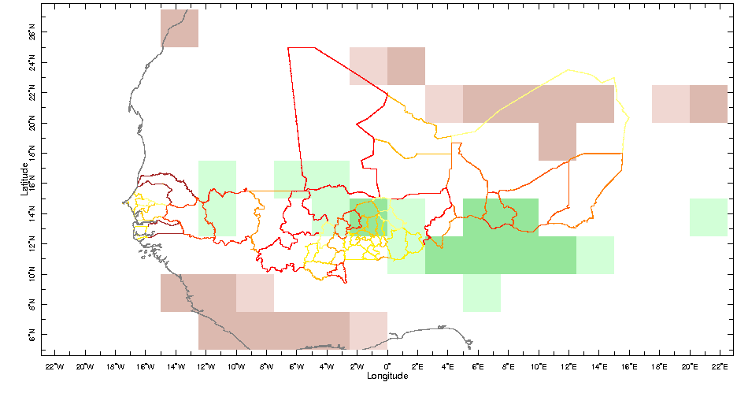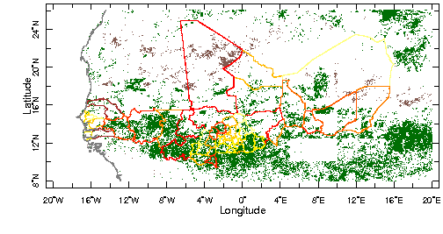
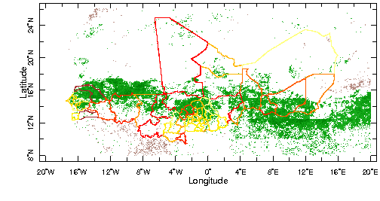GPCP 1982-2003
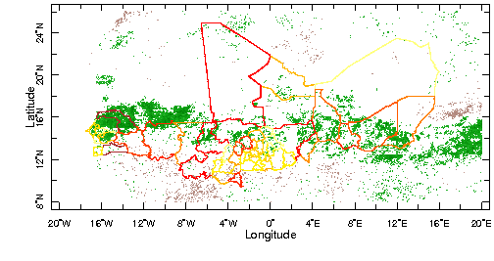
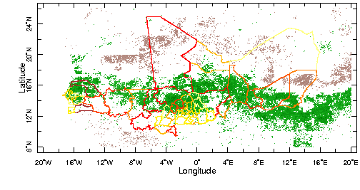 Same as on the previous page, but using GPCC version4 prcp 1982-2003
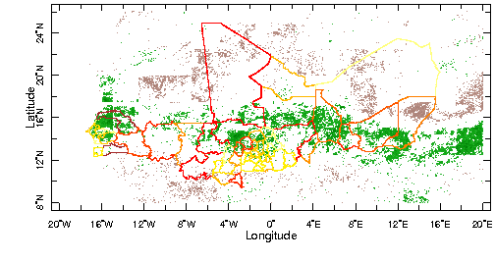
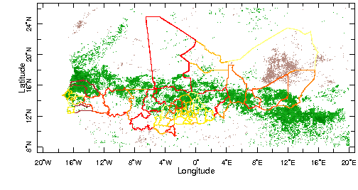Same as on the previous page, but using TS2p1 prcp 1982-2002
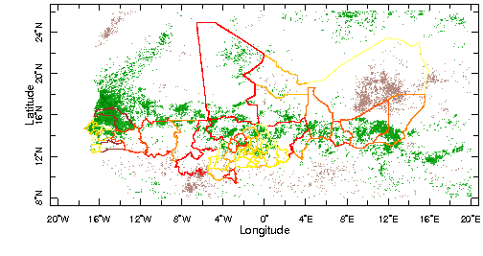
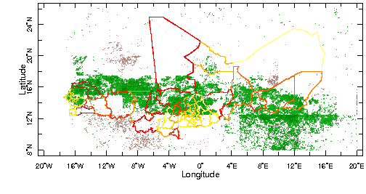Same as on the previous page, but using CMAP prcp 1982-2003
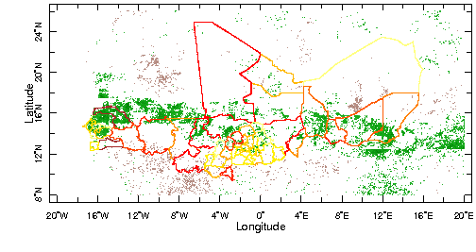
Rainfall climatologies used to mask out regions that are too wet or too dry.
Turns out they are slightly different depending on which dataset[/period]…

[SOURCES .NASA .GPCP .V2 .satellite-gauge .prcp]
[SOURCES .WCRP .GCOS .GPCC .FDP .version4 .2p5 .prcp]
SOURCES .UEA .CRU .TS2p1 .monthly .prcp
[SOURCES .NOAA .NCEP .CPC .Merged_Analysis .monthly .latest .ver1 .prcp_est]
T (Jan 1982) (Dec 2002) RANGE
[T]average
X -20 20 RANGE
Y 8 26 RANGE
12 mul %% [365 for GPCP or GPCC]
dup SOURCES .Features .Political .Africa .Provinces .the_geom
feature_id (133001) (133002) (133003) (133004) (133005) (133006) (133007) (133008) (158001) (158002) (158003) (158004) (158005) (158006) (158007) (195001) (195002) (195003) (195004) (195005) (195006) (195007) (195008) (195009) (195010) (233001) (233002) (233003) (233004) (233005) (233006) (233007) (233008) (233009) (233010) (233011) (233012) (233013) (233014) (233015) (233016) (233017) (233018) (233019) (233020) (233021) (233022) (233023) (233024) (233025) (233026) (233027) (233028) (233029) (233030) VALUES
[X Y]weighted-average
200 800 masknotrange
/units (mm/yr) def
precip_colors
SOURCES .Features .Political .Africa .Provinces .the_geom exch
X Y fig: white mask fillby grey solid countries_gaz :fig
/prcp 200 800 plotrange
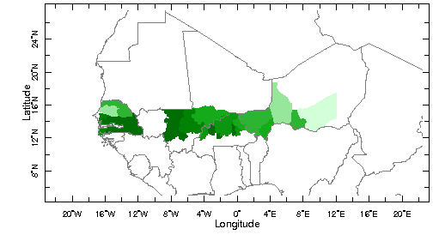NASA/GPCP
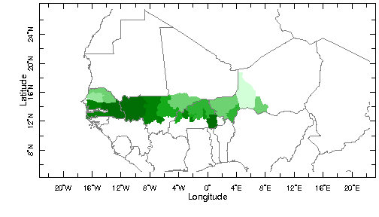WCRP/GPCC
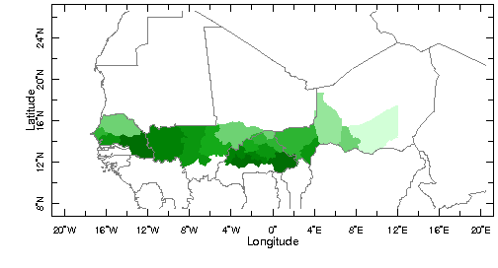
UEA/TS2p1 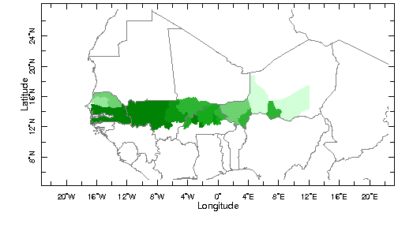NOAA/CMAP
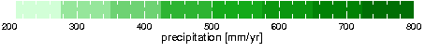
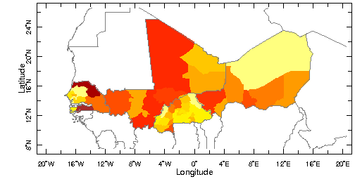 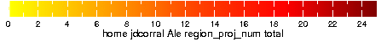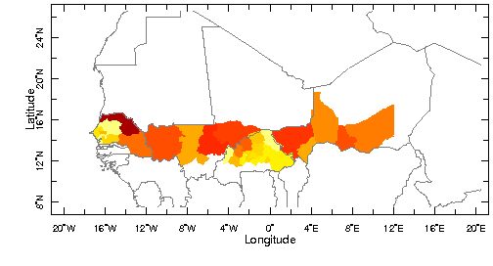 masking regions using prcp climo:

home .alesall .tmp .region_TS2p1.1982-2002annual_feature_id.cdf .prcp
feature (featureid) renameGRID 200 800 masknotrange 0 mul 1 add
home .alesall .tmp .SOURCES .UEA .CRU .TS2p1 .monthly .prcp
T (Jan 1982) (Dec 2002) RANGE
[T]average
X -20 20 RANGE
Y 8 26 RANGE
home .jdcorral .Ale .region_proj_num .the_geom
home .jdcorral .Ale .region_proj_num .total
home .alesall .tmp .region_TS2p1.1982-2002annual_feature_id.cdf .prcp
feature (featureid) renameGRID
200 800 masknotrange
0 mul
1 add
mul
startcolormap
0 500 RANGEEDGES
null white yellow
0 value
orange
100 VALUE
OrangeRed
200 VALUE
red
300 VALUE
DarkRed
400 VALUE
brown endcolormap
DATA 0 25 RANGE
X Y fig: white mask fillby grey solid countries_gaz :fig
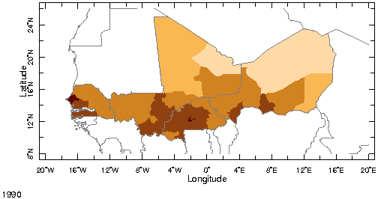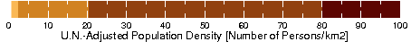
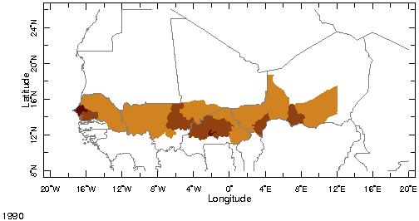
SOURCES .CIESIN .GPWv3 .grid2p5arcmin .adjusted .density
X -20 20 RANGE Y 8 26 RANGE T (1990 ) VALUES 500 maskgt
dup SOURCES .Features .Political .Africa .Provinces .the_geom
feature_id (133001) (133002) (133003) (133004) (133005) (133006) (133007) (133008) (158001) (158002) (158003) (158004) (158005) (158006) (158007) (195001) (195002) (195003) (195004) (195005) (195006) (195007) (195008) (195009) (195010) (233001) (233002) (233003) (233004) (233005) (233006) (233007) (233008) (233009) (233010) (233011) (233012) (233013) (233014) (233015) (233016) (233017) (233018) (233019) (233020) (233021) (233022) (233023) (233024) (233025) (233026) (233027) (233028) (233029) (233030) VALUES [X Y]weighted-average
home .alesall .tmp .region_TS2p1.1982-2002annual_feature_id.cdf .prcp
feature (feature_id) renameGRID
200 800 masknotrange 0 mul 1 add mul
SOURCES .Features .Political .Africa .Provinces .the_geom exch
X Y fig: white mask fillby grey solid countries_gaz :fig
/aprod 0 100 plotrange

http://iridl.ldeo.columbia.edu/expert/SOURCES/.CIESIN/.GPWv3/.grid2p5arcmin/.adjusted/.density/X/-20/20/RANGE/Y/8/26/RANGE/home/.jdcorral/.Ale/.region_proj_num/.the_geom/home/.jdcorral/.Ale/.region_proj_num/.total/startcolormap/0/500/RANGEEDGES/null/white/yellow/0/value/orange/100/VALUE/OrangeRed/200/VALUE/red/300/VALUE/DarkRed/400/VALUE/brown/endcolormap/DATA/0/20/RANGE/X/Y/fig:/colors/||/strokeby/grey/thinnish/:fig//density/0/100/plotrange/

http://iridl.ldeo.columbia.edu/expert/home/.alesall/.tmp/.trend_ndvig_8km_annual.cdf/.adif/home/.alesall/.tmp/.rms_trend_ndvig_8km_annual.cdf/.ndvi/div/-2.1/2.1/masknotrange/home/.alesall/.tmp/.corr-prcp-ndvi_annual_8km.cdf/.correlation/-0.4/0.4/maskrange/0/mul/1/add/mul/X/-20/20/RANGE/Y/8/26/RANGE/correlationcolorscale/home/.jdcorral/.Ale/.region_proj_num/.the_geom/home/.jdcorral/.Ale/.region_proj_num/.total/startcolormap/0/500/RANGEEDGES/null/white/yellow/0/value/orange/100/VALUE/OrangeRed/200/VALUE/red/300/VALUE/DarkRed/400/VALUE/brown/endcolormap/DATA/0/20/RANGE/X/Y/fig:/colors/||/strokeby/grey/thinnish/blue/rivers/:fig//aprod/-10/10/plotrange/

http://iridl.ldeo.columbia.edu/expert/home/.alesall/.tmp/.trend_ndvig_8km_annual.cdf/.adif/X/-20/20/RANGE/Y/8/26/RANGE/home/.jdcorral/.Ale/.region_proj_num/.the_geom/home/.alesall/.tmp/.region_tval_trend_ndvig_8km_annual_popd1990gt500.cdf/.aprod/feature/%28featureid%29renameGRID/-2.1/2.1/masknotrange/home/.alesall/.tmp/.region_corr_ndvig_8km-prcp_gpcp_annual_popd1990gt500.cdf/.aprod/feature/%28featureid%29renameGRID/-0.4/0.4/maskrange/0/mul/1/add/mul/ correlationcolorscale/X/Y/fig:/white/mask/fillby/grey/solid/countries_gaz/:fig//aprod/-10/10/plotrange/

http://iridl.ldeo.columbia.edu/expert/home/.alesall/.tmp/.trend_ndvig_8km_annual.cdf/.adif/home/.alesall/.tmp/.rms_trend_ndvig_8km_annual.cdf/.ndvi/div/-2.1/2.1/maskrange/home/.alesall/.tmp/.corr-prcp-ndvi_annual_8km.cdf/.correlation/-0.4/0.4/maskrange/0/mul/1/add/mul/home/.alesall/.tmp/.corr-prcp-ndvi_detrend-annual_8km.cdf/.correlation/-0.4/0.4/masknotrange/0/mul/1/add/mul/X/-20/20/RANGE/Y/8/26/RANGE/correlationcolorscale/home/.jdcorral/.Ale/.region_proj_num/.the_geom/home/.jdcorral/.Ale/.region_proj_num/.total/startcolormap/0/500/RANGEEDGES/null/white/yellow/0/value/orange/100/VALUE/OrangeRed/200/VALUE/red/300/VALUE/DarkRed/400/VALUE/brown/endcolormap/DATA/0/20/RANGE/X/Y/fig:/colors/||/strokeby/grey/thinnish/blue/rivers/:fig//aprod/-10/10/plotrange/

http://iridl.ldeo.columbia.edu/expert/home/.alesall/.tmp/.trend_ndvig_8km_annual.cdf/.adif/X/-20/20/RANGE/Y/8/26/RANGE/home/.jdcorral/.Ale/.region_proj_num/.the_geom/home/.alesall/.tmp/.region_tval_trend_ndvig_8km_annual_popd1990gt500.cdf/.aprod/feature/%28featureid%29renameGRID/-2.1/2.1/maskrange/home/.alesall/.tmp/.region_corr_ndvig_8km-prcp_gpcp_annual_popd1990gt500.cdf/.aprod/feature/%28featureid%29renameGRID/-0.4/0.4/maskrange/0/mul/1/add/mul/home/.alesall/.tmp/.region_corr-prcp-ndvi_detrend-annual_8km_popd1990gt500.cdf/.aprod/feature/%28featureid%29renameGRID/-0.4/0.4/masknotrange/0/mul/1/add/mul/correlationcolorscale/X/Y/fig:/white/mask/fillby/grey/solid/countries_gaz/:fig//aprod/-10/10/plotrange/

http://iridl.ldeo.columbia.edu/expert/home/.alesall/.tmp/.trend_ndvig_8km_annual.cdf/.adif/home/.alesall/.tmp/.rms_trend_ndvig_8km_annual.cdf/.ndvi/div/-2.1/2.1/maskrange/home/.alesall/.tmp/.corr-prcp-ndvi_annual_8km.cdf/.correlation/-0.4/0.4/masknotrange/0/mul/1/add/mul/X/-20/20/RANGE/Y/8/26/RANGE/correlationcolorscale/home/.jdcorral/.Ale/.region_proj_num/.the_geom/home/.jdcorral/.Ale/.region_proj_num/.total/startcolormap/0/500/RANGEEDGES/null/white/yellow/0/value/orange/100/VALUE/OrangeRed/200/VALUE/red/300/VALUE/DarkRed/400/VALUE/brown/endcolormap/DATA/0/20/RANGE/X/Y/fig:/colors/||/strokeby/grey/thinnish/blue/rivers/:fig//aprod/-10/10/plotrange/
http://iridl.ldeo.columbia.edu/expert/home/.alesall/.tmp/.trend_ndvig_8km_annual.cdf/.adif/X/-20/20/RANGE/Y/8/26/RANGE/home/.jdcorral/.Ale/.region_proj_num/.the_geom/home/.alesall/.tmp/.region_tval_trend_ndvig_8km_annual_popd1990gt500.cdf/.aprod/feature/%28featureid%29renameGRID/-2.1/2.1/maskrange/home/.alesall/.tmp/.region_corr_ndvig_8km-prcp_gpcp_annual_popd1990gt500.cdf/.aprod/feature/%28featureid%29renameGRID/-0.4/0.4/masknotrange/0/mul/1/add/mul/correlationcolorscale/X/Y/fig:/white/mask/fillby/grey/solid/countries_gaz/:fig//aprod/-10/10/plotrange/

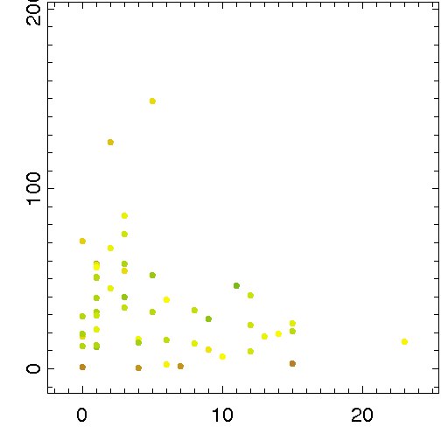

home .jdcorral .Ale .region_proj_num .total DATA -2 25 RANGE
home .alesall .tmp .region_popd1990gt500_featureid2.cdf .density
feature (featureid) renameGRID DATA -10 200 RANGE
home .alesall .tmp .region_tval_trend_ndvig_8km_annual_popd1990gt500.cdf .aprod
feature (featureid) renameGRID
fig: /fntsze 30 def /XOVY 1 def scattercolor :fig /aprod -1 4 plotrange

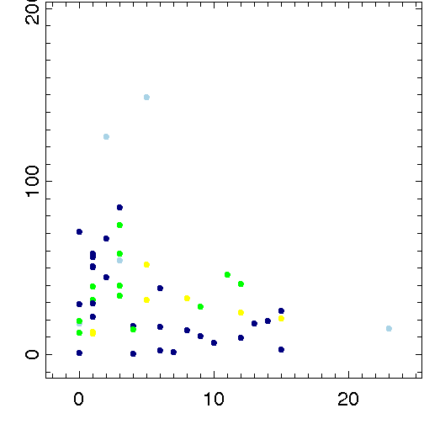
I need a better colorscale for sure, but in the end a summary plot like this one is what is needed!

home .jdcorral .Ale .region_proj_num .total DATA -2 25 RANGE
home .alesall .tmp .region_popd1990gt500_featureid2.cdf .density
feature (featureid) renameGRID DATA -10 200 RANGE
home .alesall .tmp .region_cluster2_YEStrend_YEScorr_NOdetrendcorr.cdf .flag
home .alesall .tmp .region_cluster1_NOtrend_YEScorr_YESdetrendcorr.cdf .flag add
home .alesall .tmp .region_cluster3_YEStrend_NOcorr_YESrestrend.cdf .flag add
feature (featureid) renameGRID
startcolormap 0 500 RANGEEDGES null black blue 0 value LightBlue 100 VALUE green 200 VALUE yellow 300 VALUE red 400 VALUE DarkRed endcolormap
DATA 0 4 RANGE
fig: /fntsze 30 def /XOVY 1 def scattercolor :fig /flag 0 4 plotrange
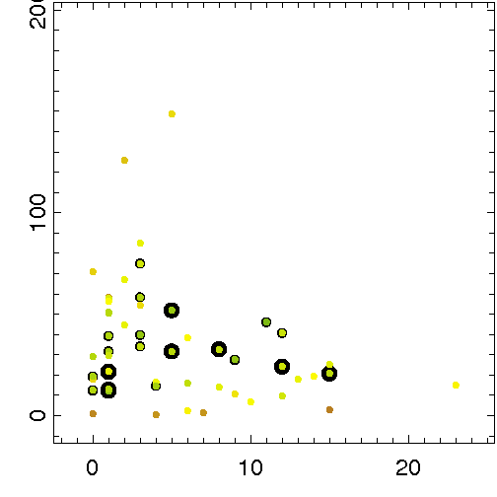

home .jdcorral .Ale .region_proj_num .total DATA -2 25 RANGE
home .alesall .tmp .region_popd1990gt500_featureid2.cdf .density
feature (featureid) renameGRID DATA -10 200 RANGE
home .alesall .tmp .region_cluster2_YEStrend_YEScorr_NOdetrendcorr.cdf .flag
home .alesall .tmp .region_cluster1_NOtrend_YEScorr_YESdetrendcorr.cdf .flag add
home .alesall .tmp .region_cluster3_YEStrend_NOcorr_YESrestrend.cdf .flag add
feature (featureid) renameGRID
home .jdcorral .Ale .region_proj_num .total DATA -2 25 RANGE
home .alesall .tmp .region_popd1990gt500_featureid2.cdf .density
feature (featureid) renameGRID DATA -10 200 RANGE
home .alesall .tmp .region_tval_trend_ndvig_8km_annual_popd1990gt500.cdf .aprod
feature (featureid) renameGRID
fig: /XOVY 1 def /fntsze 30 def scattersized scattercolor :fig
/flag 1 3 plotrange /aprod -1 4 plotrange

questa variante non mi convince… http://iridl.ldeo.columbia.edu/expert/home/.jdcorral/.Ale/.region_proj_num/.total/DATA/-2/25/RANGE/home/.alesall/.tmp/.region_popd1990gt500_featureid2.cdf/.density/feature/%28featureid%29renameGRID/DATA/-10/200/RANGE/home/.alesall/.tmp/.region_cluster2_YEStrend_YEScorr_NOdetrendcorr.cdf/.flag/home/.alesall/.tmp/.region_cluster1_NOtrend_YEScorr.cdf/.flag/add/home/.alesall/.tmp/.region_cluster3_YEStrend_NOcorr.cdf/.flag/add/feature/%28featureid%29renameGRID/home/.jdcorral/.Ale/.region_proj_num/.total/DATA/-2/25/RANGE/home/.alesall/.tmp/.region_popd1990gt500_featureid2.cdf/.density/feature/%28featureid%29renameGRID/DATA/-10/200/RANGE/home/.alesall/.tmp/.region_tval_trend_ndvig_8km_annual_popd1990gt500.cdf/.aprod/feature/%28featureid%29renameGRID/fig://XOVY/1/def//fntsze/30/def/scattersized/scattercolor/:fig//flag/1/3/plotrange//aprod/-1/4/plotrange/

